**Group 17 – Design Specification**

Authors: Alexander Webb (ajw21), Frederick Kranich (frk2), George Vinters (ghv), Grigor Mironov (gmm11), Peter George (peg4), Jose Iznardo (jov2), Jack Thomson (jat36)

Date: 19/11/2015

Version: 1.1

Status: Release

Department of Computer Science

Aberystwyth University

Aberystwyth

Ceredigion

SY23 3DB

Copyright © Aberystwyth University

Contents

1 Introduction 4

1.1 Purpose of this Document 4

1.2 Scope 4

1.3 Objectives 4

2 Deployment Description 4

2.1 Applications in the System 4

2.2 Application Interaction 5

2.2.1 TaskerMAN 5

2.2.2 TaskerCLI 6

3 Interaction Design 7

3.1 Use-cases 7

3.2 User Interface Design 7

3.2.1 TaskerMAN 7

3.2.2 TaskerCLI 7

4 Component Description 7

5 Significant Classes 8

5.1 Interface Description 9

6 Detailed Design 12

6.1 Sequence Diagrams 12

6.2 State Diagrams 17

6.3 Activity Diagrams 18

6.4 Risk Reduction and Spike Work 19

Database Research: 19

Java Research: 19

Website Research: 19

Final Decisions on the Design: 19

6.4 Significant Data Structures 20

7 Appendix 21

7.1 Appendix A 21

7.2 Appendix B 45

8 References 49

9 Document History 50

# 1 Introduction

## 1.1 Purpose of this Document

The purpose of this document is to detail the design of the final system.

## 1.2 Scope

The document will detail the applications that the system contain along with details of the interaction. The document should include useful design information such as the user interface designs and the UML diagrams of the system. This document should conform to standards laid out in SE.QA.05A [1]. The layout of this document is similar to the that with in SE.QA.05A[1] and will be adapted to cover all of the program where necessary.

## 1.3 Objectives

The objectives of this document are as follows:

* Clearly lay out the design of the program.
* Allow the development team to be able to create a full program from the information in this specification.
* Allow the team to be able to understand the system in terms of what the system comprises of and how they interact.

# 2 Deployment Description

## 2.1 Applications in the System

The primary database, TaskerSRV, being used will by MySQL. Inside of this, the database will be manipulated using the SQL query language in order to access data and manipulate it. This includes add, update and delete functionality.

The web application, TaskerMAN, will been designed to work on the three major web browsers. These three browsers are most commonly used and are therefore targets for functionality in the application.

Primary application, TaskerCLI, language will be Java, written in the eclipse IDE as a standard for the project.

The system will be designed to run on the target computers with in the Computer Science department. The operating systems that the system will run on are either Linux Mint or OSX but the TaskerCLI will be able to run on multiple operating systems including windows. This covers all major operating systems including most distributions of the Linux operating systems. This ensures that the majority of people will be able to use the application as required. The TaskerCLI will be running in the JVM which allows the TaskerCLI to be incorporated in to many operating systems with ease.

When installing the application onto a user machine, a CD will be used to install the application. This makes it possible to install the application using physical media in order to deliver the application.

When communicating with the databases (TaskerSRV), the web client (TaskerMAN) will be using PHP as its primary server side language in order to send and receive requests to and from the databases. The main content of the TaskerMAN will be written to meet the standards of HTML5.

## 2.2 Application Interaction

### 2.2.1 TaskerMAN

The nature of the interaction between the web client and the database is based around the interaction between three components of the overall system; the users’ personal computer, the web client onto which TaskerMAN is hosted, and the database (which for the purposes of this description will be described as being hosted in the university system). The User PC platform will need to have a modern web browser and an internet connection in order to access the Database proper, although the user will have access to a “compatibility mode” which saves changes and progress on local storage. These will be uploaded to the database the next time the user runs TaskerCLI with an internet connection.

The web server is the application which hosts TaskerMAN, namely the HTML, CSS and PHP which are used to build it. PHP will be the language used for the clients’ interaction with the database. The site will be designed for use by administrators and managers, thus they’ll be able to create tasks, vie all tasks with their allocated team member(s), filter specific tasks by their name, status and member allocated, allocate them to specific team members, reallocate existing tasks to different members, mark tasks as abandoned. Authorizing certain user to utilize all TaskerMAN facilities is an optional feature for the development team to implement.

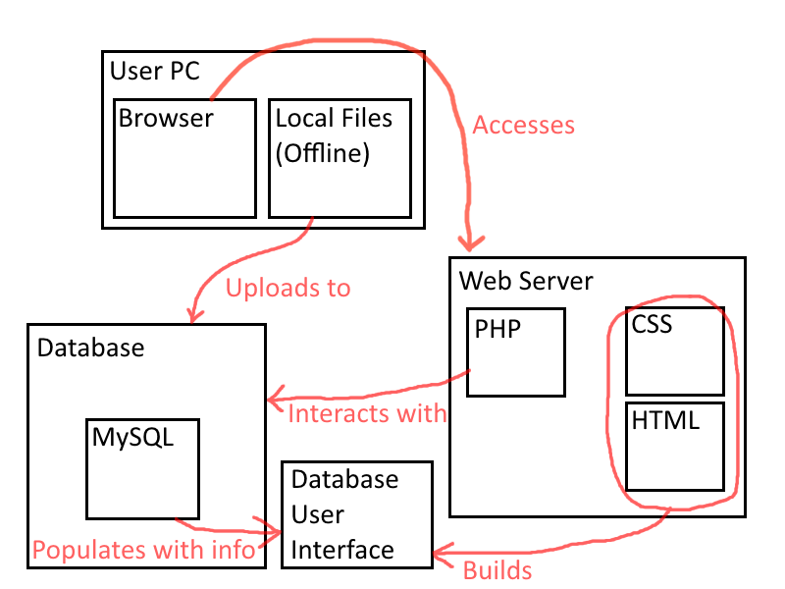

Web Server and Browser – TaskerMAN, User PC – TaskerCLI & Database - TaskerSRV.

### 2.2.2 TaskerCLI

To make a connection between Java and a database we need to create DAO (Data Access Objects) for each table we want to access. There will be a class called 'database' in order to hold all the DAO, and Connection objects (objects that hold the connection between our code and the server). Each DAO needs to be extended from an abstract class called DAO which holds the reference instance of the database object and the reference instance of the Connection. We also need to create a few classes extending the abstract DAO class.

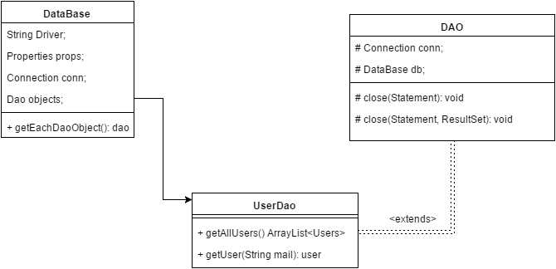

The database class has getters for each DAO we have. The abstract DAO class has methods for closing the statement instance and the resulting instance (these objects are required for retrieval of information from the database). Each DAO needs to have all the required methods with its appropriate SQL statements for information retrieval. This UML diagram has not been completed as the database has not been created yet, so the amount of tables and fields we have is unknown. This is an abstract idea for the purposes of design.

To create a connection we need a JBDC driver for each database type. In our case we use MySQL, so we use the MySQL driver for our connection.

# 3 Interaction Design

## 3.1 Use-cases

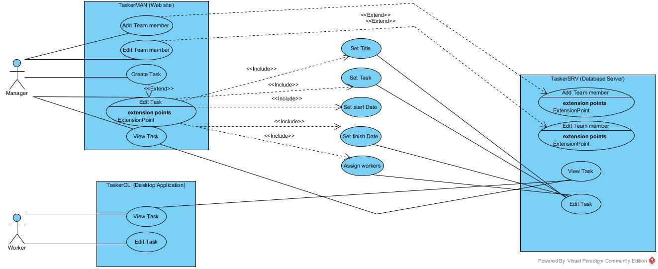

## 3.2 User Interface Design

The following designs for the web and desktop applications will be subject to change. The designs do not completely represent the final system.

### 3.2.1 TaskerMAN

The design for TaskerMAN is located in appendix A.

### 3.2.2 TaskerCLI

The design for TaskerCLI is located in appendix b.

# 4 Component Description

This section will describe how the system is composed and what components are within those components.

The central component of the system is the Database (TaskerSRV). This will be held by the Computer Science department servers. This is made up of multiple tables, the tables allows the storing of all the data required for the entire system. The Database will be written in MySQL and accessed through SQL queries. The queries will be sent by the other elements of the system. The other elements will control the data in the database through the queries.

The TaskerMAN section will comprise of the web server. The web server is an apache web server that is held by Information Services. The server will hold the PHP web page files that will control the main content of the page. The PHP files will contain the HTML code for the web pages and will be written to HTML5 standards. The PHP will utilise a MySQL connection to the database (TaskerSRV) and will send SQL queries to it through the connection. The database will send back the data from the database along the same connection which will be saved in to variables within the web browser.

The TaskerCLI will run in the JVM (Java Virtual Machine). The JVM will change the Java code to allow the TaskerCLI to run in multiple operating systems. TaskerCLI will use Data Access Objects (DAO’s) to enable it to gain access to the database. The DAO’s will transfer SQL queries to the database and retrieve the data in to the main Java application.

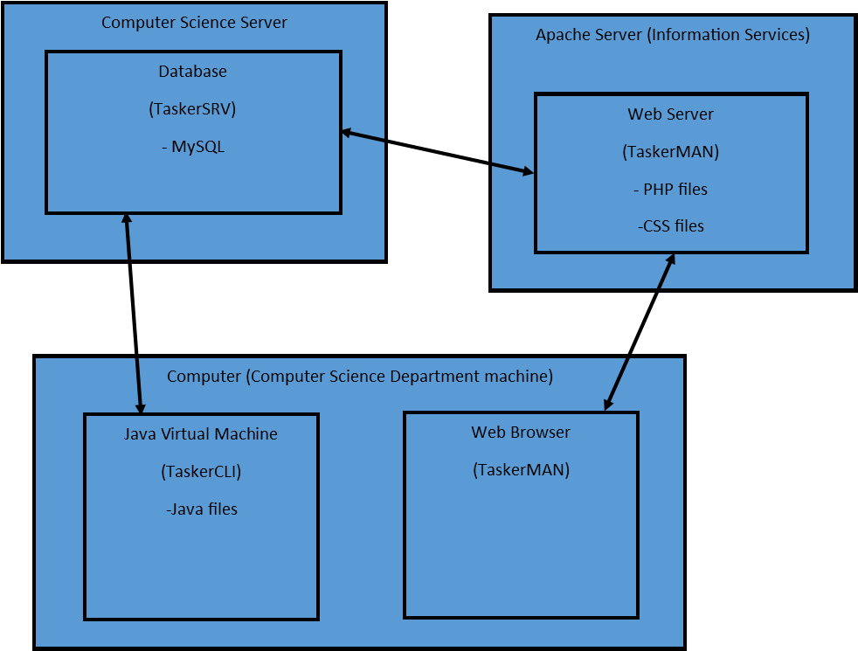

*Diagram showing major components and overall structure.*

# 5 Significant Classes

**Login –** This class takes in a Database object and presents a GUI. The login activity, is used to verify the login and password of the user wanting to use the system, the GUI which is created will prompt the user to enter a username and a password. Once the users presses the login button, the class uses the database object which is passed to check if it is valid login if so, the user is passed to another GUI if it fails the user is notified.

**GUI –** This class takes in a database object and user object. The glass provides the graphic interface for the user to view the task list custom to them using their login. The class uses the TaskTableModel class to gather the data needed to populate the GUI’s table and display it to the user on the refreshTableView call.

**TaskModelView –** This class is used to compile the list of the Task objects this allows for easy manipulation from the GUI class and lets data be updated and modified. The class also stores the column names in an array for the GUI to use when presenting the data.

**TASK -** This is the raw data class for the task, this class stores the data about the tasks and allows them to be viewed or edited. The class stores an ID, Task String, User information, Team allocated, Time allocated and its current status. This data is all accessed from higher classes for manipulation and presentation.

**DATABASE –** This class is used for database interaction for the client. It creates a Database Access Object for the connection to the SQL database. Once this is set up it is then used for updating data throughout the program, such as updating user, task, element and team. This is used a front for connecting between the GUI and the DAO.

## 5.1 Interface Description

*Application*

+main(): void

The primary starting method for the program and what is initially run when the client side application is started up.

*GUI*

+refreshTabeView() : void

Focused on refreshing the table view.

+getUser() : User

Gets the current logged on user

Userlogindialouge

-loginUser(username : String) void

The loginUser method serves to log the user into the client based application.

*User*

+getUsername() : String

Gets username from a variable

+setUsername(username) : String

Sets username to a variable

+getId() : int

Gets id from a variable

+setMail(mail : String) : void

Sets mail address to a variable.

+getMail() : void

Gets mail from a variable.

Database:

+getUserid(id : int) : user

Gets the users unique id from a variable

+selectTask(id : int) : void

Selects a task from the database table

+loginUser(parameter : String) : User

Allows the user to log into the database, giving the permission to access tasks and other info.

+updateUser(user : user): void

Used to update the user’s credentials such as id or email address.

+updateTask(task : task) : void

Updates a task in the database when called.

+updateElement(element : taskElement) : void

Updates a single element of a task inside of the task element database.

+updateTeam(team : team) : void

Updates a team and its link to individual members.

DAO (Links: Userdao, Tasksdao, TaskElementdao, Teamdao)

#close(st: statement, rs: ResultsSet) : void

Closes the link between the database tables and the java client application.

TaskTabelModel

+getRowCount() : int

Gets the total number of rows in the desired database.

+getColumCout(): int

Gets the total number of columns in the desired database table

+getColumName(colum : int) : String

Gets the name of the desired column in the database table.

+getvalueAt(index: int, columnIndex: int) : object

Gets the value of s specific cell in the database table.

+getColumnClass(columIndex: int) : Class

Get the class of the column?

Task(Extends: TaskTableModel)

+getId() : int

Gets the id of the task.

+getName() : String

Gets the name of the task.

+setName() : void

Sets the name of the task.

+getTeam(): Team

Gets the team allocated to the task.

+setTeam:

Allocates a team to a task

+getMember() : member

Gets members associated to the team

+setMember(member : Member) : void

Sets members to the task.

+getDate() : Date

Gets the date

+getStatus(): Task_Status

Gets the current status of the task.

+setStatus(status: Task_Status): void

Sets the new status of the task

Team(Extends: TaskTabelModel)

+getid() : int

Gets the id of the team

+getName() : String

Gets the current name of the task.

+setName(Name: String): void

Sets the new name of a task.

+getAllUsers() : list<User>

Lists the names of all users currently associated with the group.

TaskElement(Extends: TaskTabelModel)

+getId() : int

Gets the id of the task element

+getTask(): Task

Gets the task associated to the element

+getName(): String

Gets the name of the task element

+setName(name : String): void

Sets the name of the task element

+getDescription() : String

Gets the current description of the task element.

+setDescription(description: String): void

Sets a new description for the task element.

+getComment() : String

Gets the current comment for the task element.

+setComment(comment : String) : void

Sets a new comment for the current task element.

# 6 Detailed Design

## 6.1 Sequence Diagrams

**TaskerMAN**

*View tasks:*

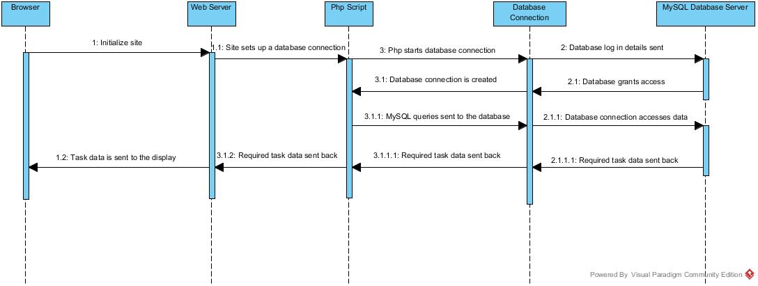

*View my team:*

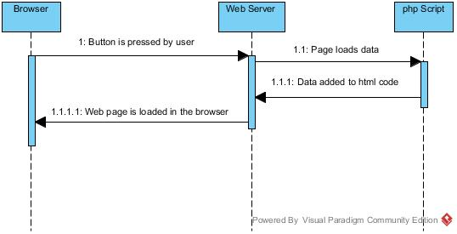

*Add new team member:*

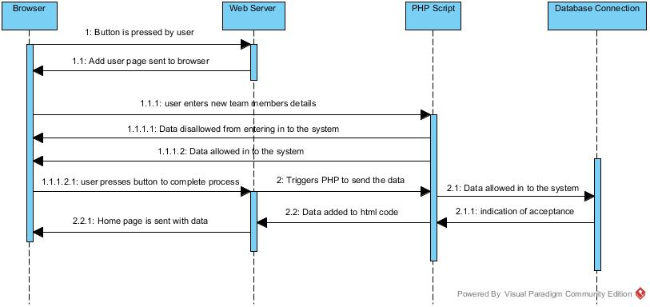

*Update existing team member:*

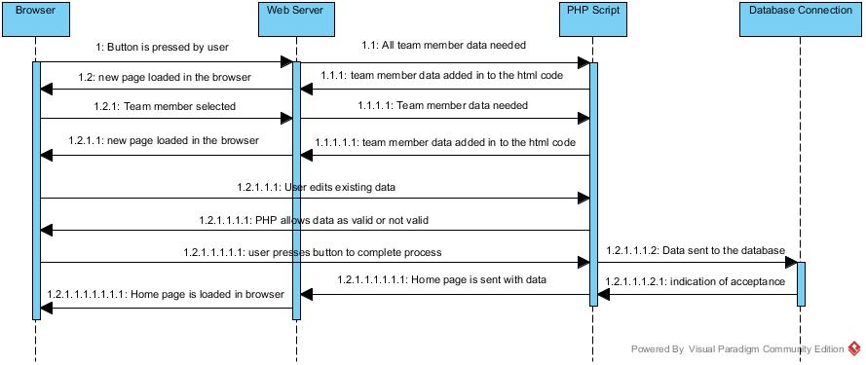

*Delete team member:*

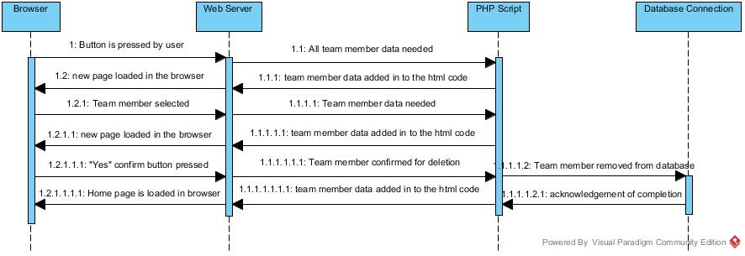

*Add tasks:*

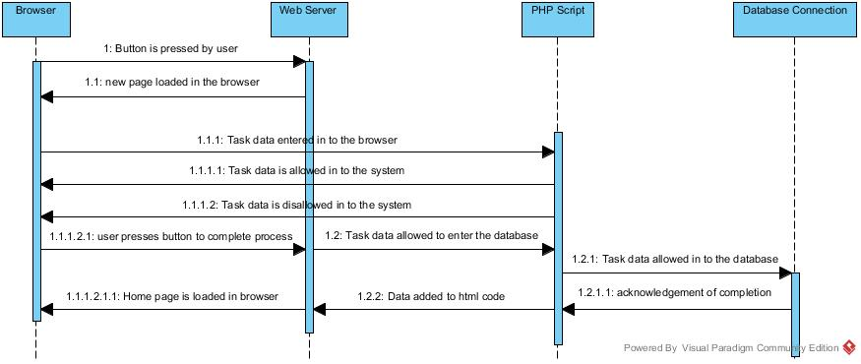

*Reallocating tasks:*

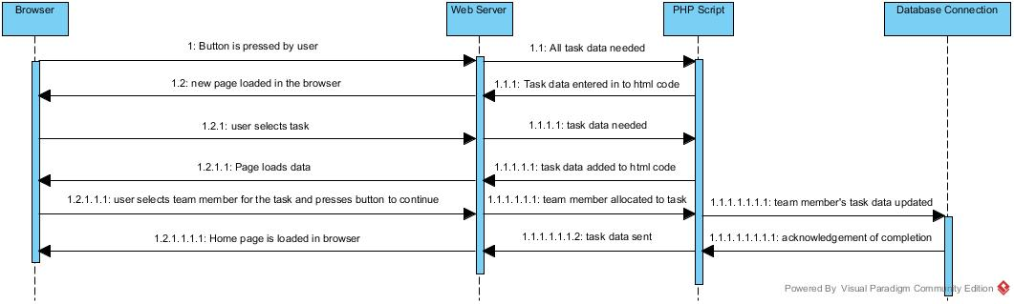

*Abandon tasks:*

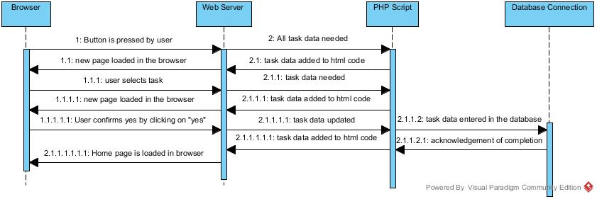

*View tasks in detail:*

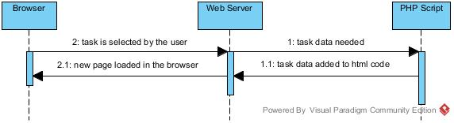

**TaskerCLI**

*User identification (log in) and Local storage of tasks:*

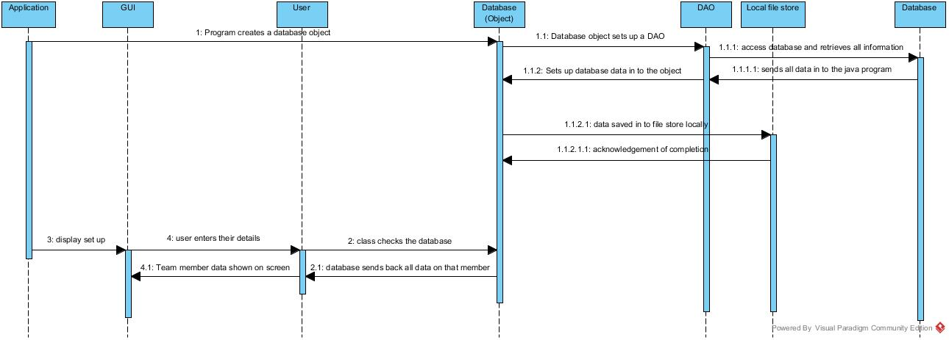

*Local editing of tasks and task synchronisation:*

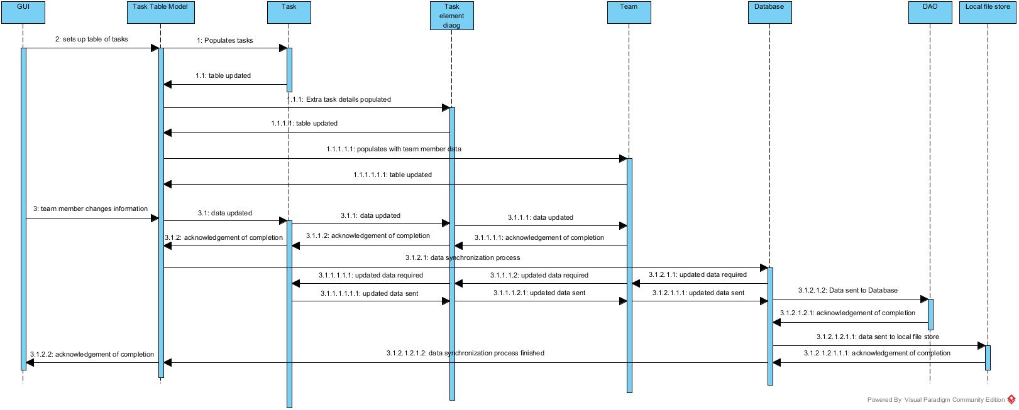

## 6.2 State Diagrams

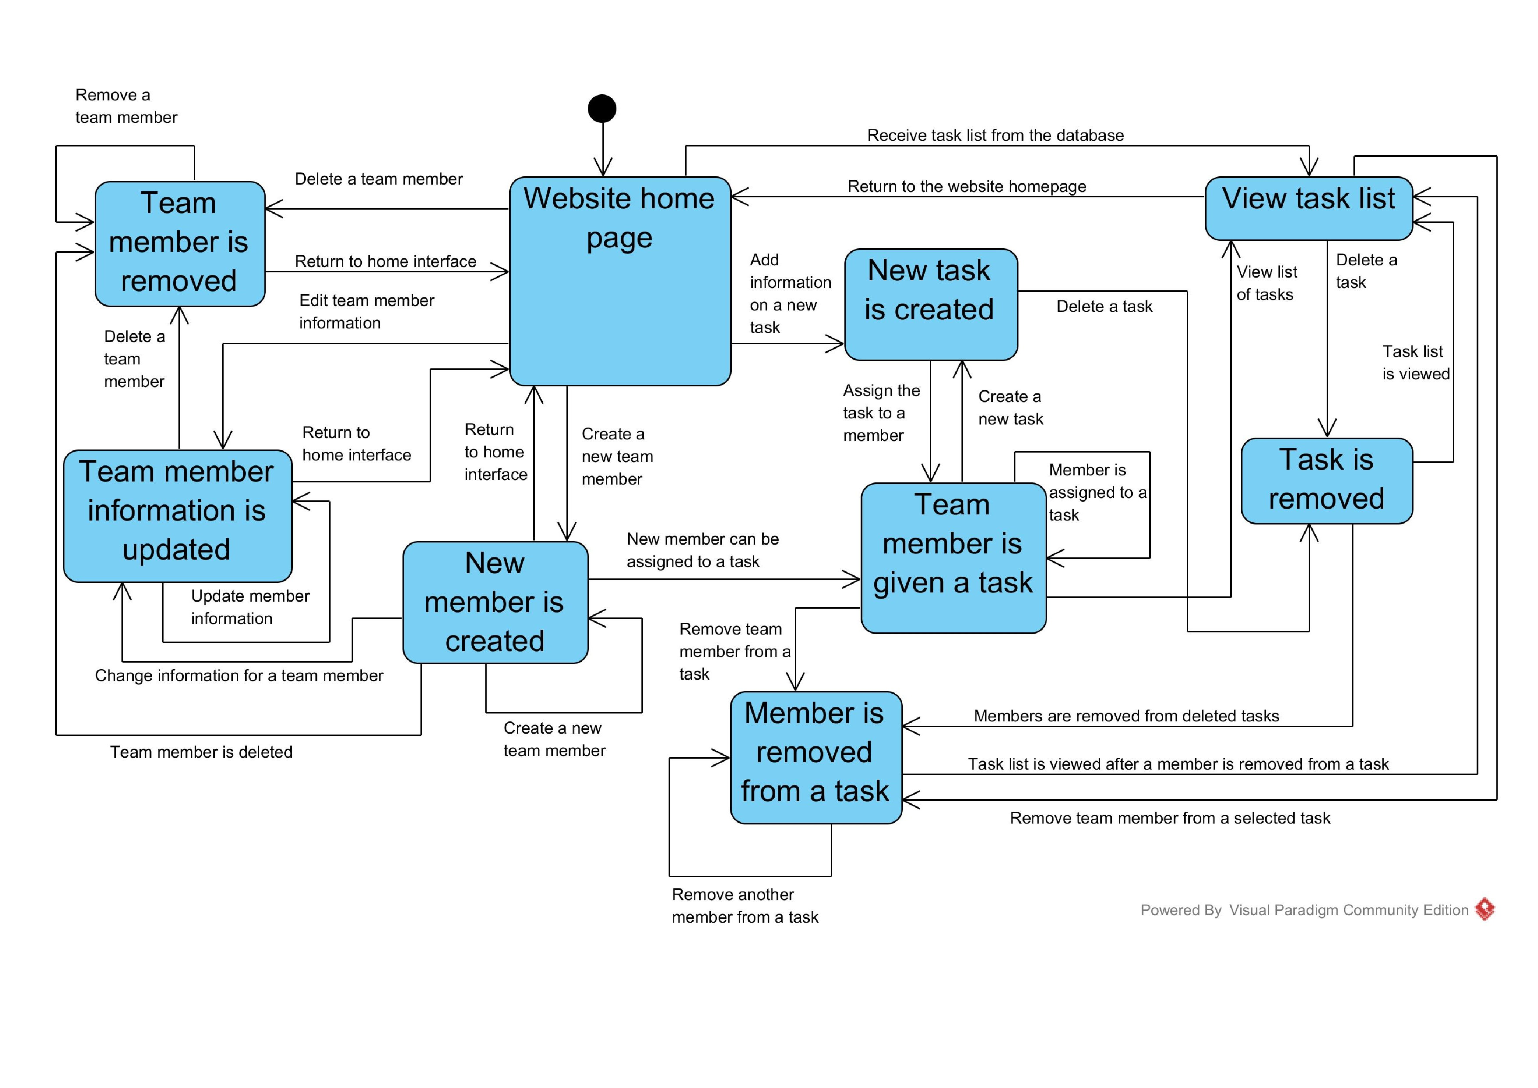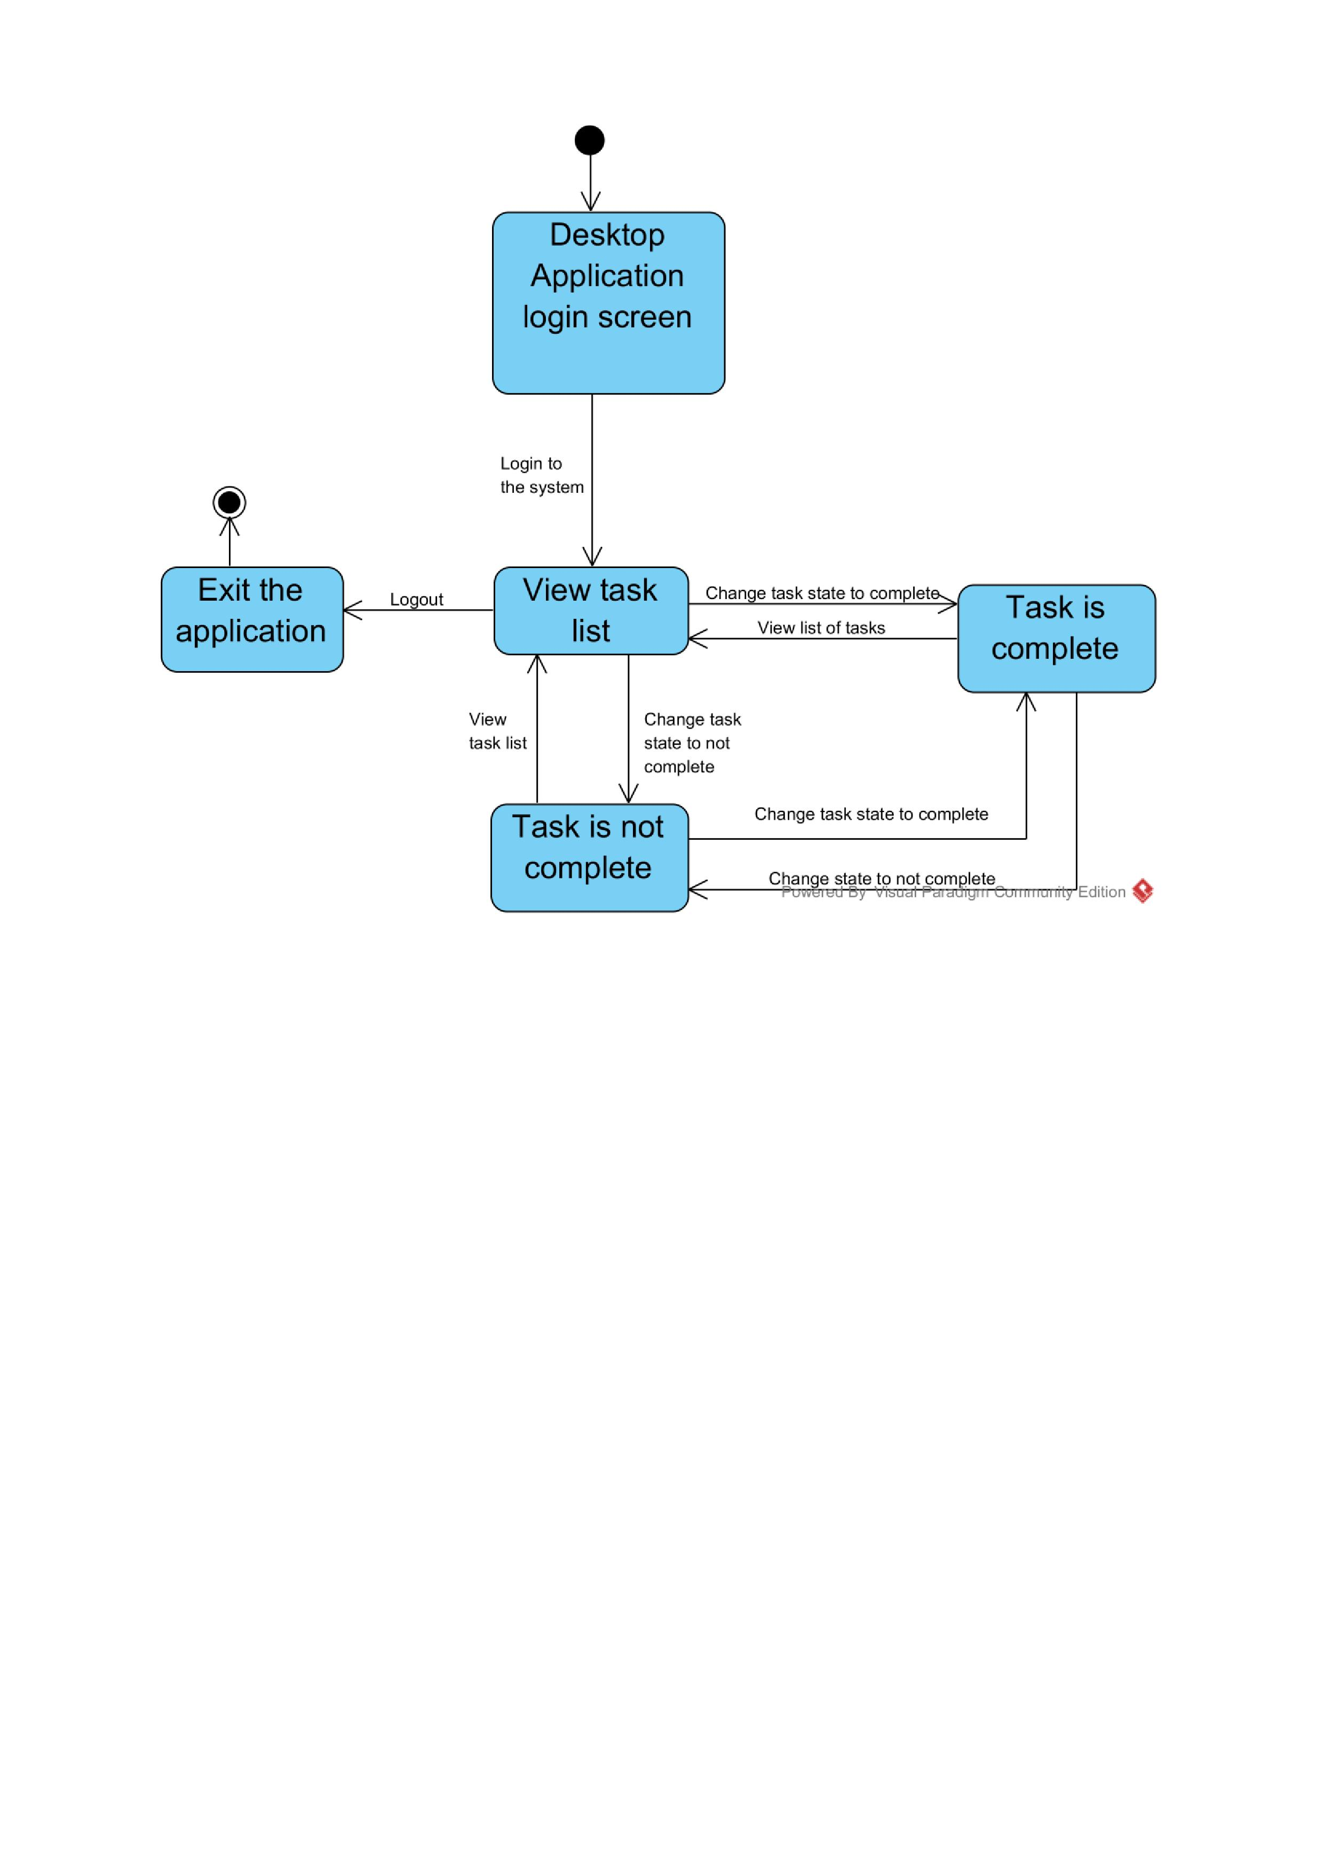

## 6.3 Activity Diagrams

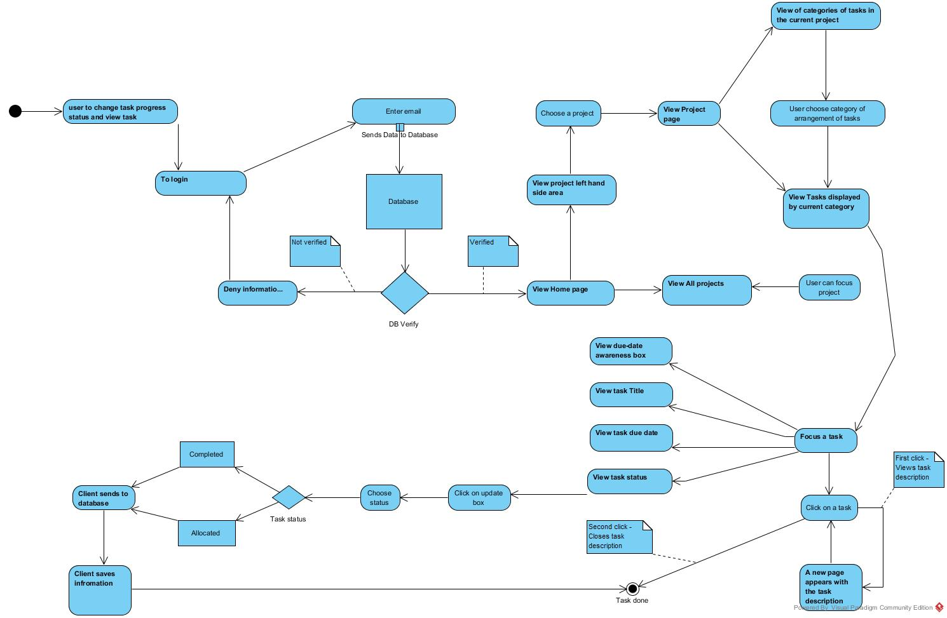

## 6.4 Risk Reduction and Spike Work

This section will detail all the decisions that the team has made about the final design. This will include a brief report of spike work that people have performed that will have reduced the risk to the project.

### Database Research:

The team looked in to what database platforms were available and how to utilise them. We had a look at Oracle database systems and MySQL database systems. The team decided upon MySQL as the target machines of the computer science department, supports MySQL databases rather than Oracle databases.

The group decided that this would be the central point of the system that each of the other components will be linked to. The database will hold the information central to the system and distribute the data across the 2 user platforms.

### Java Research:

The team looked in to the challenges that the java interface had with in it. We discovered that we needed some form of mechanism to control timing. The team looked in to threading the Java interface. The outcome of this research is that it is possible to do this easily, and only need standard Java libraries which is good as the target machine will already have the libraries installed.

The team also looked in to how the Java interface can gain access to the database. We knew that the database would be in MySQL format so this made finding the interaction capabilities a lot easier to find. The team discovered that the interface could talk to the database through Database Access Objects (DAO’s). There would be one DAO for every table in the database. The Java interface would use the DAO’s to assemble a copy of the database with in the interface. The DAO’s would also provide a method of updating the database when the data is created, updated or deleted.

### Website Research:

The challenges with the website would be linking it to the database. The research for the website was decided that due to the CS25010 – Web Development module covering this that the required knowledge would be gained from there. The module has explained how to get the data from the database and appropriately handle the data within the website. The website would talk to the database through PHP.

### Final Decisions on the Design:

The user when logging in will either present their email or username at log in. This will be incorporated in to the implementation of the design.

The TaskerMAN component of the system will also have a log in section. This is not a functional requirement but makes sense to include.

The system will only be for ONE team. The group has decided that the systems implementation will only be able to support the operation of one team with many people and tasks with in it.

## 6.5 Significant Data Structures

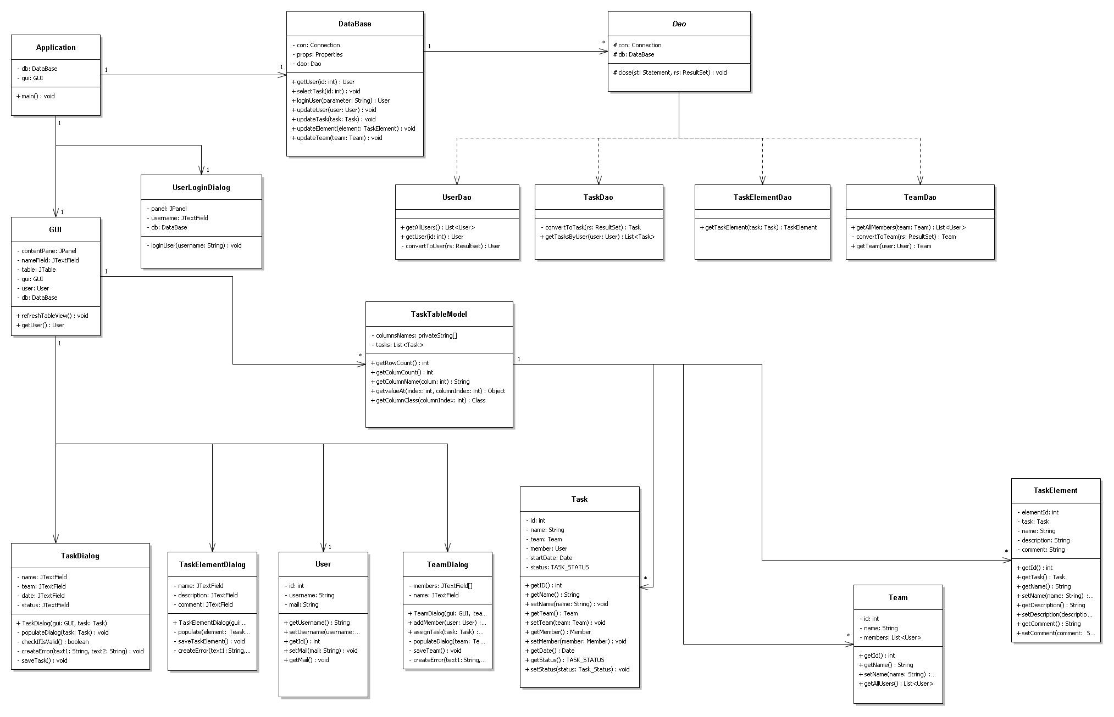

# 7 Appendix

## 7.1 Appendix A

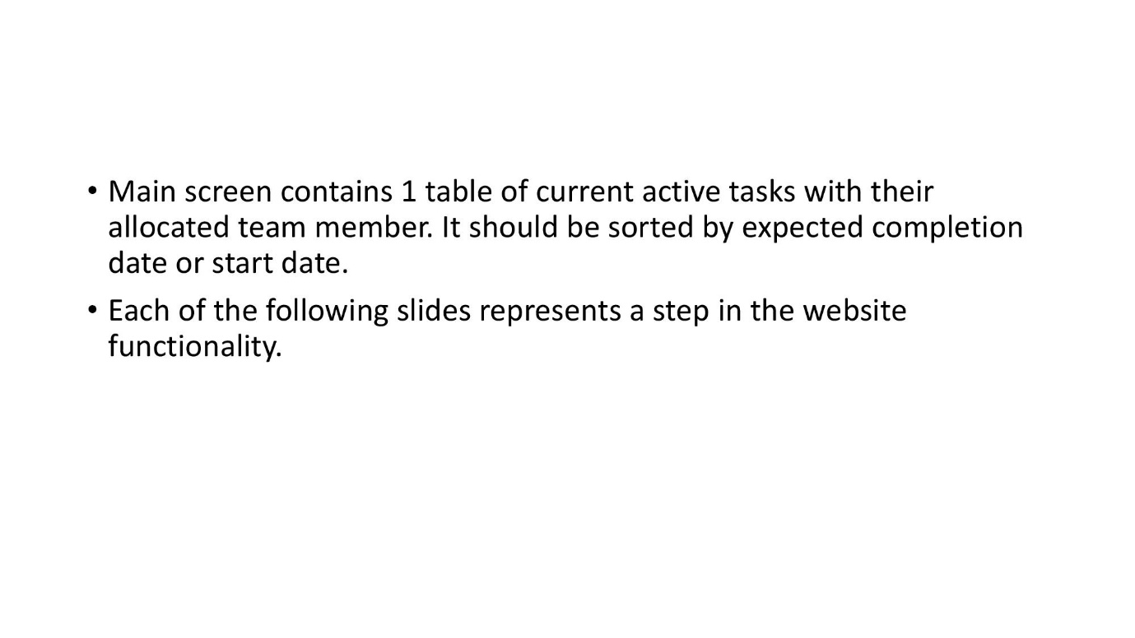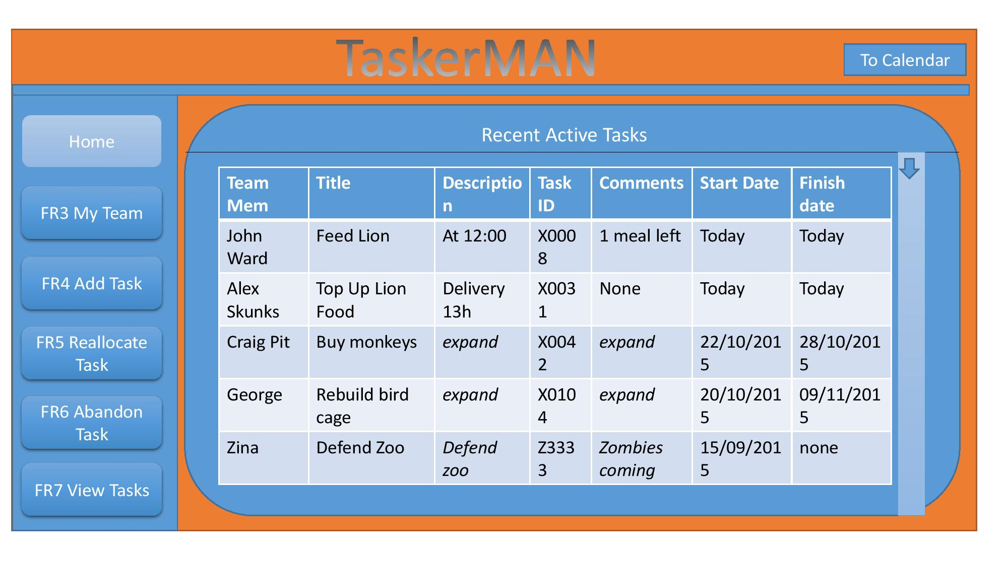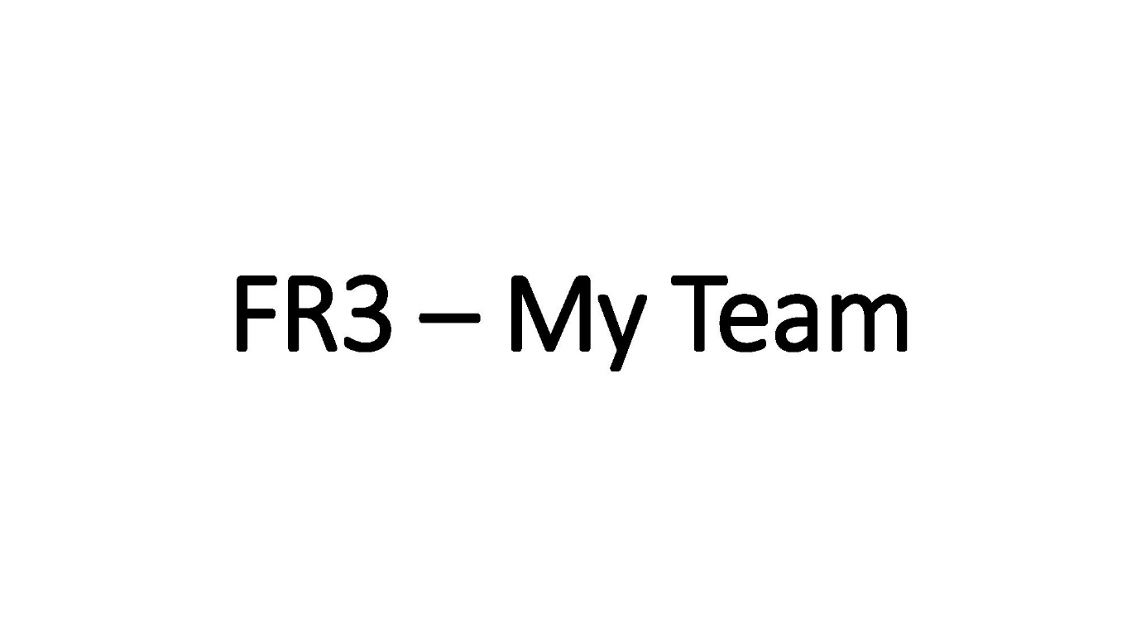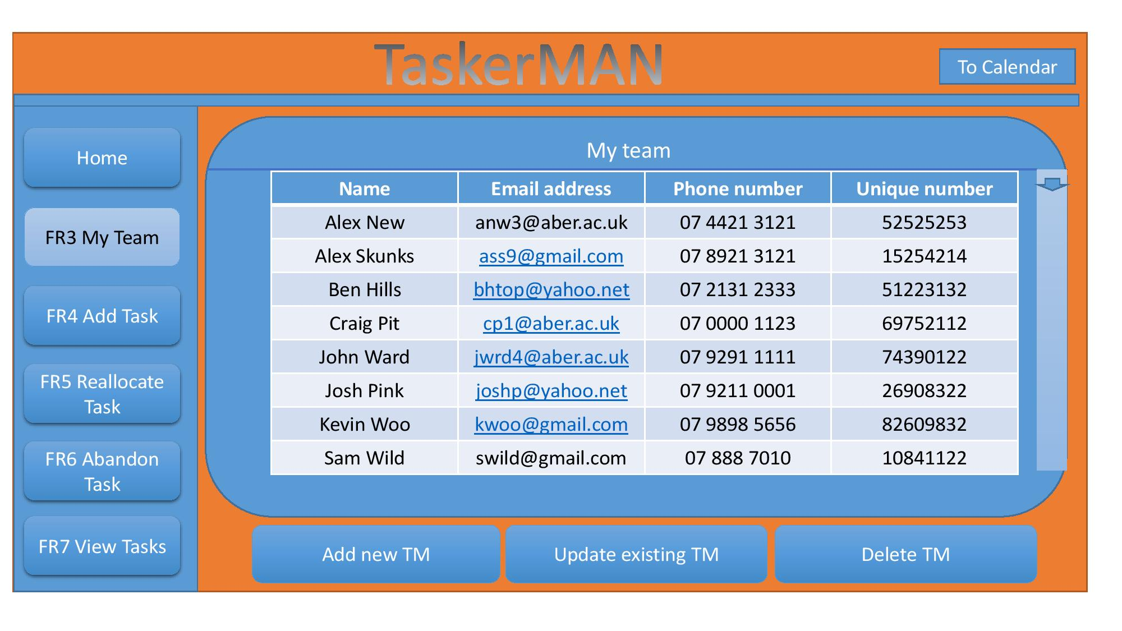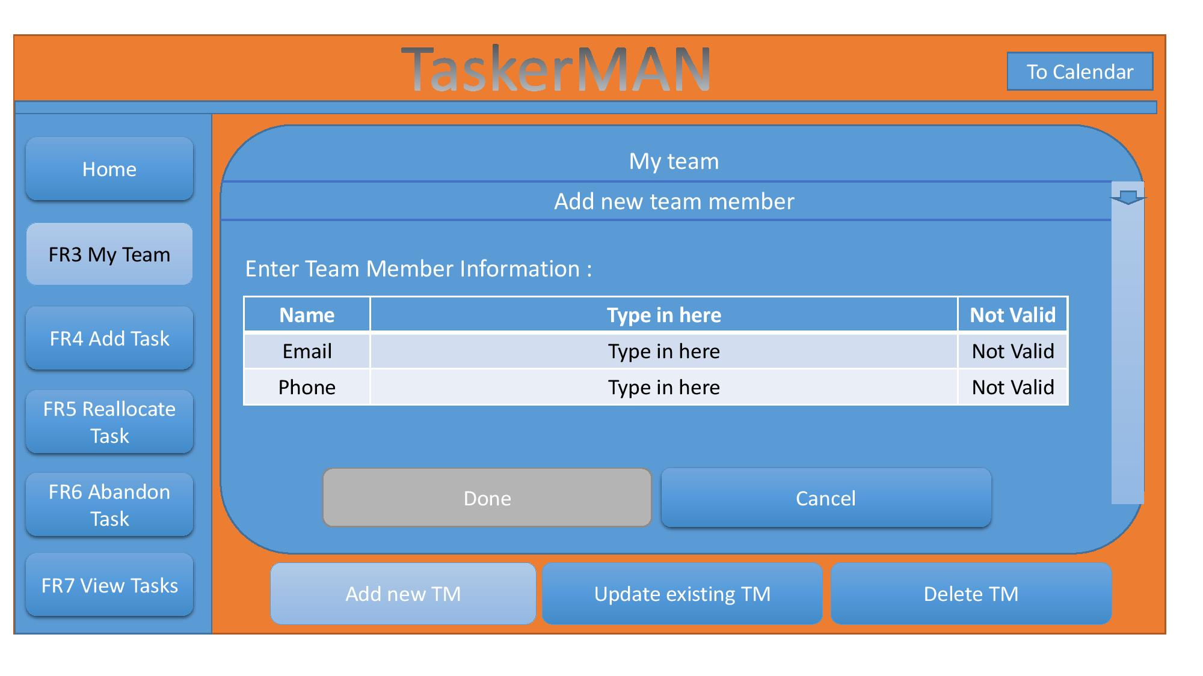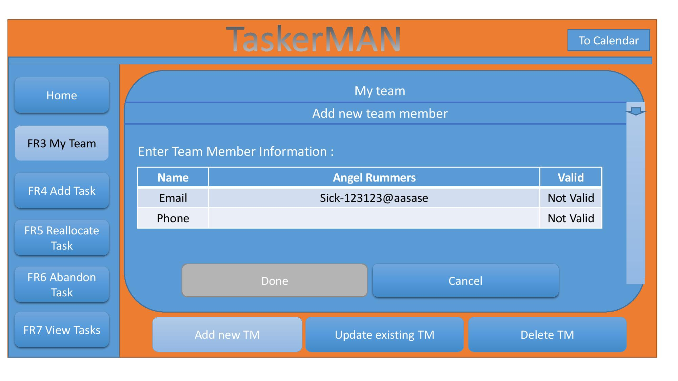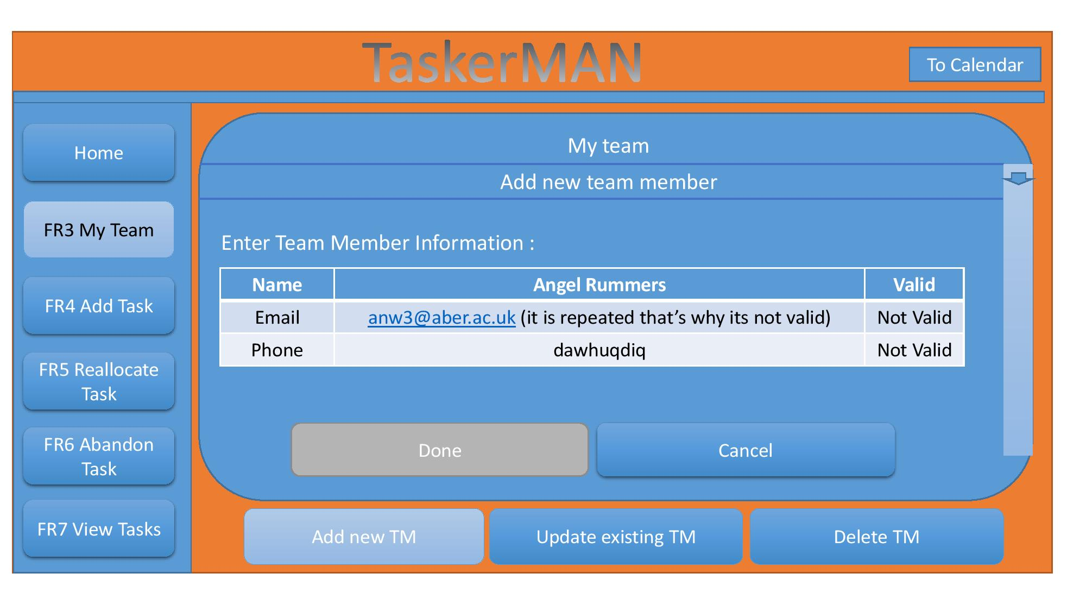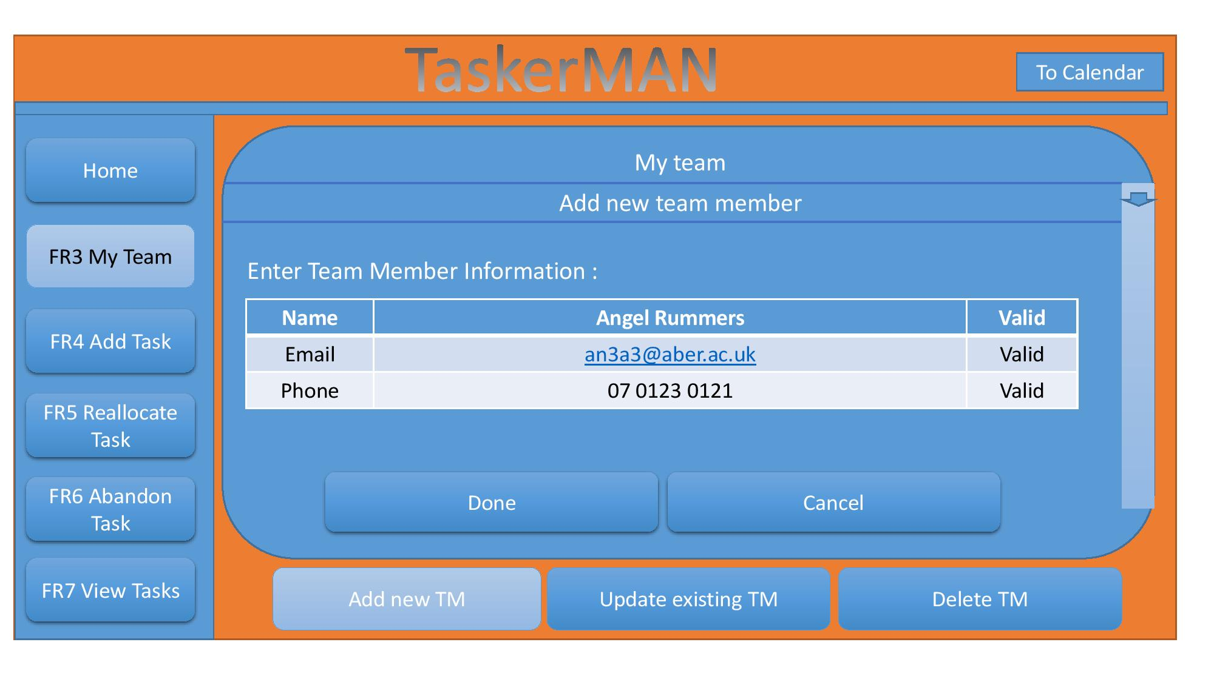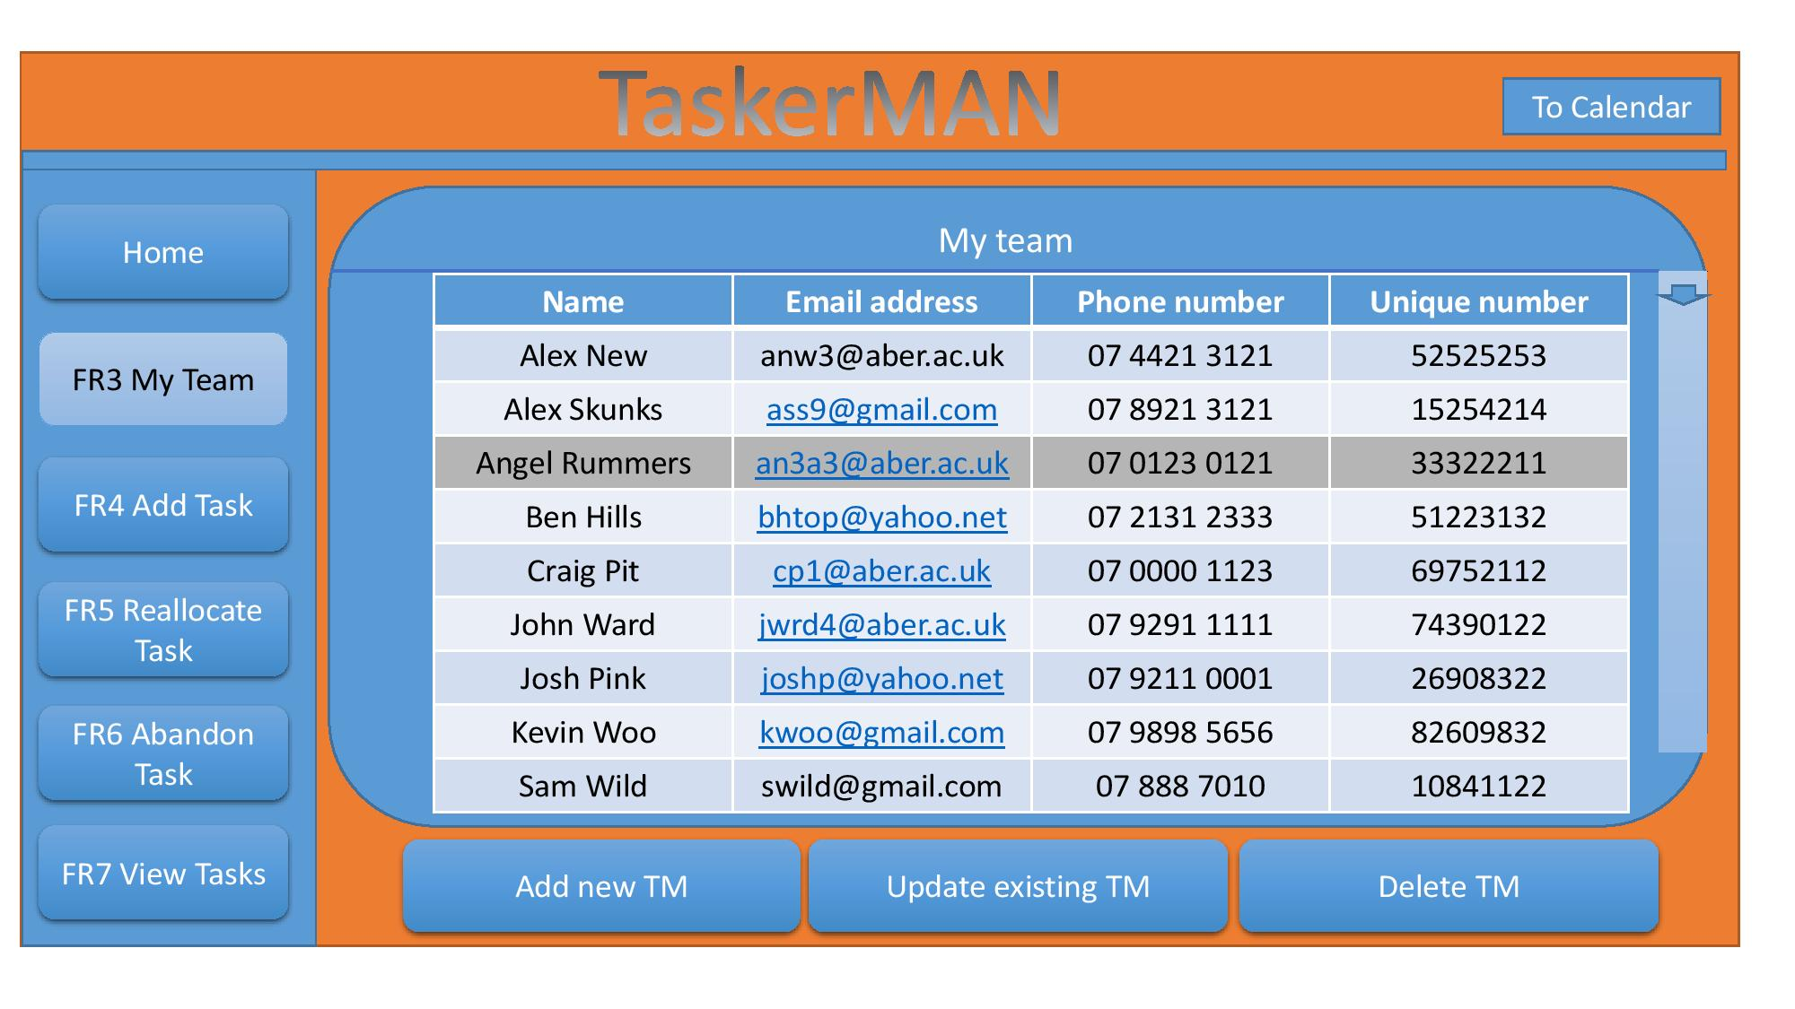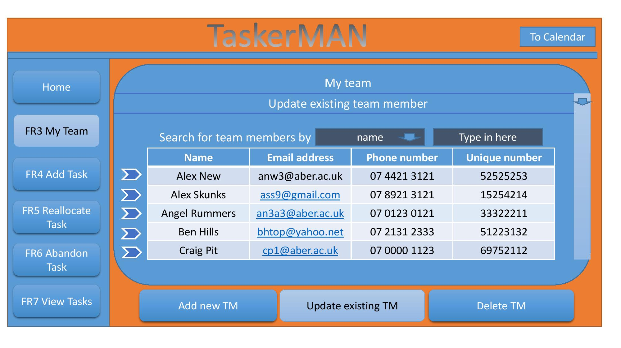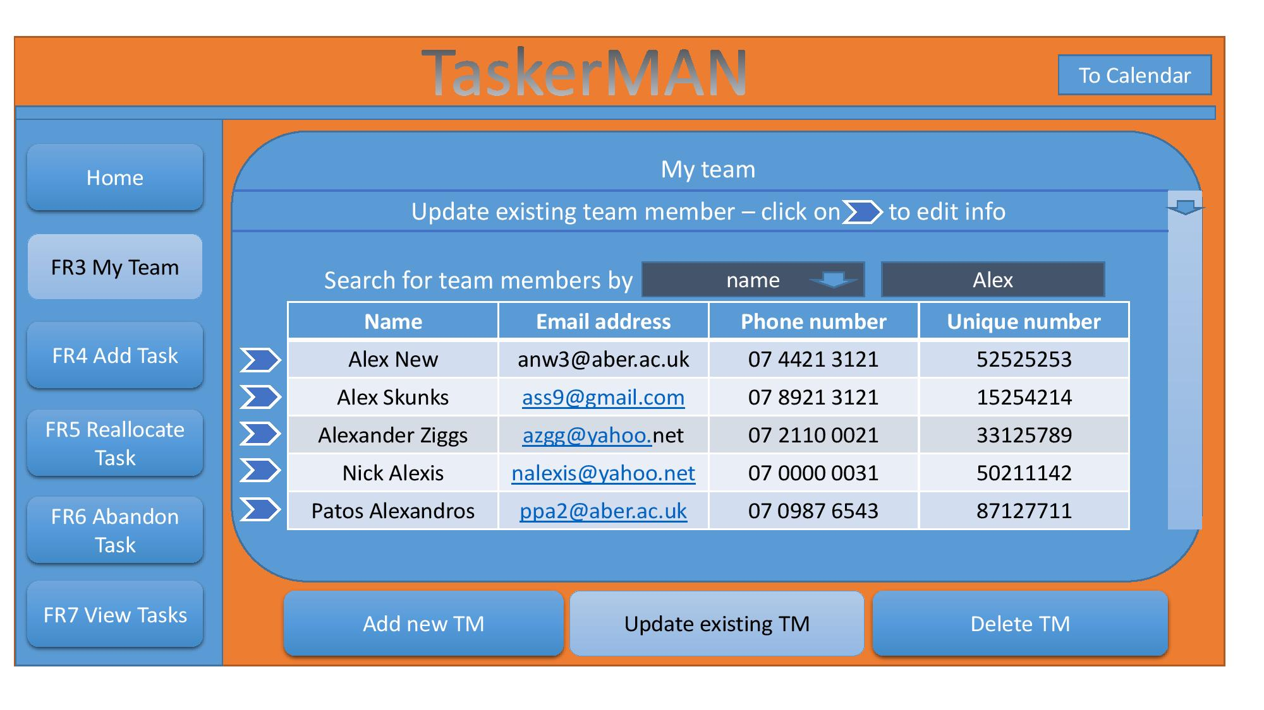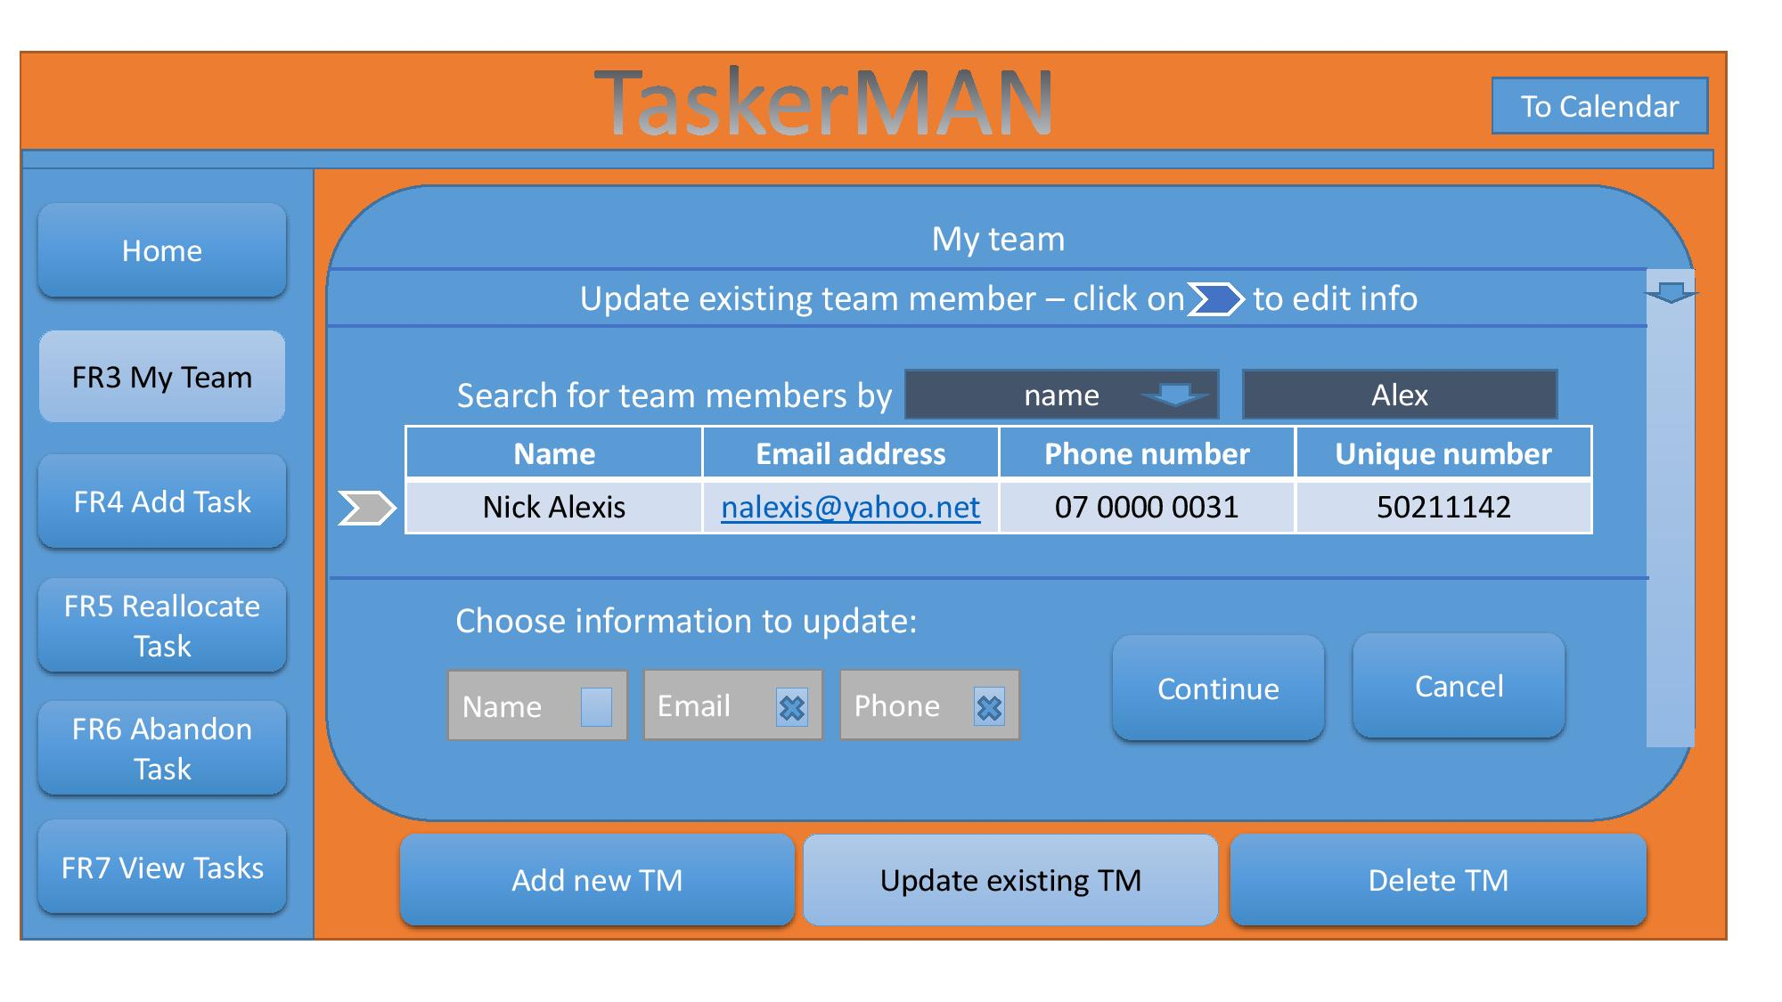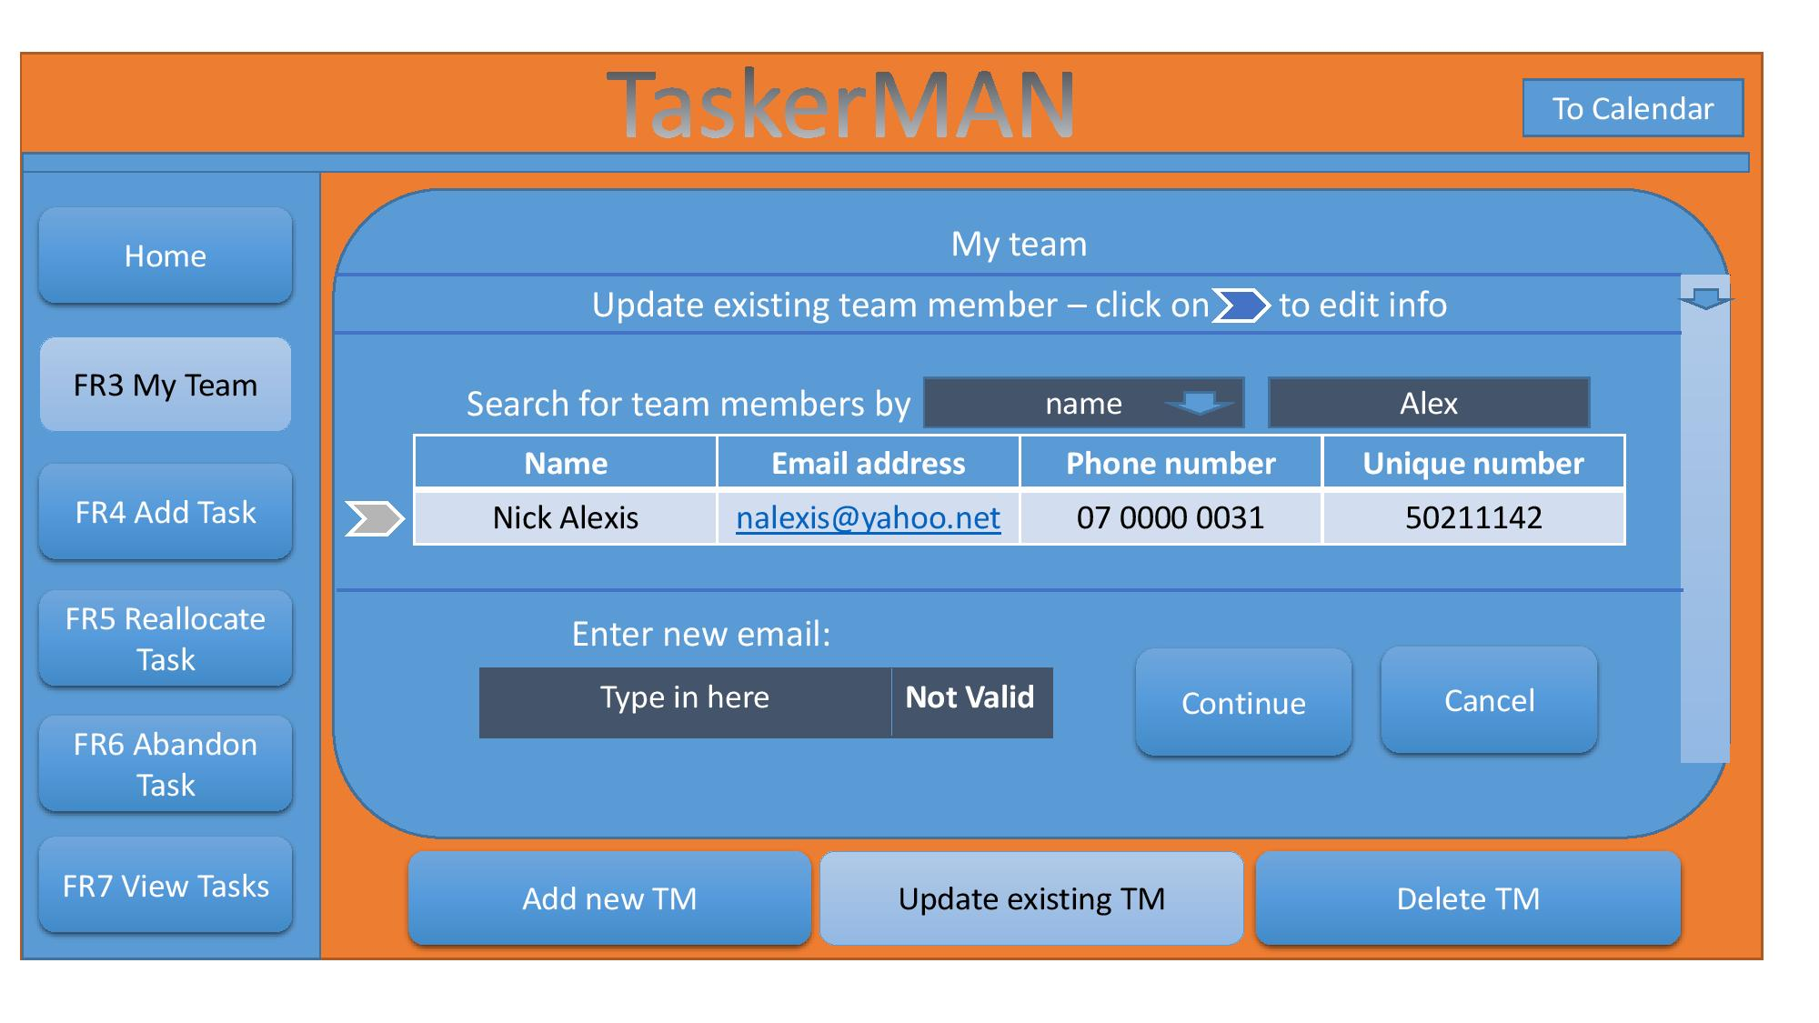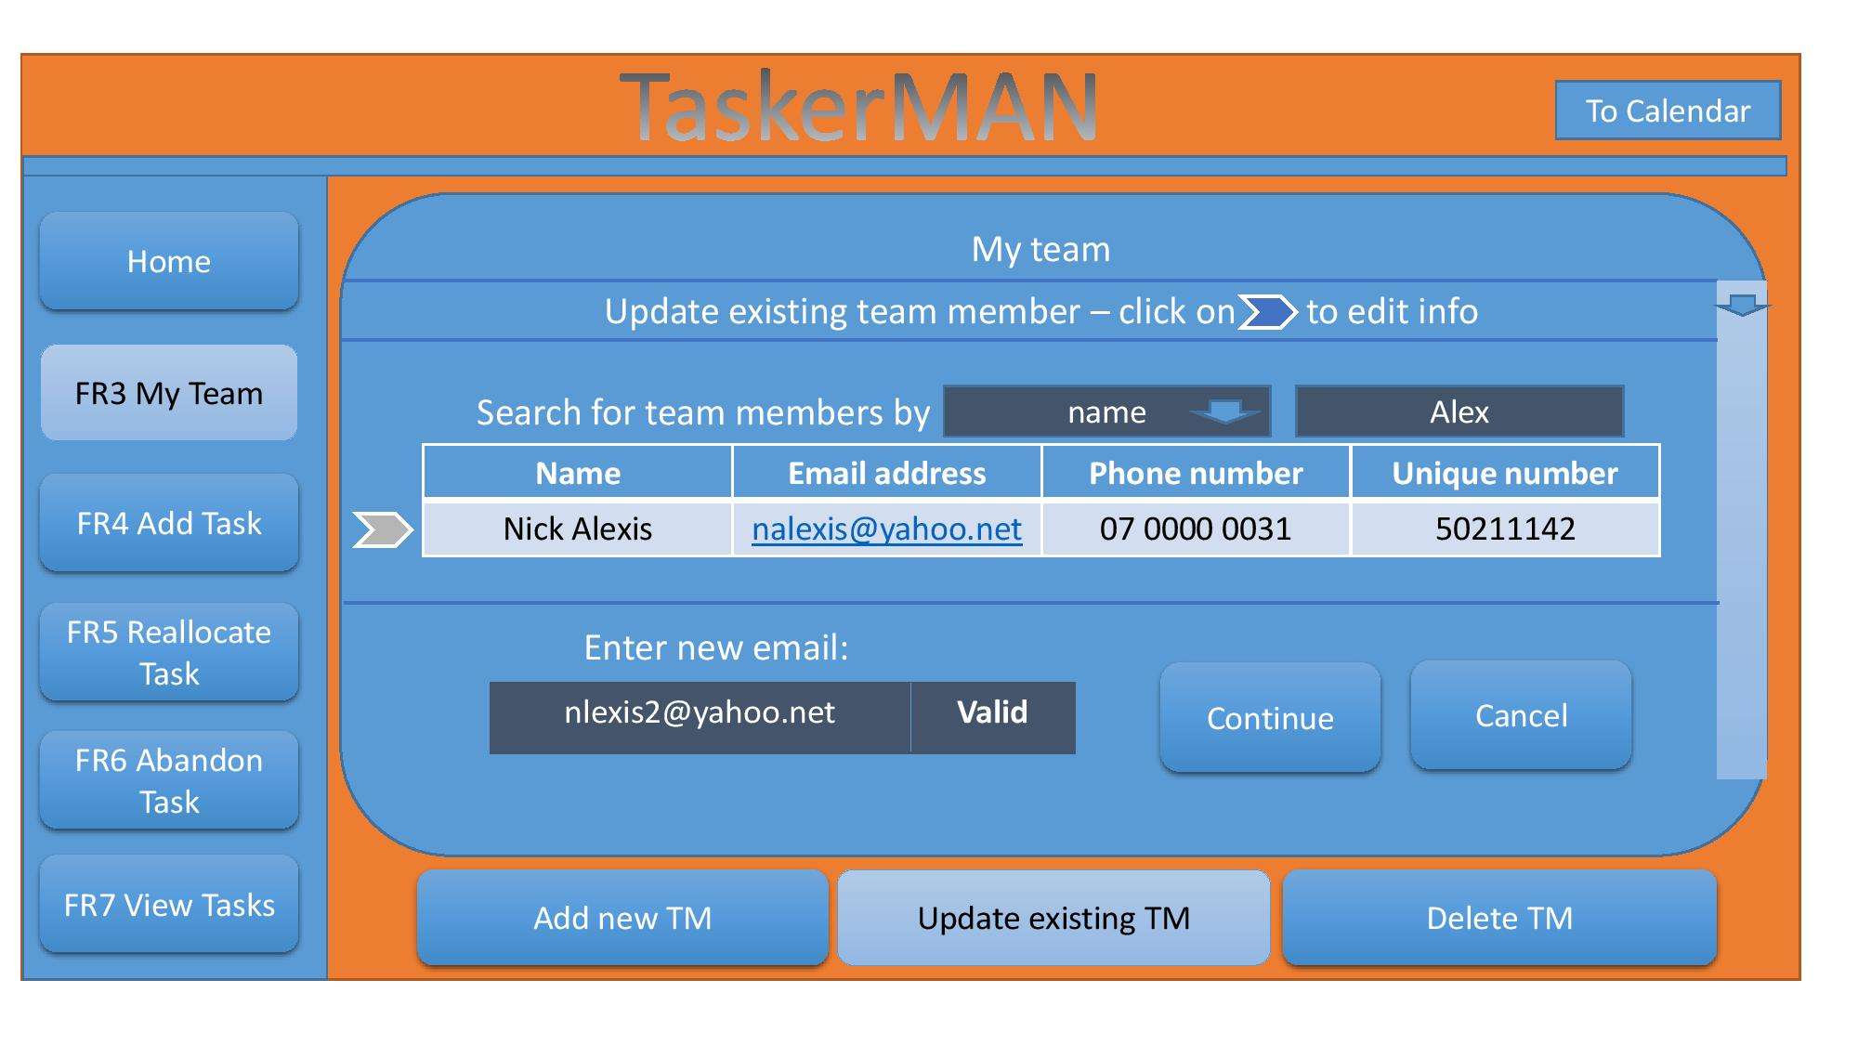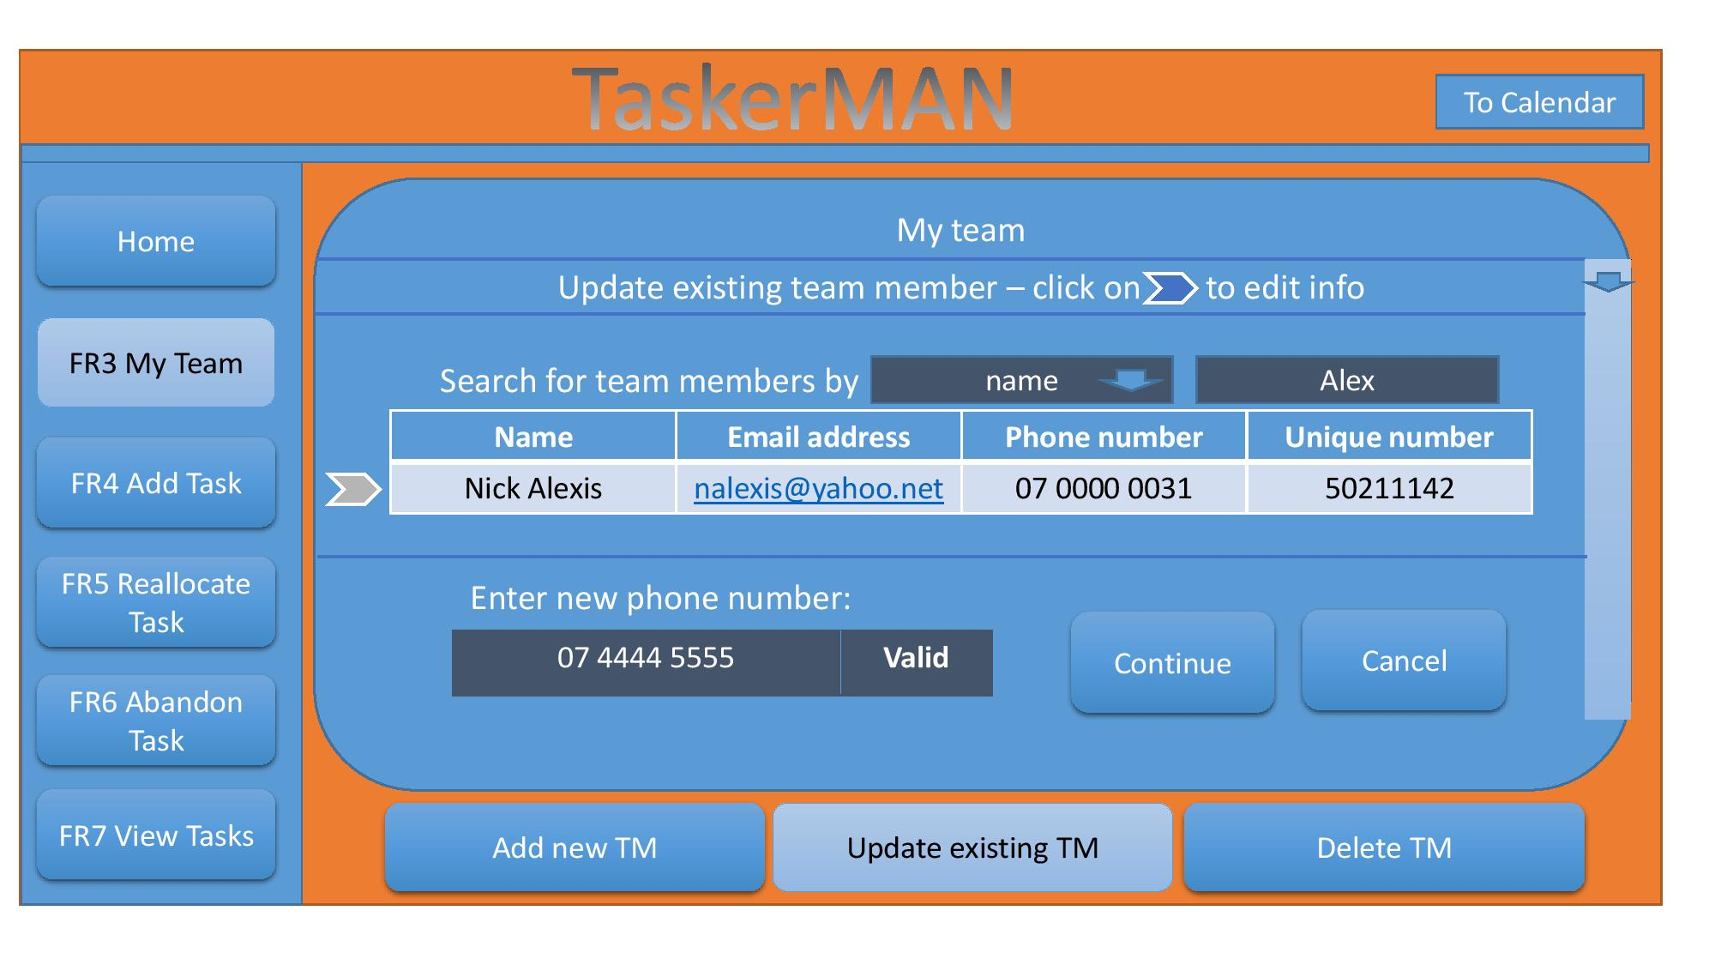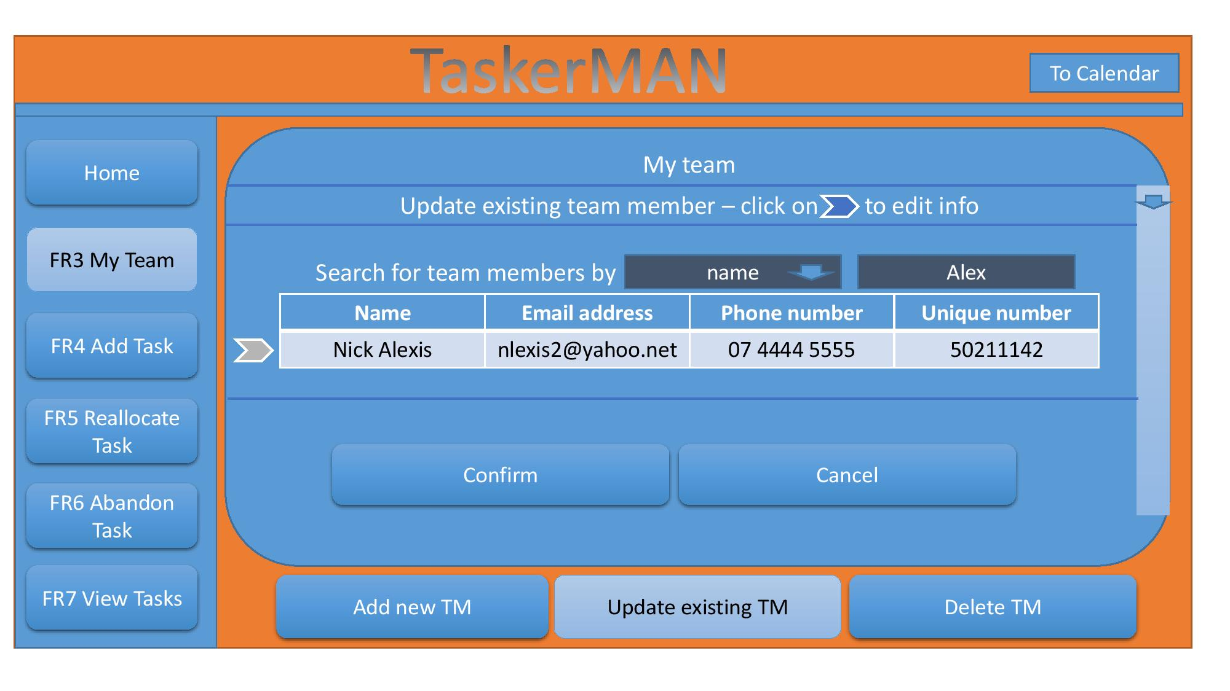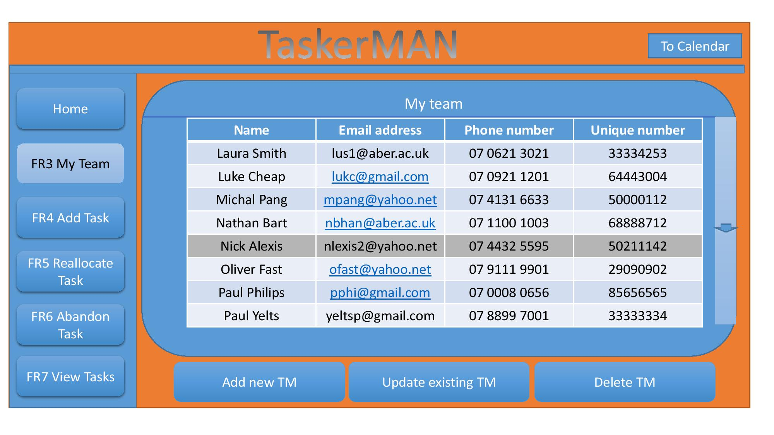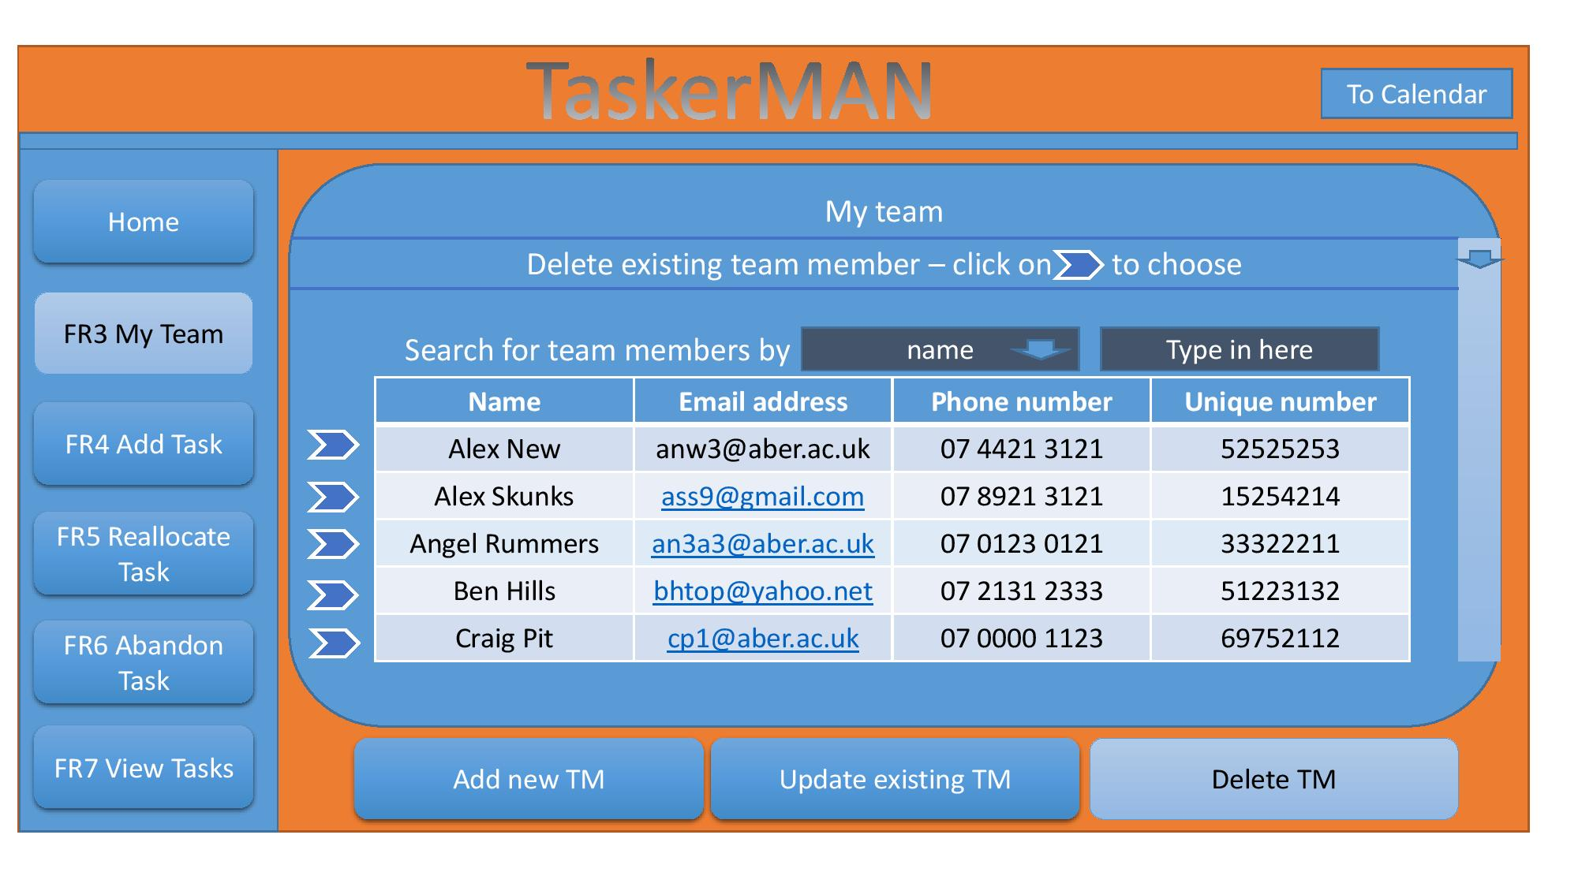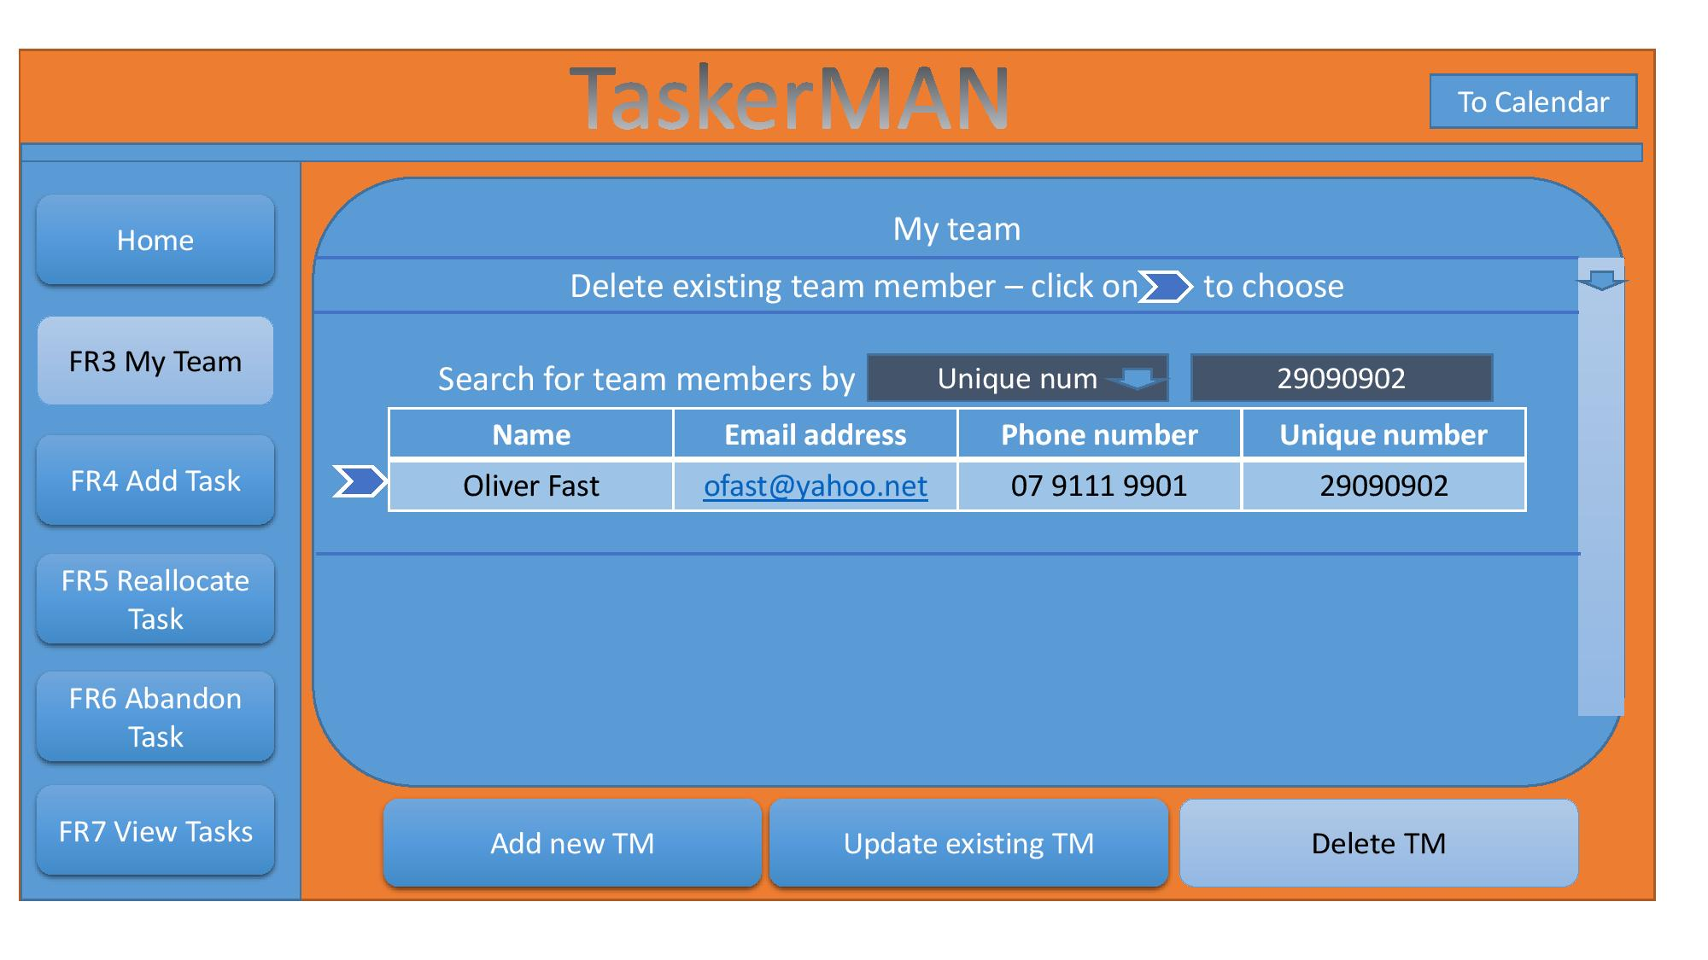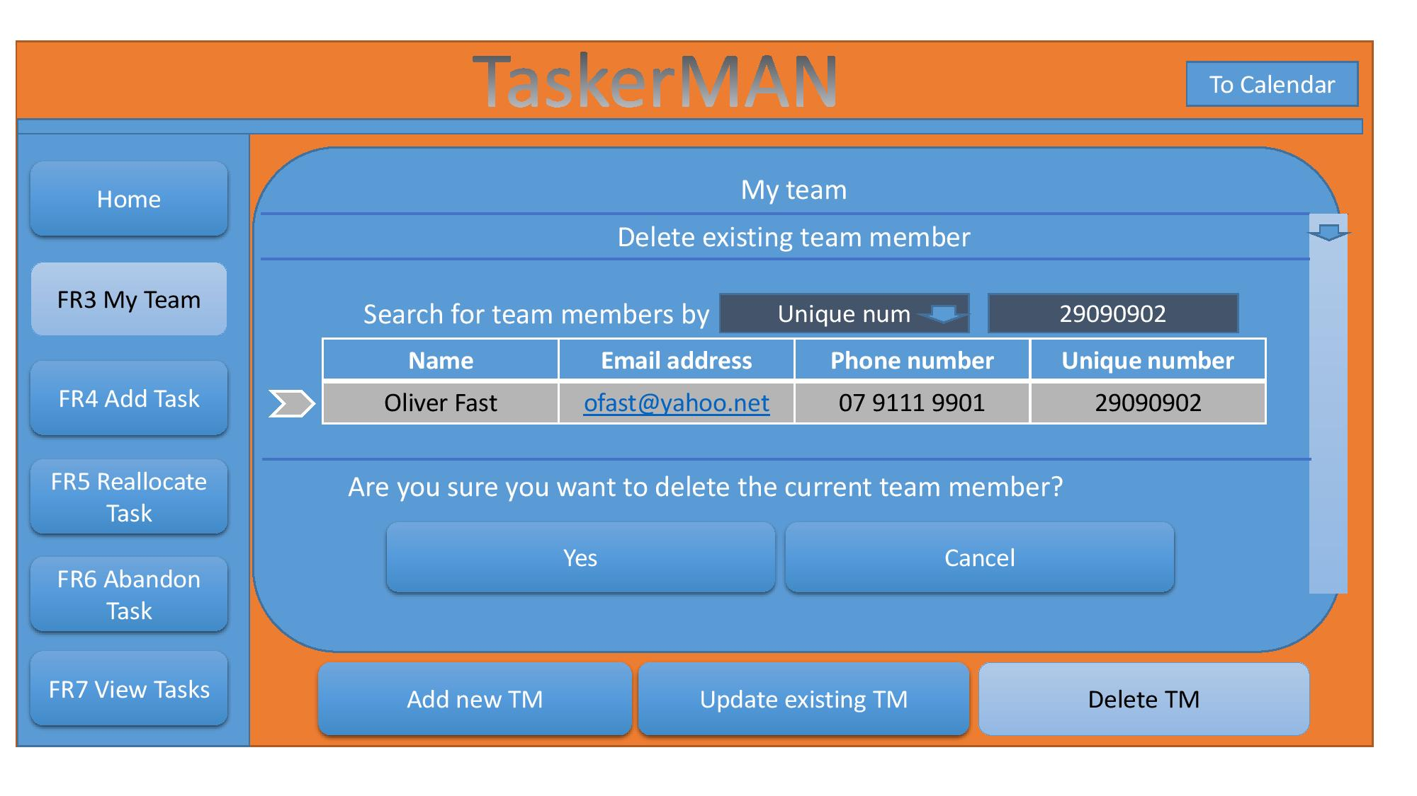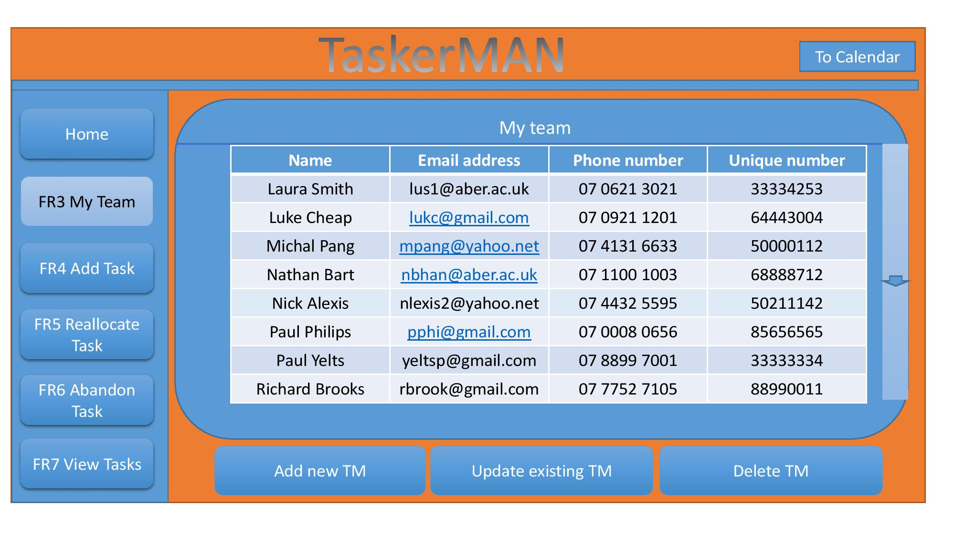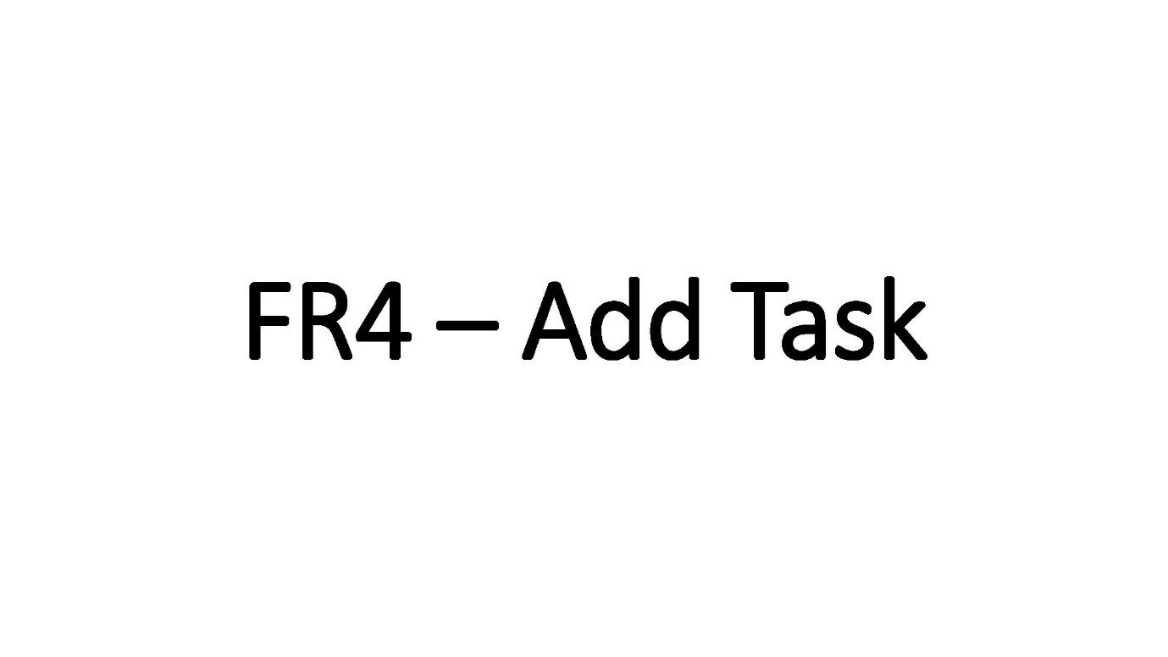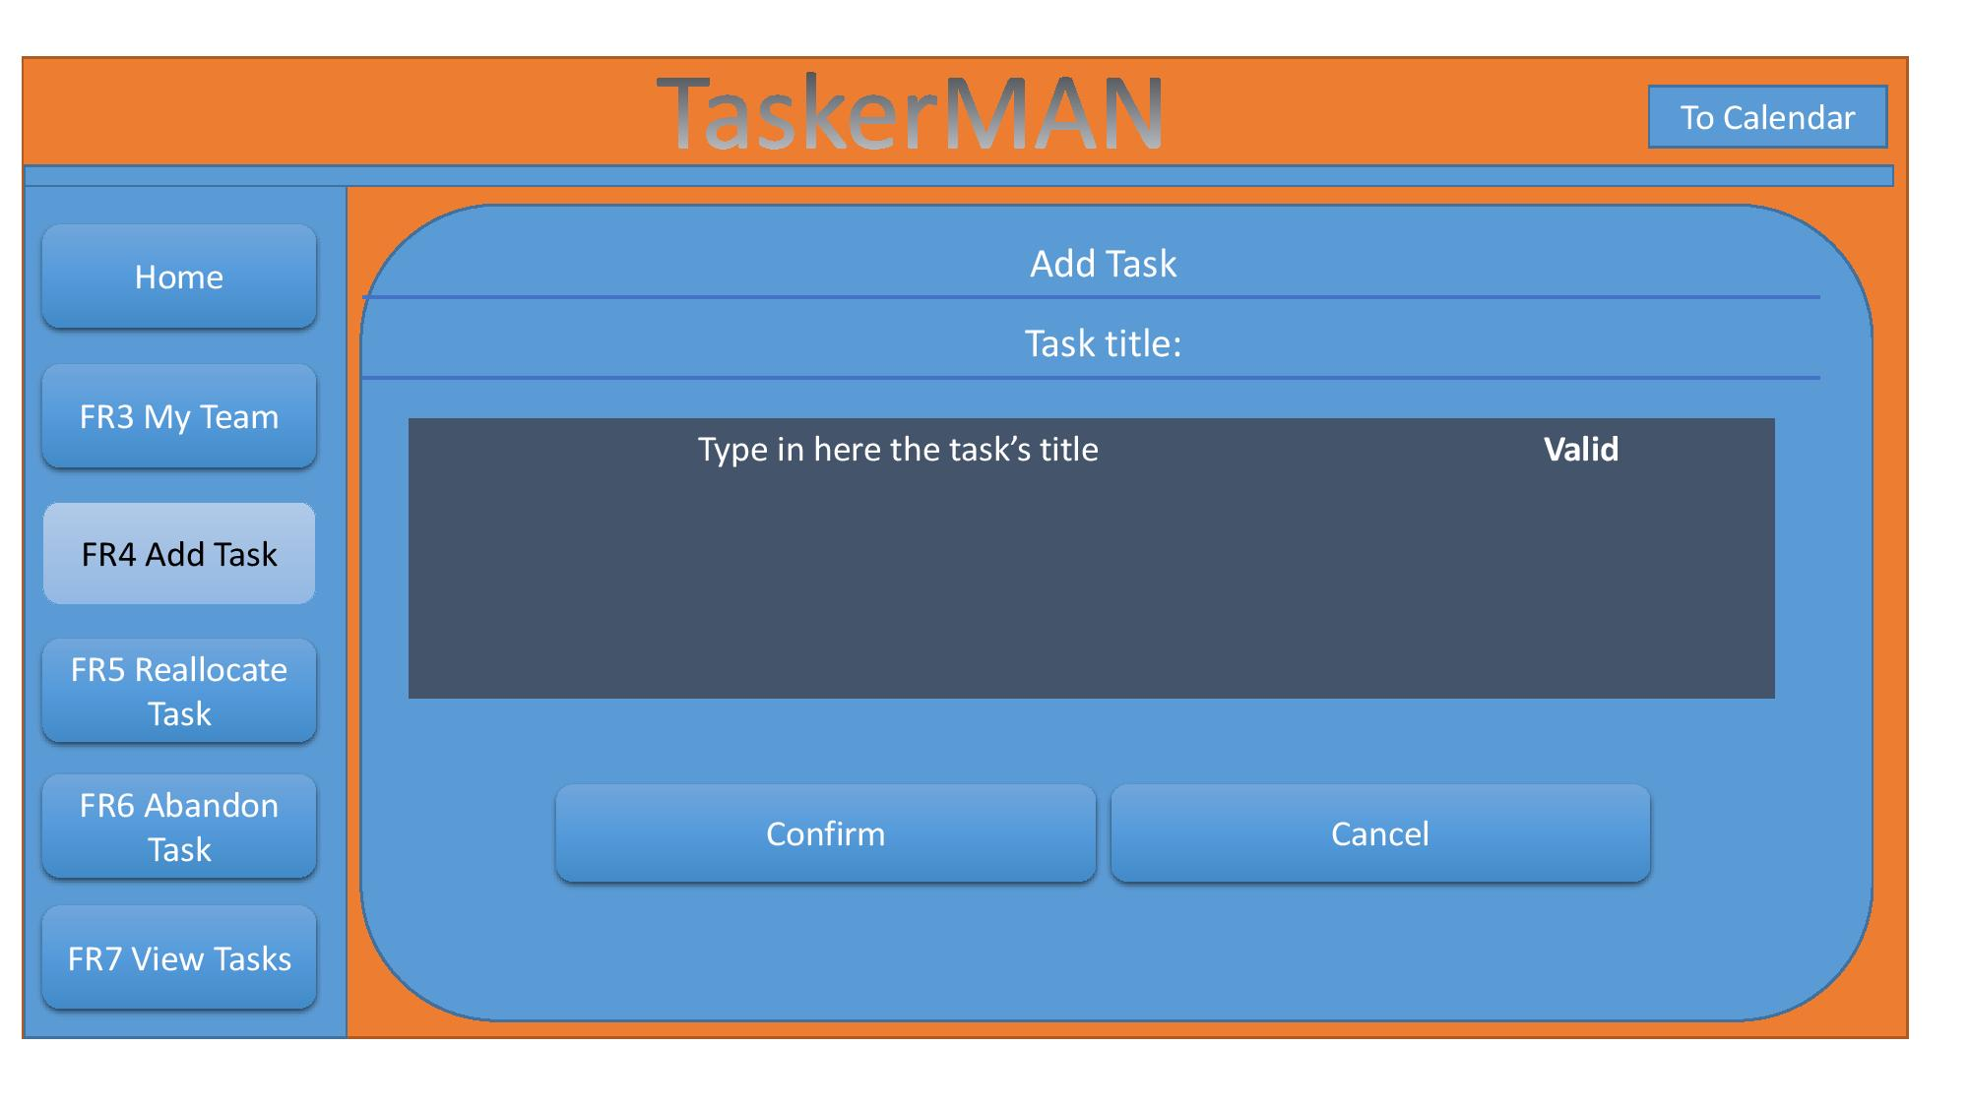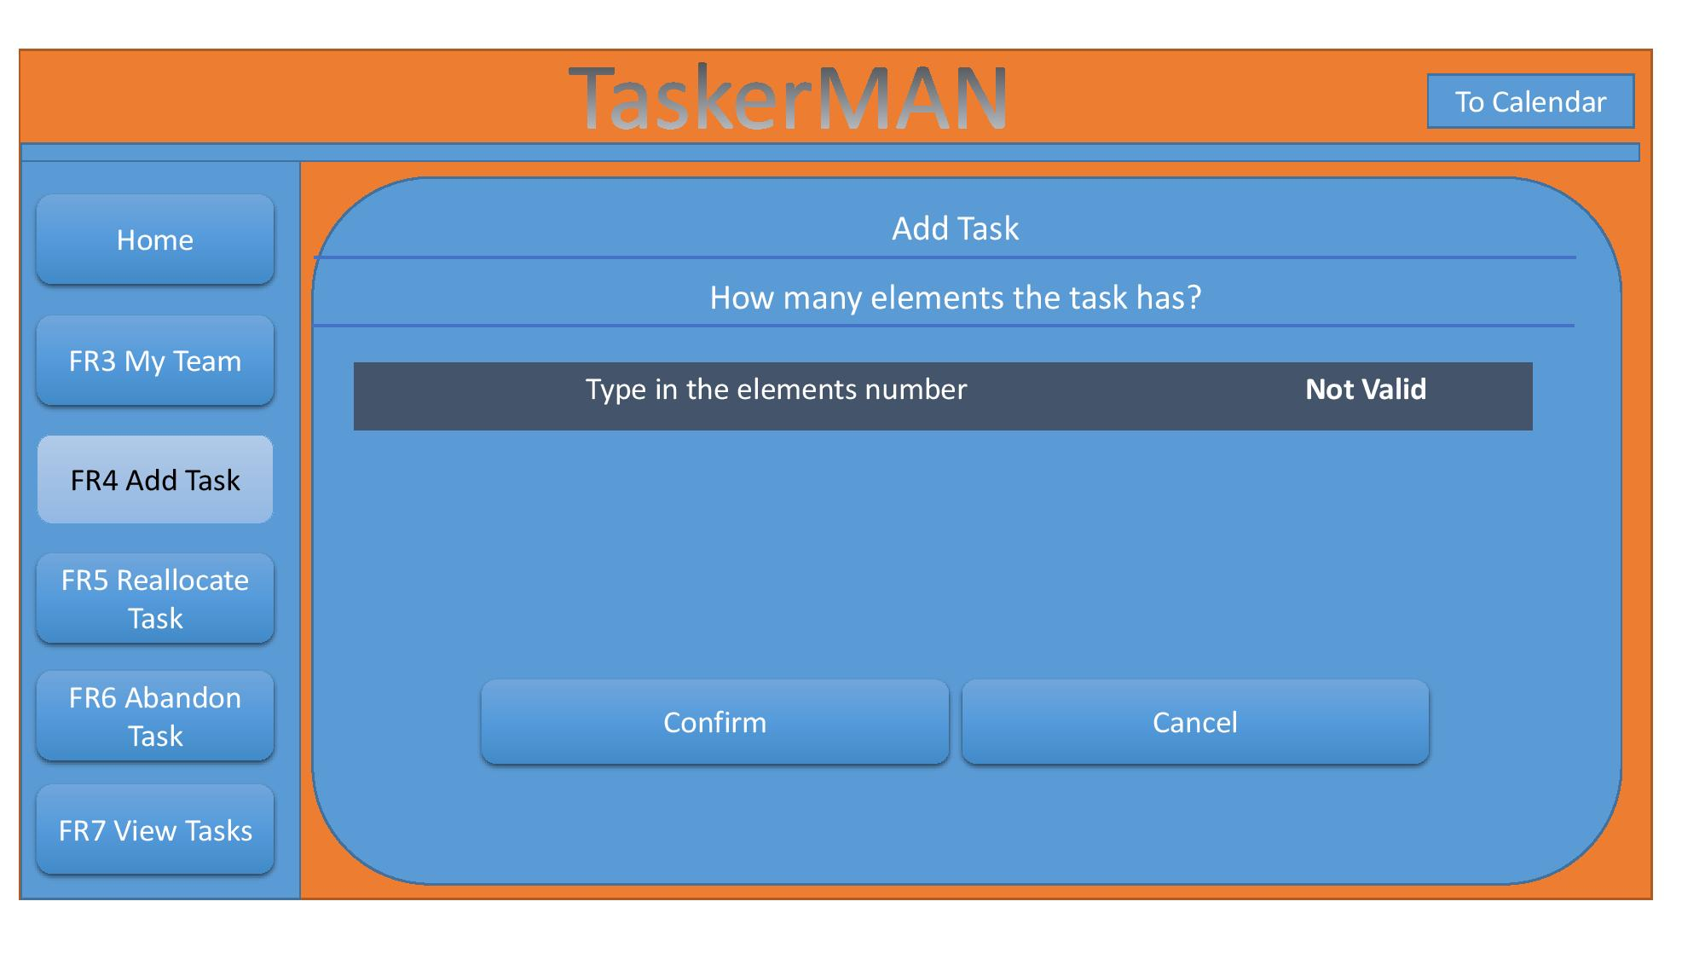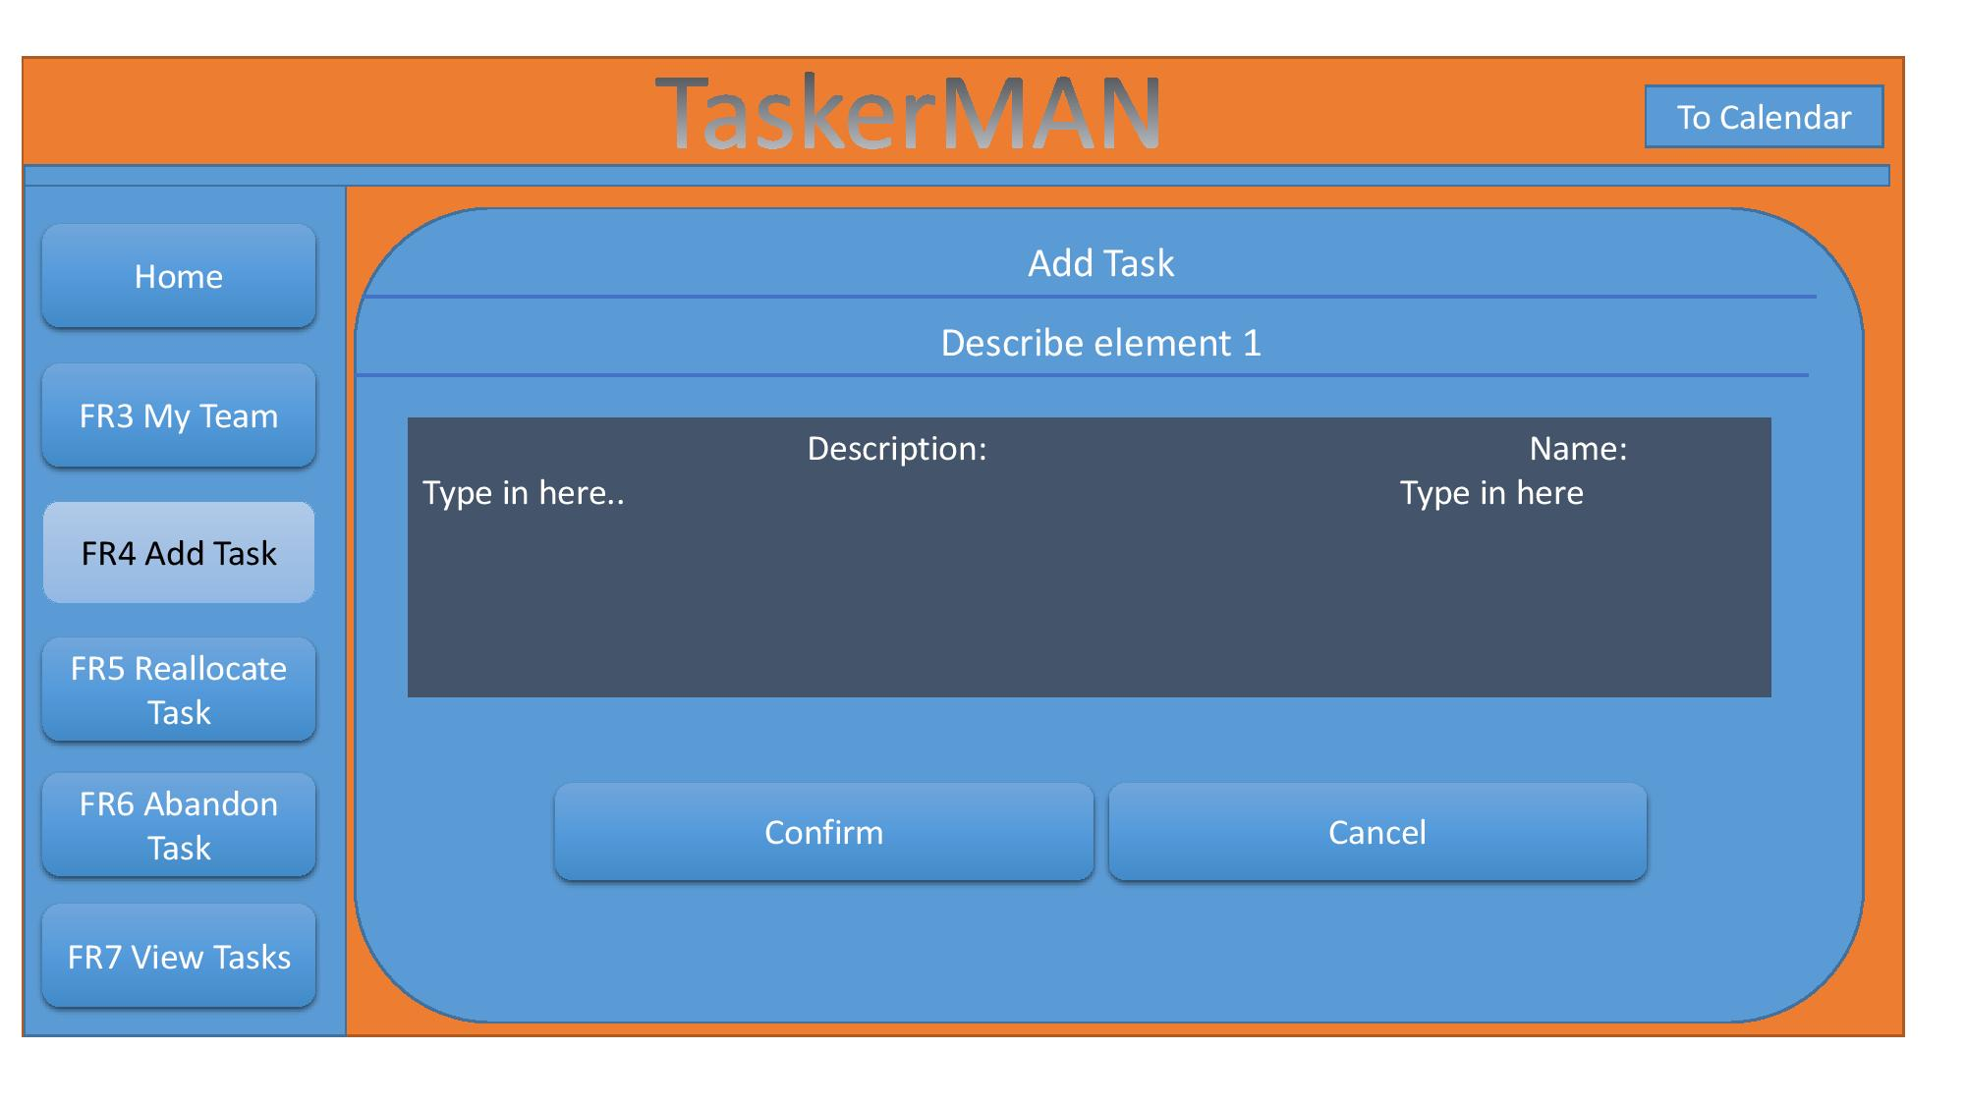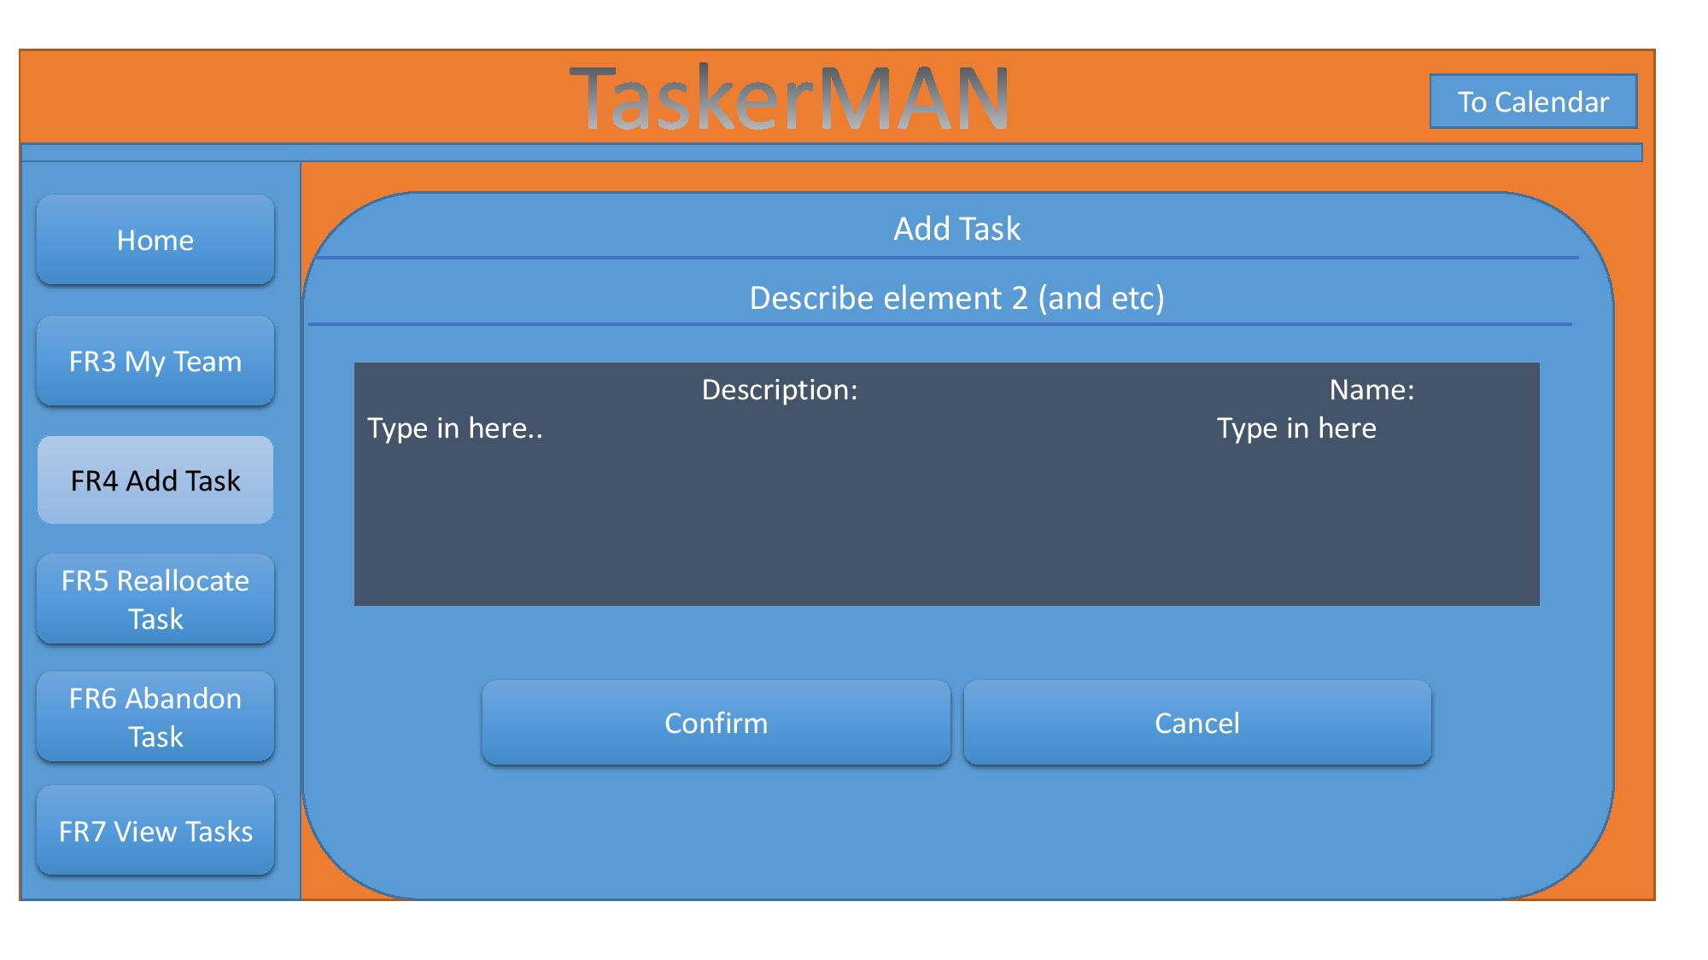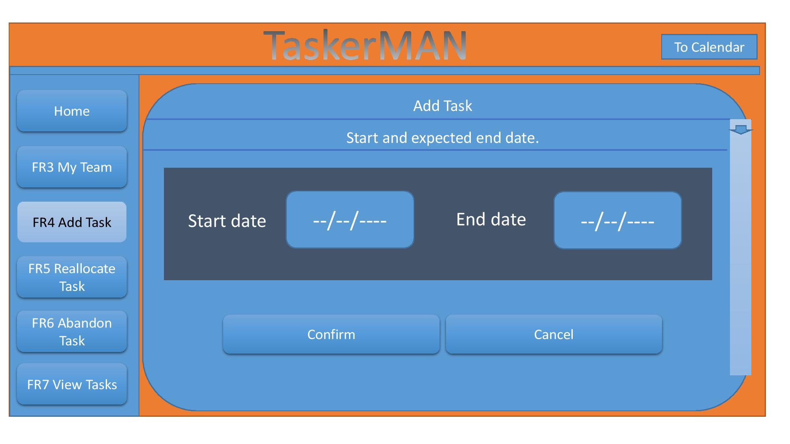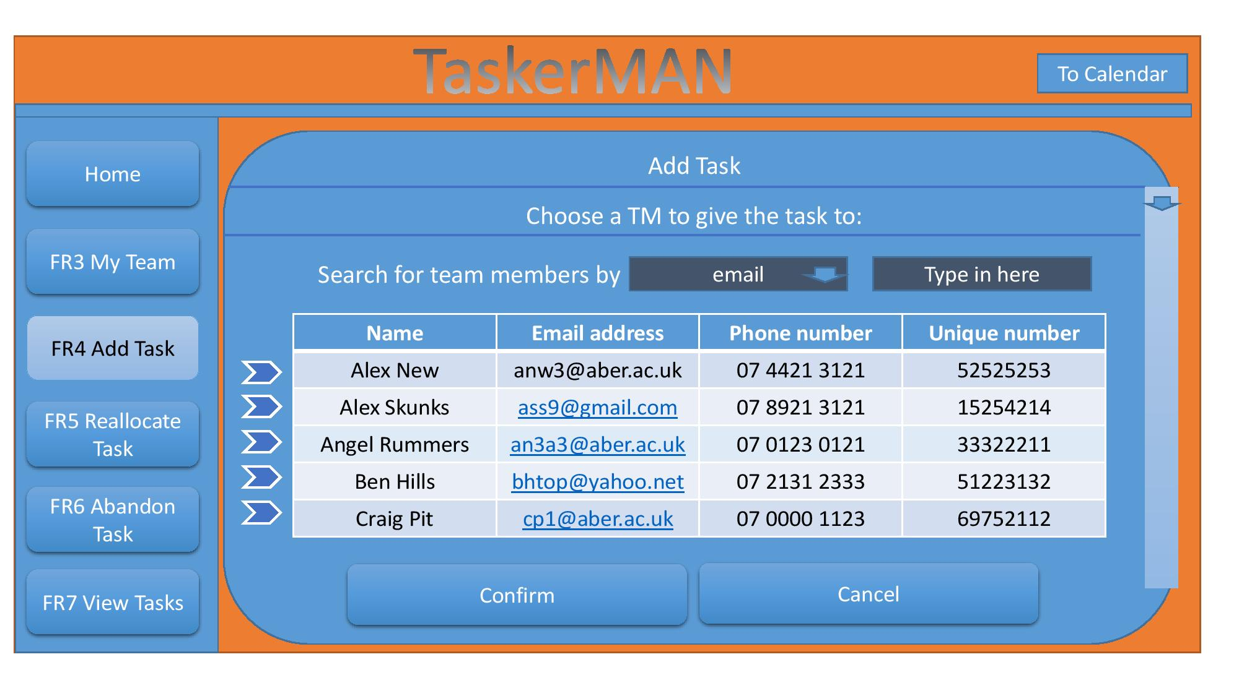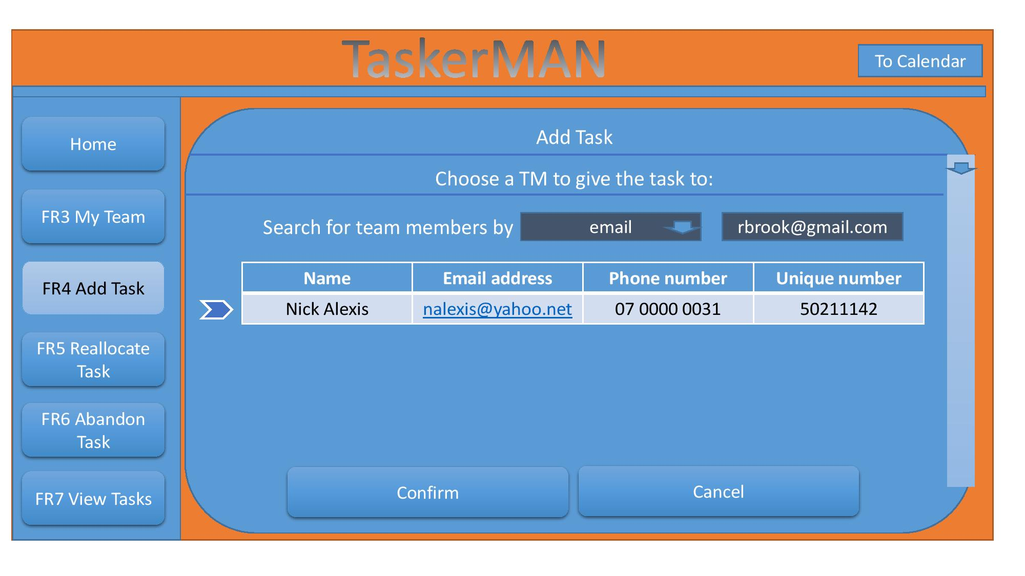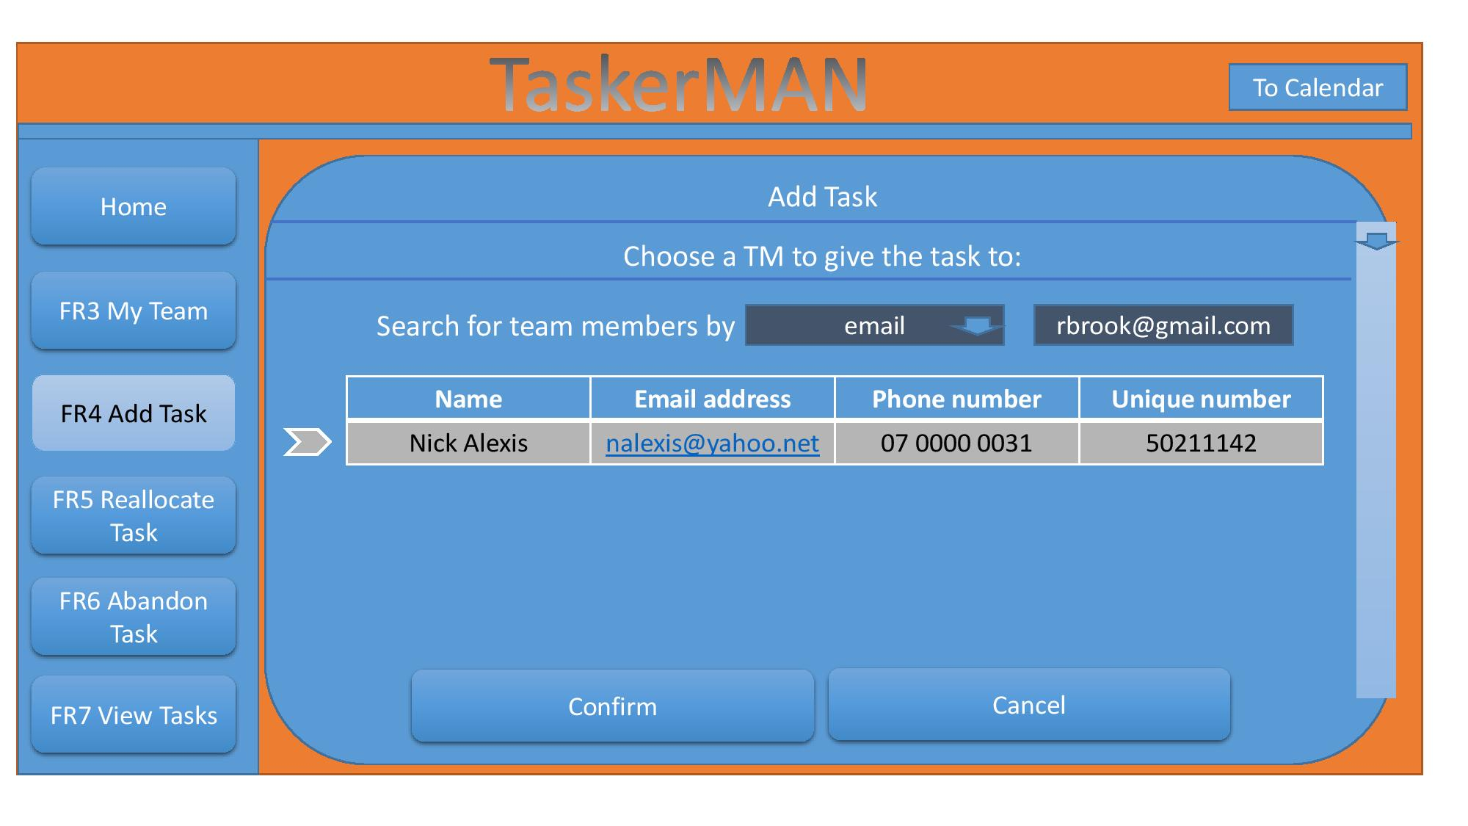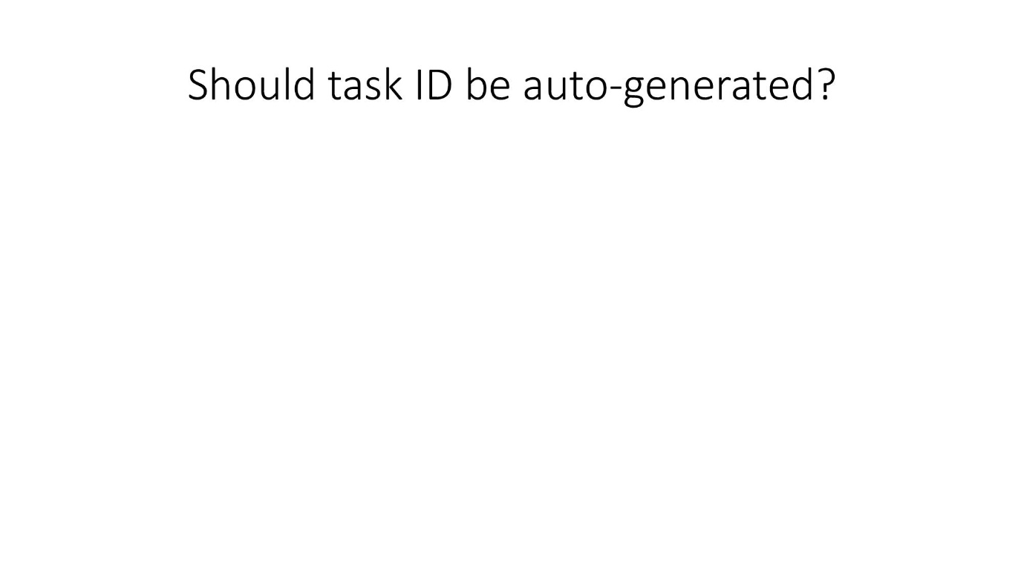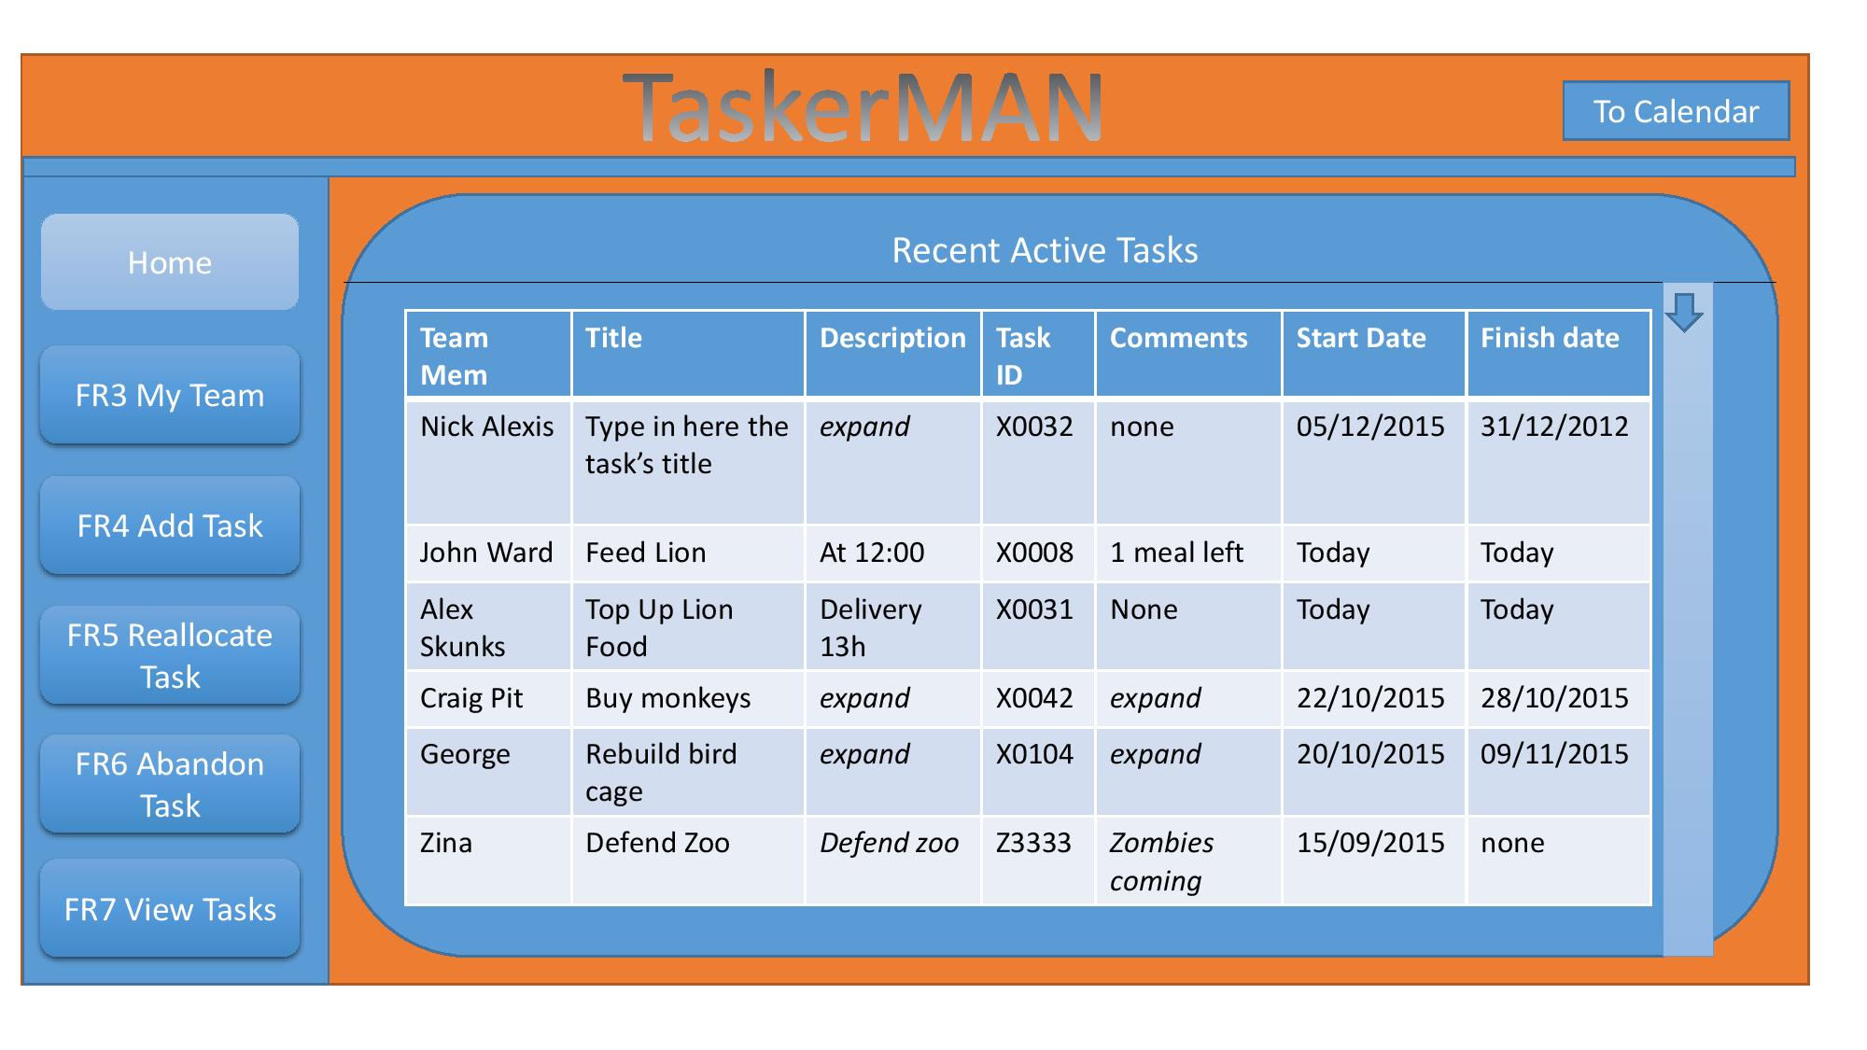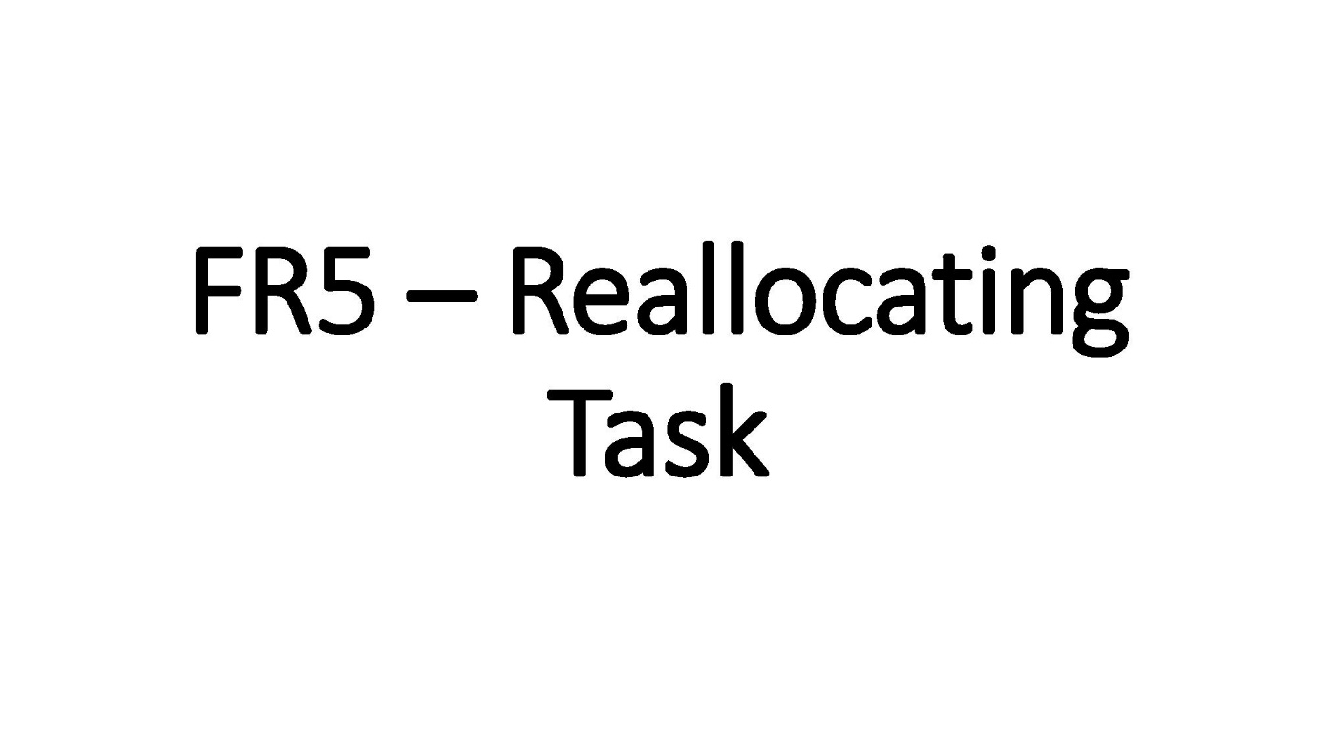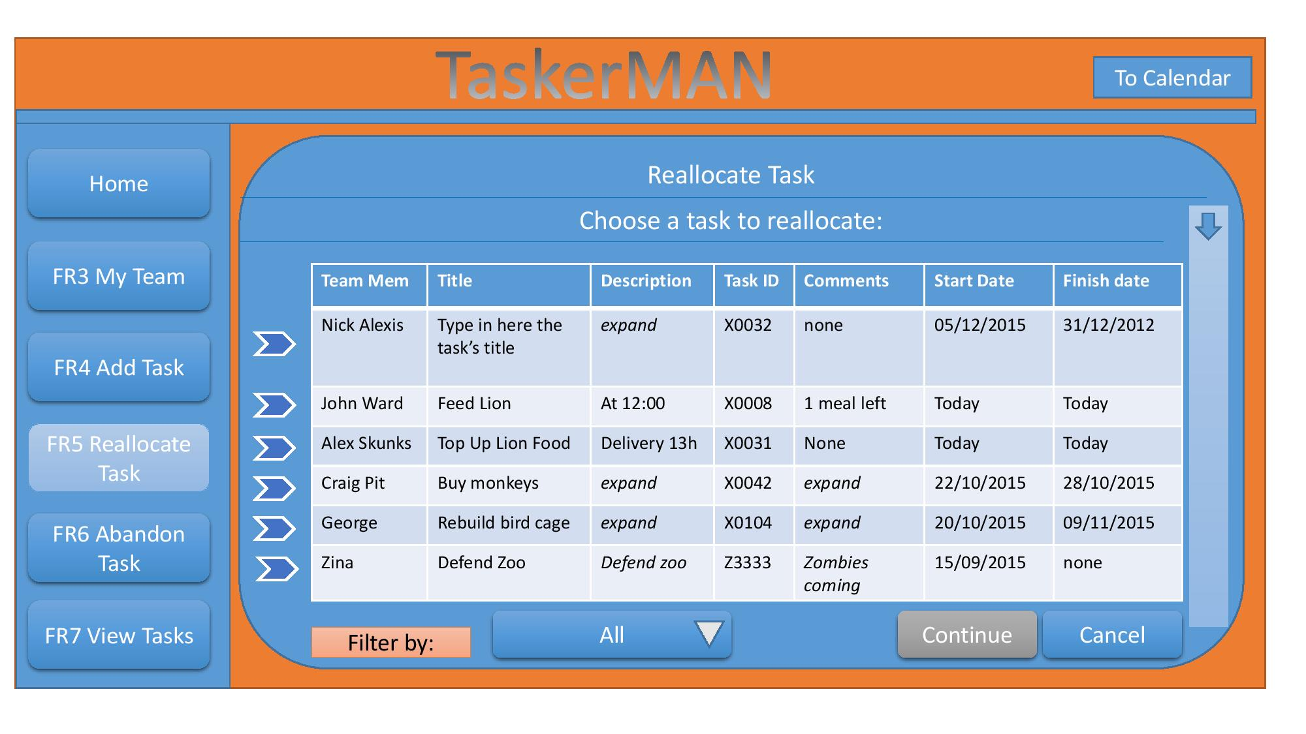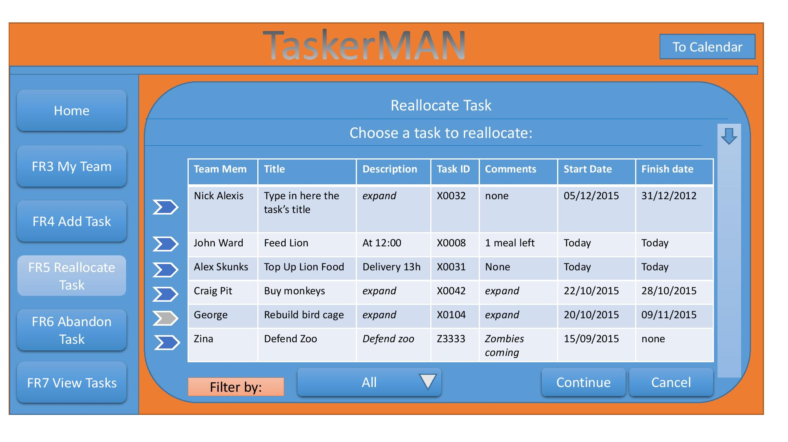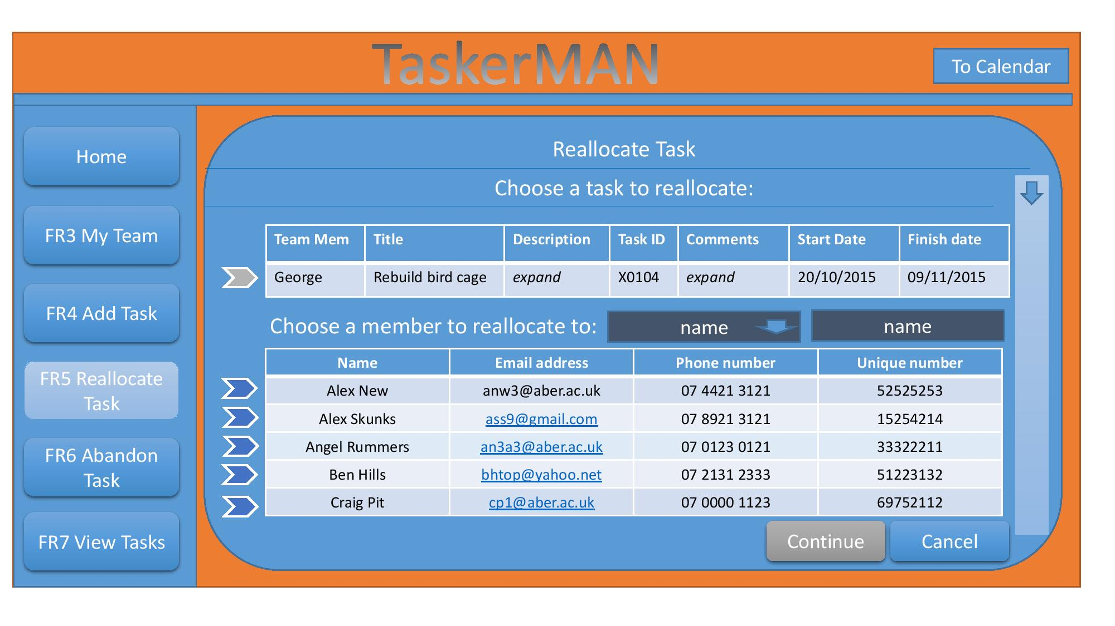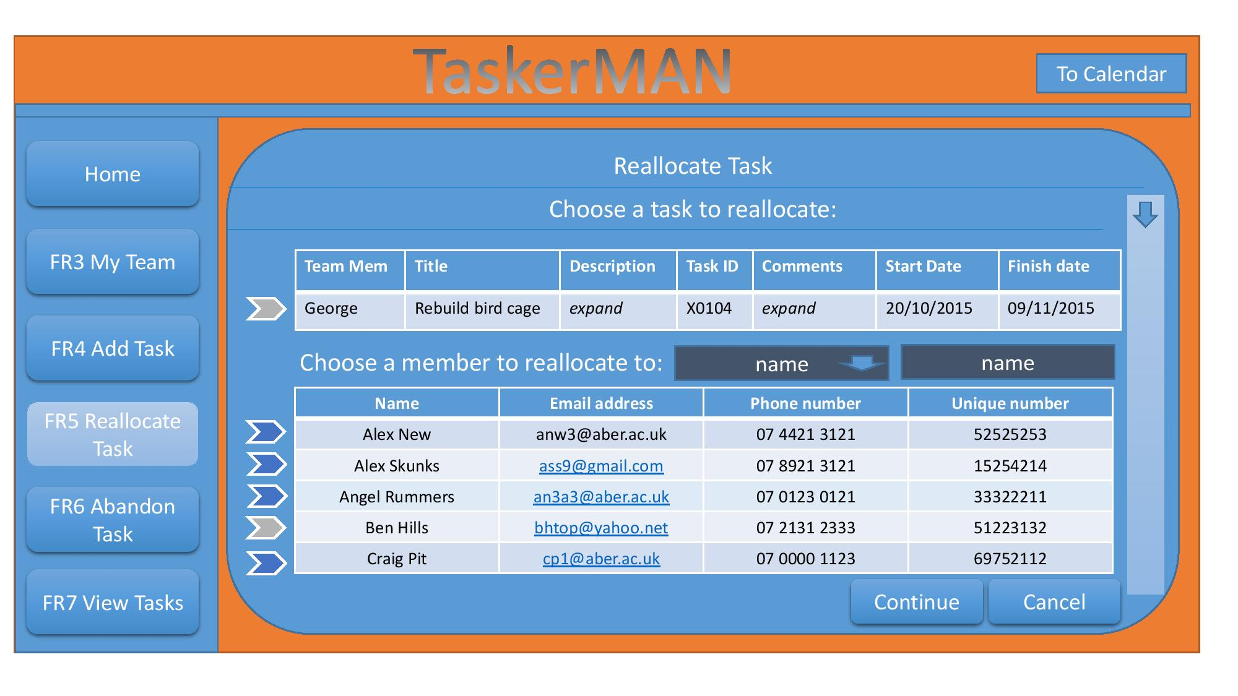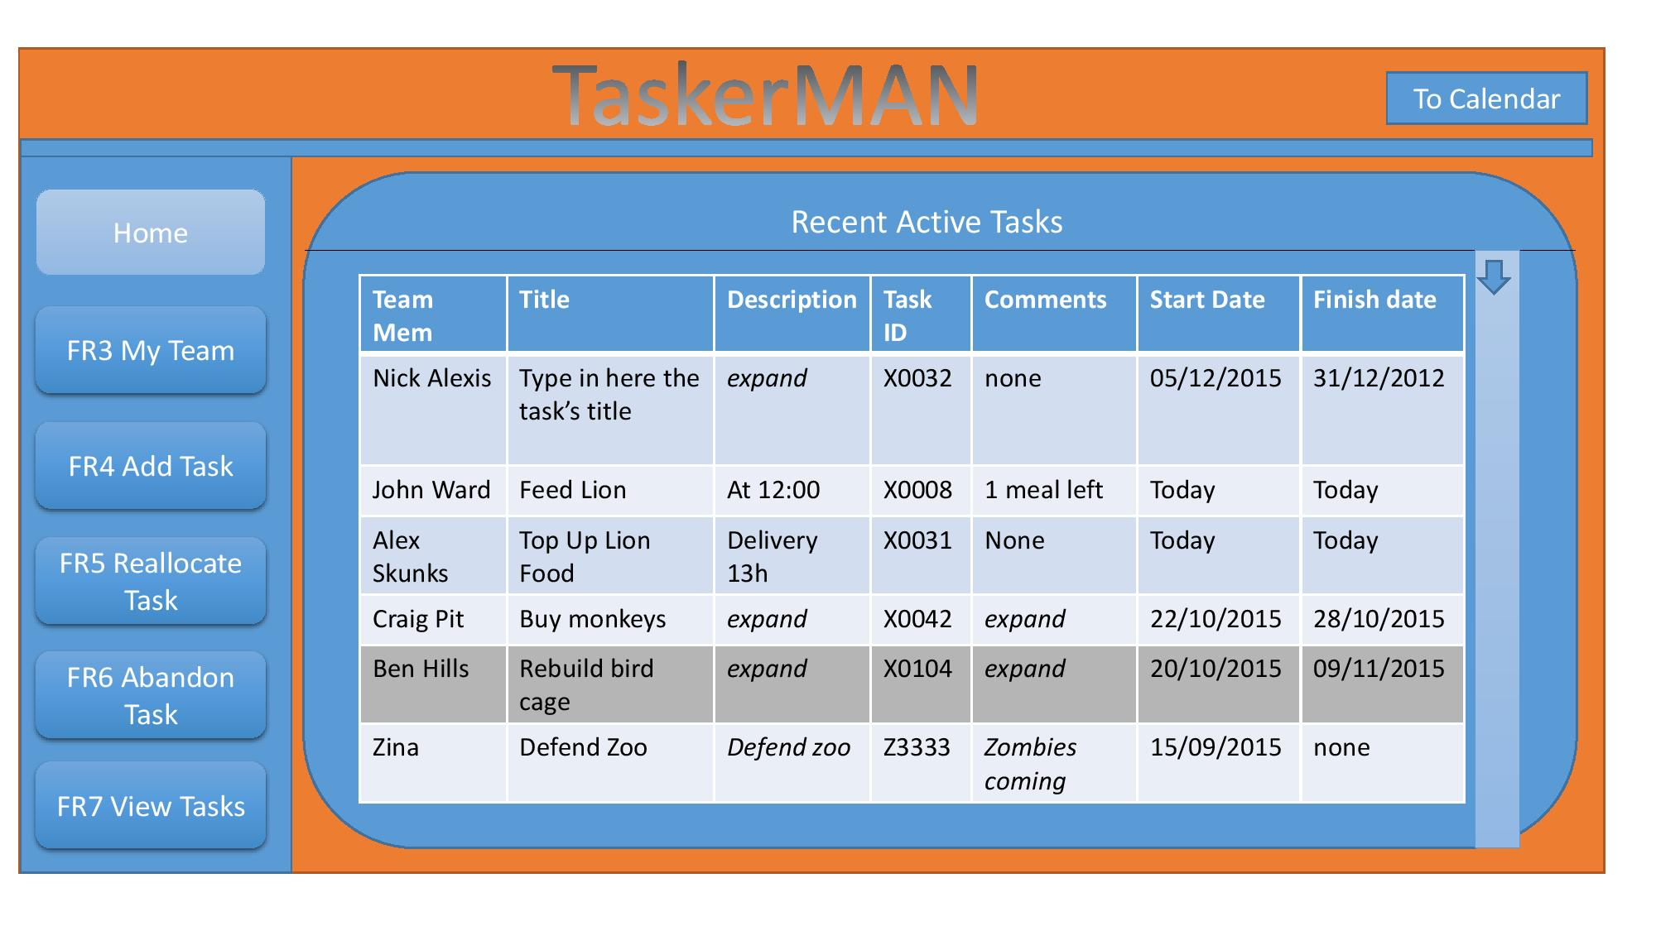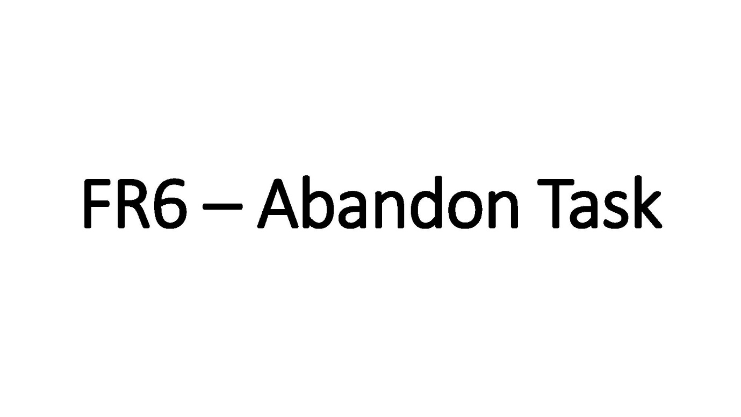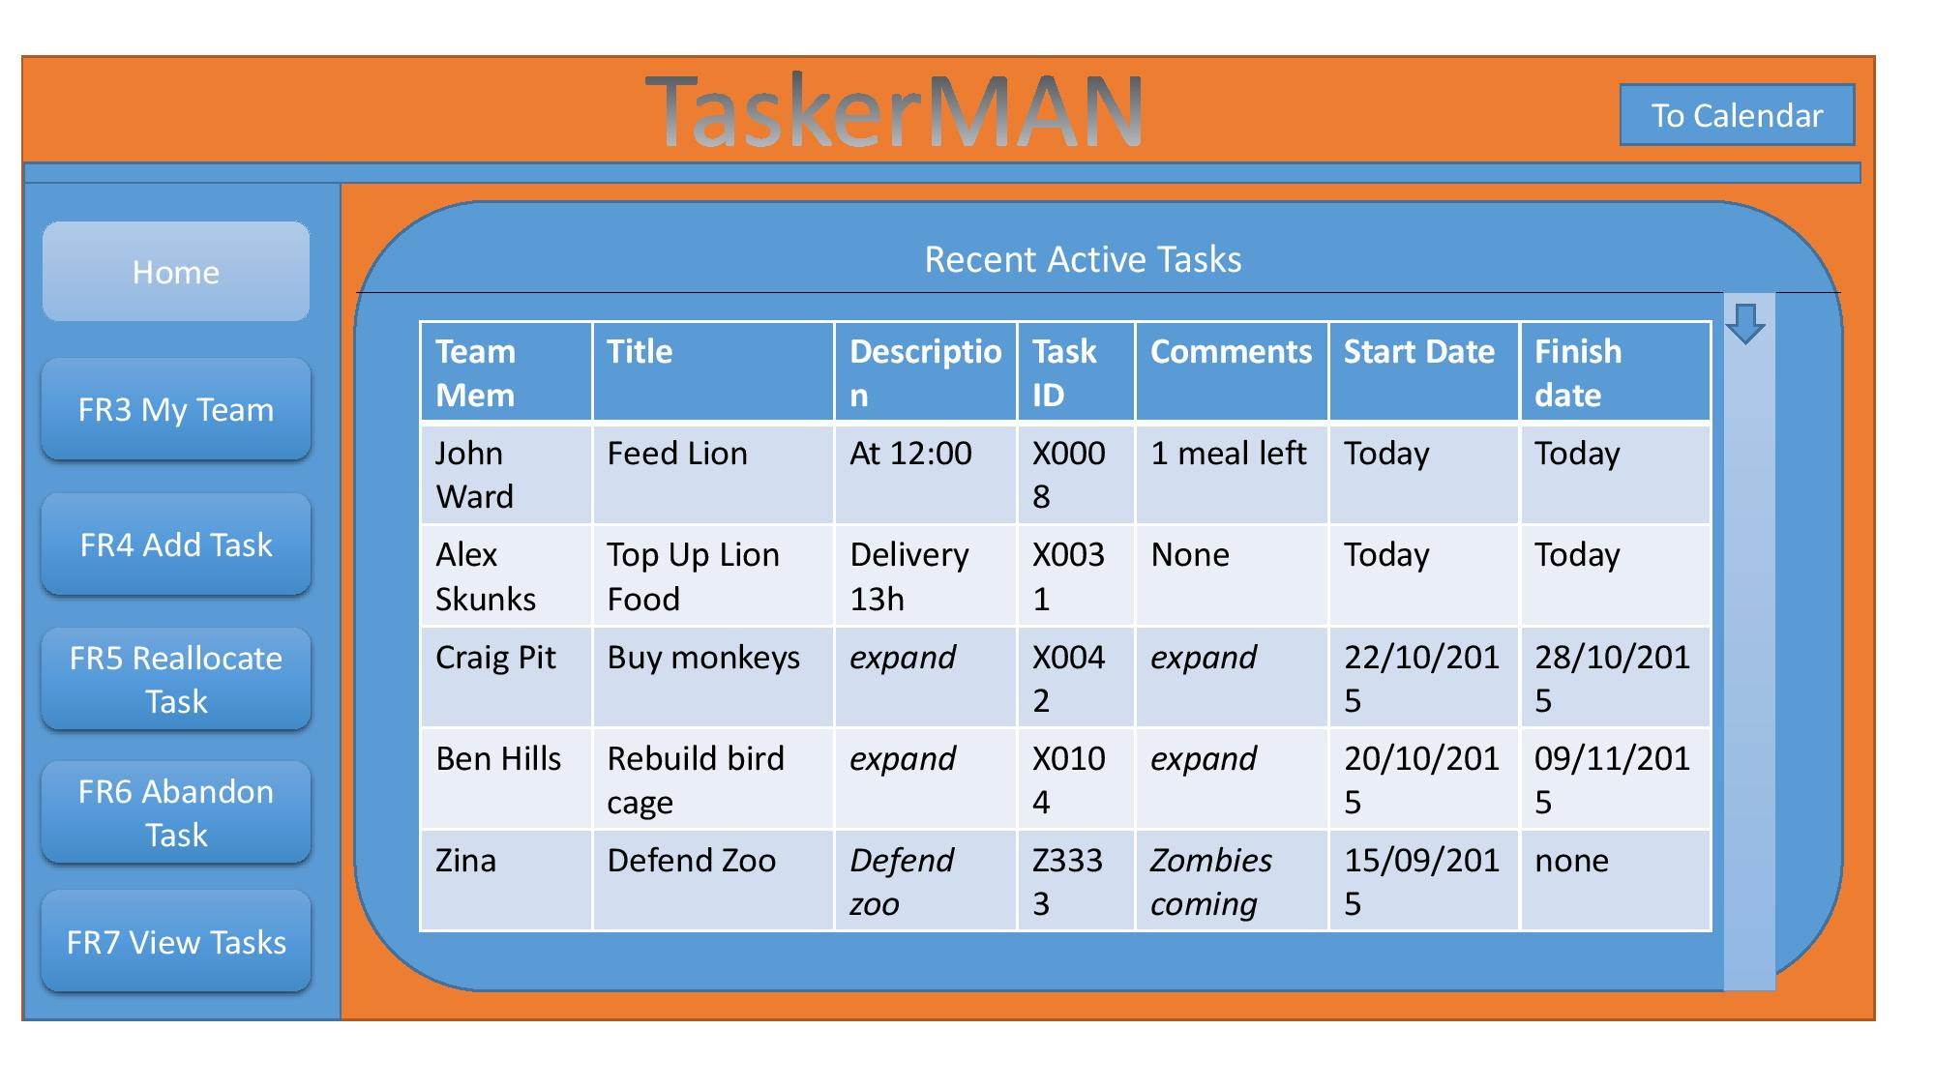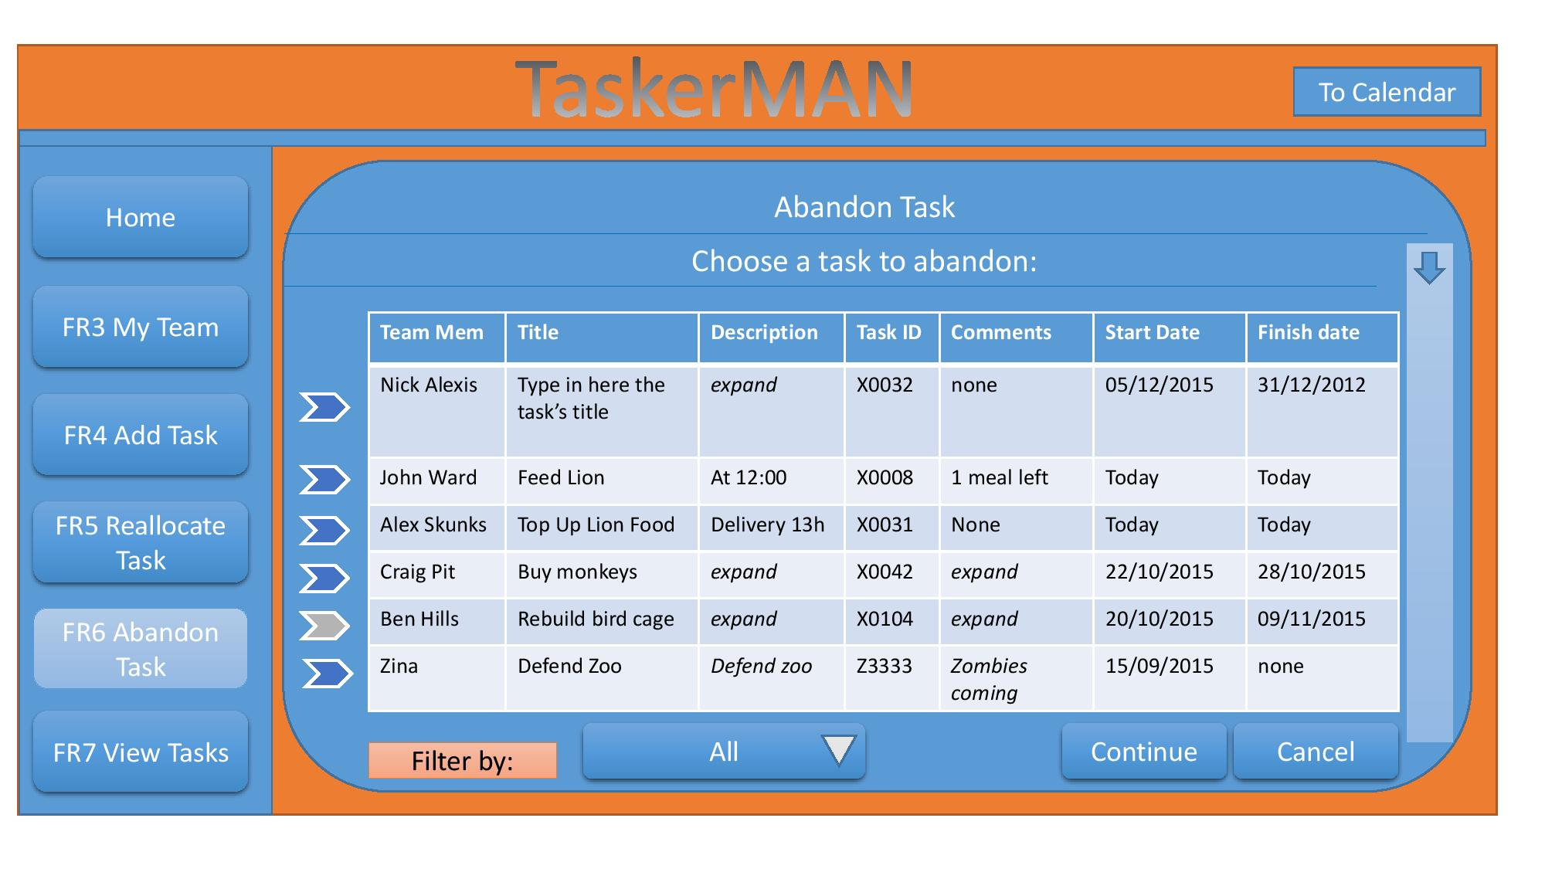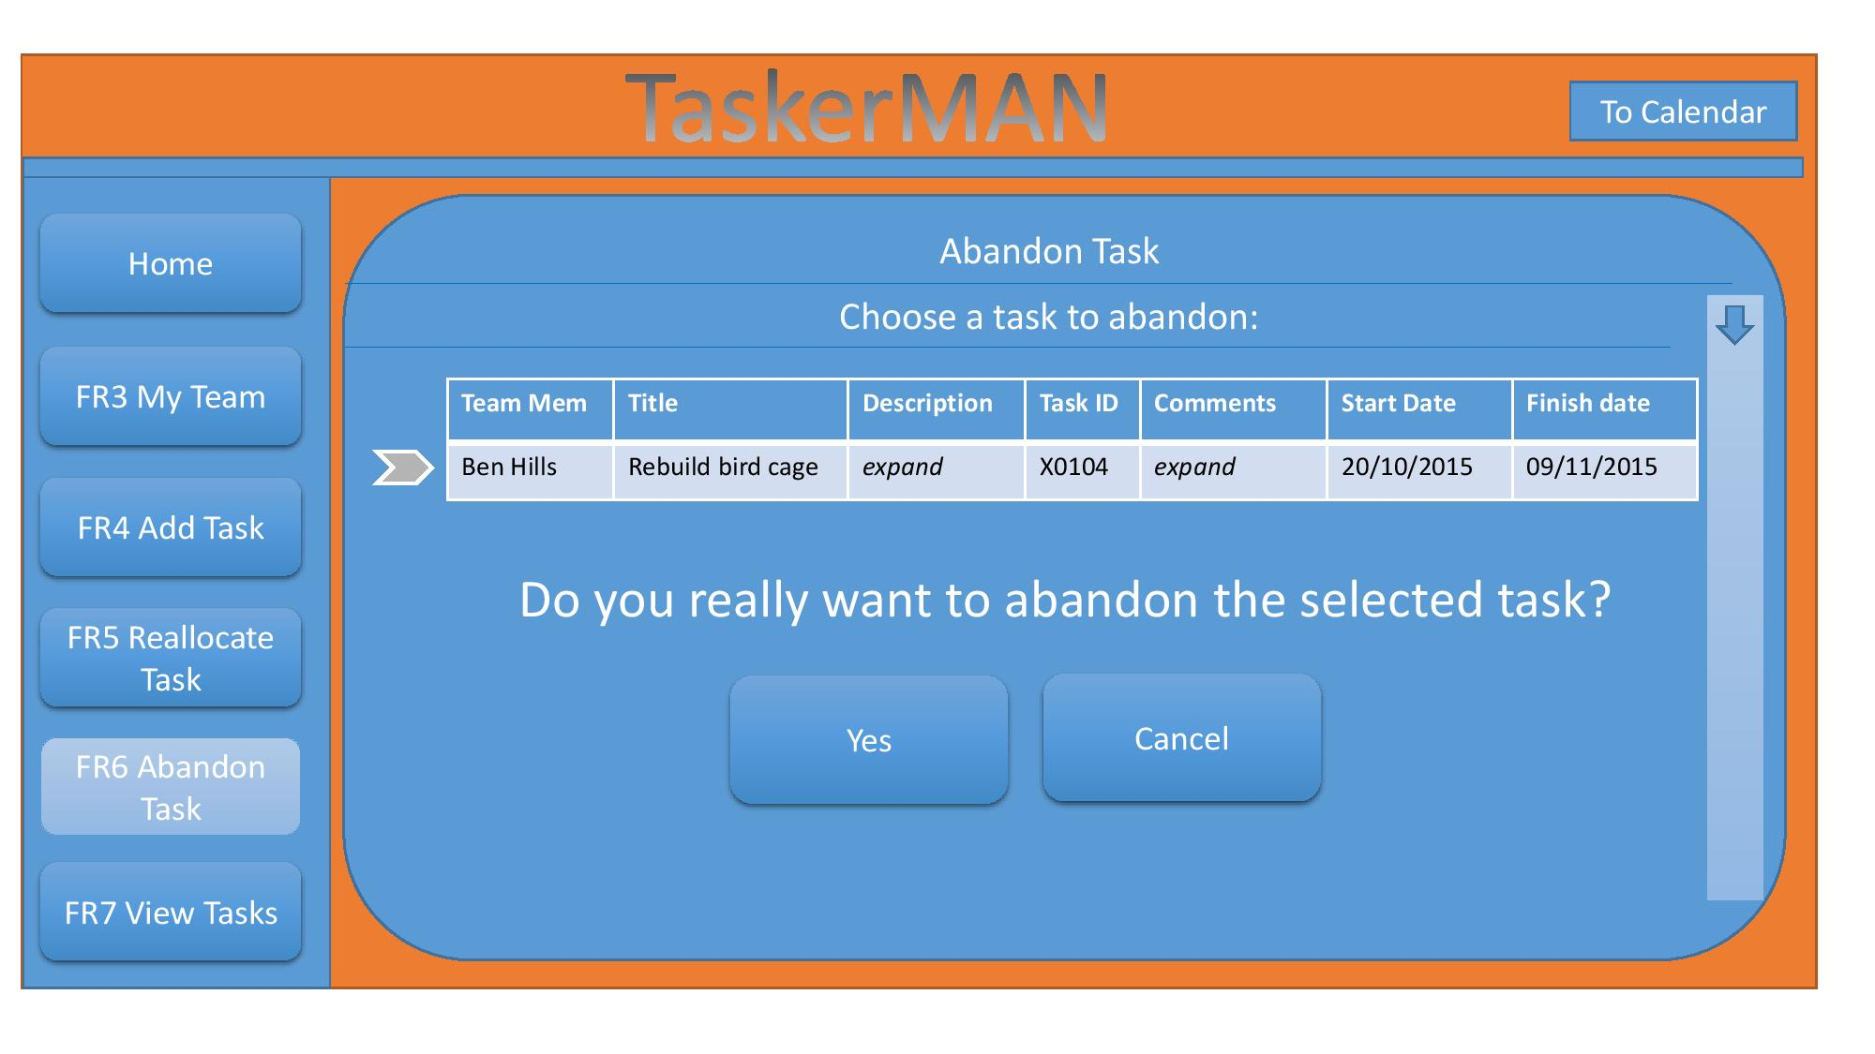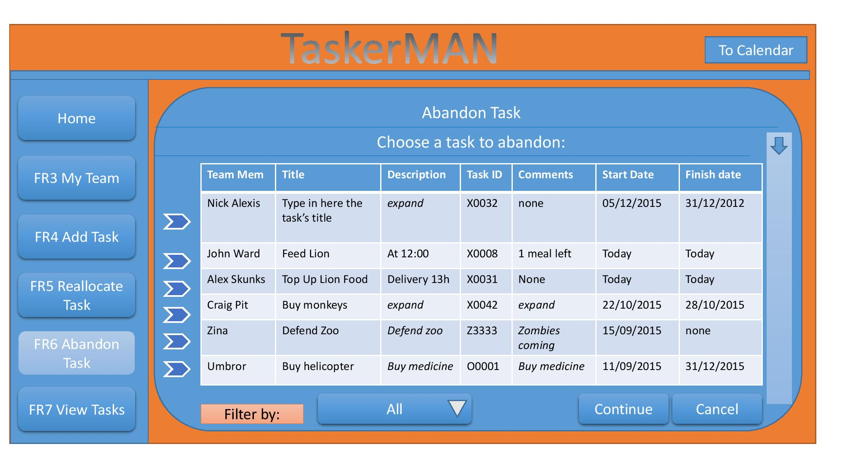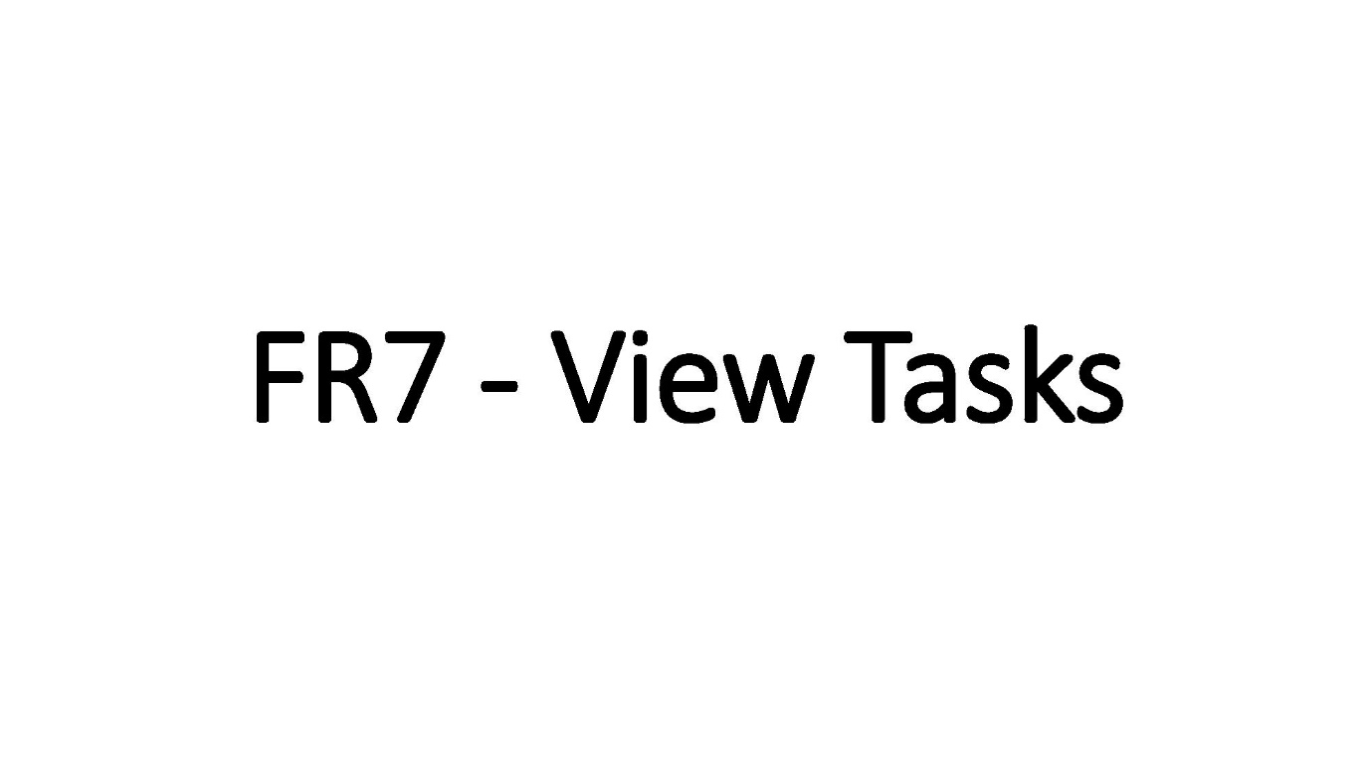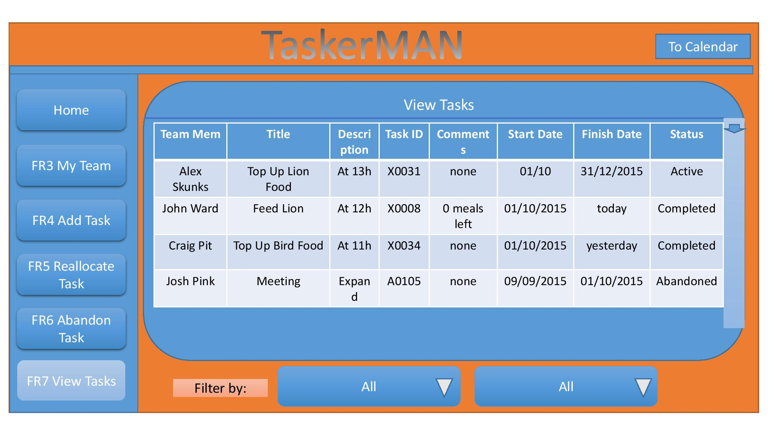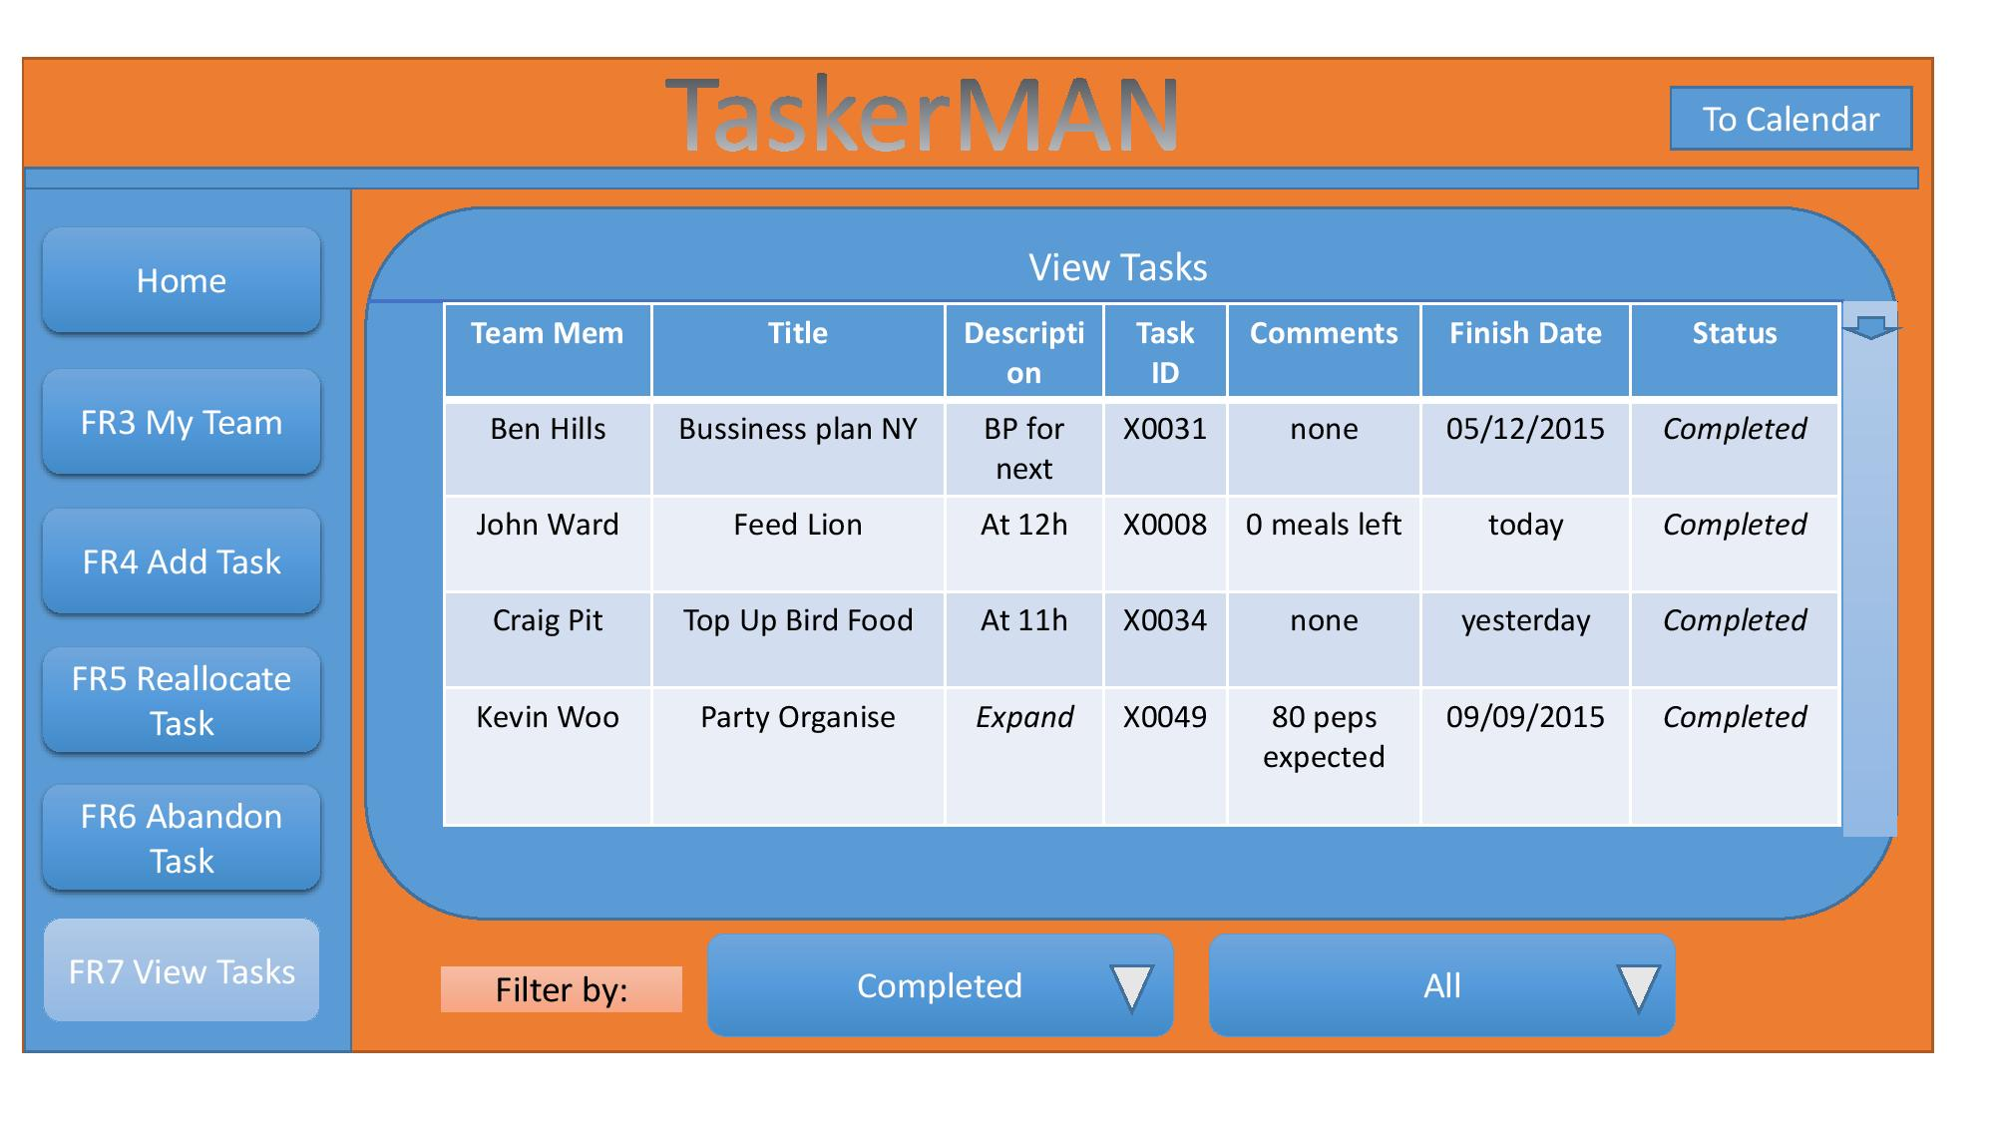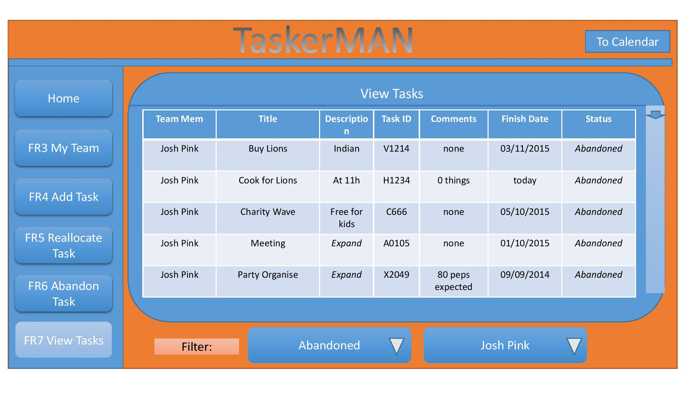

7.2 Appendix B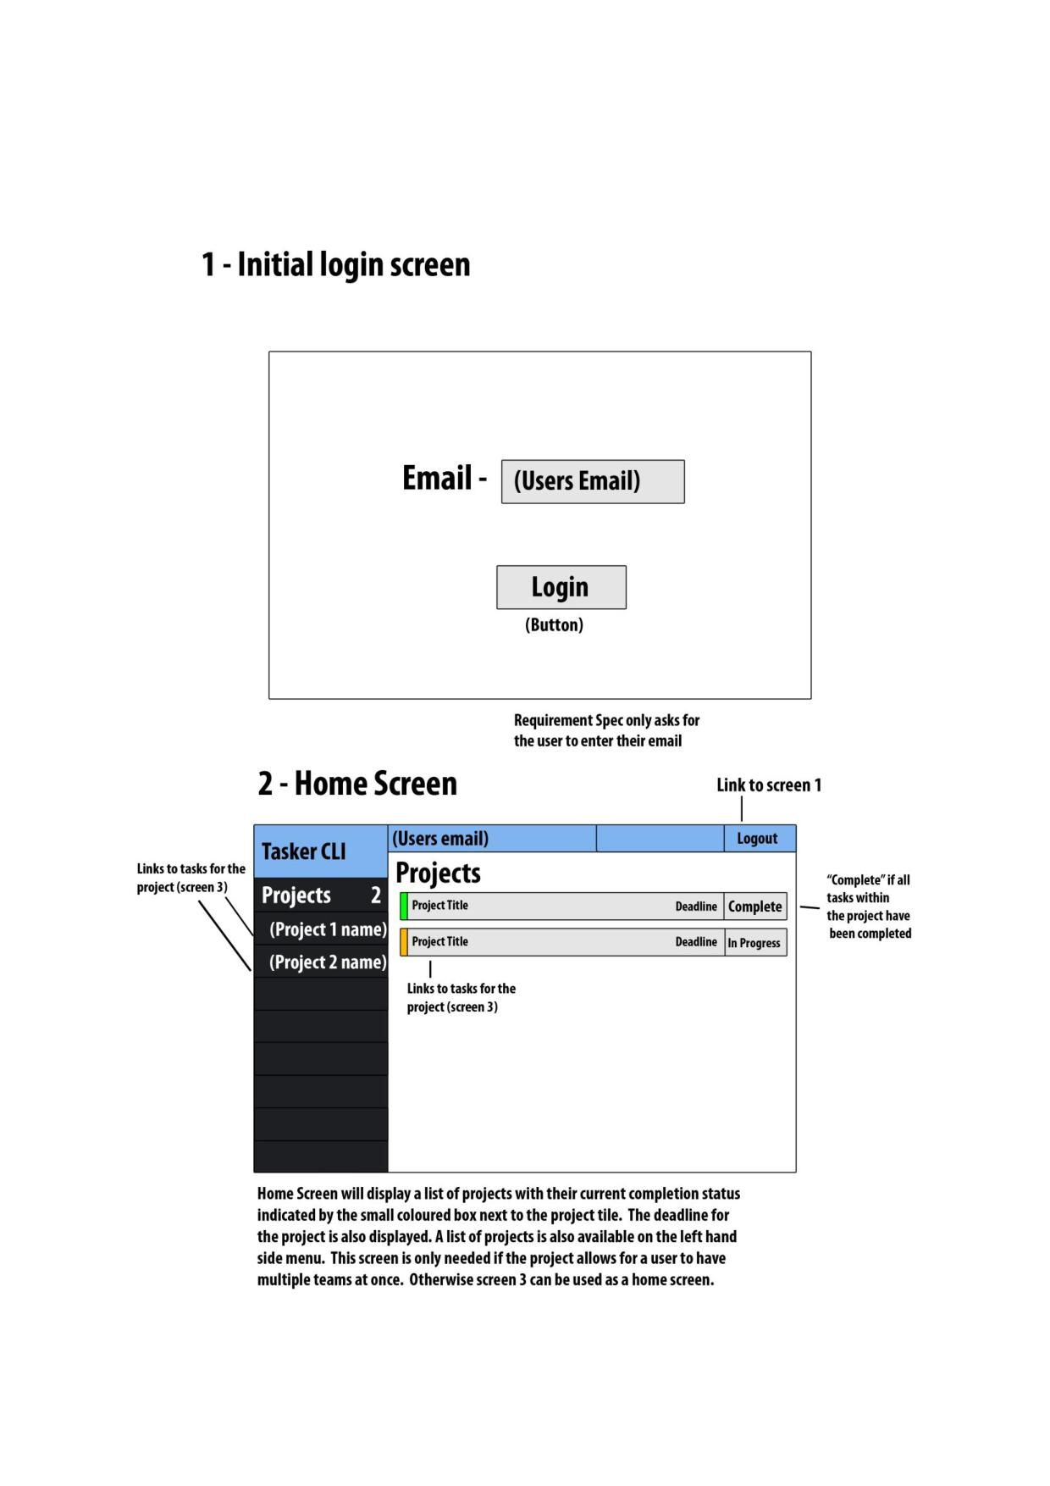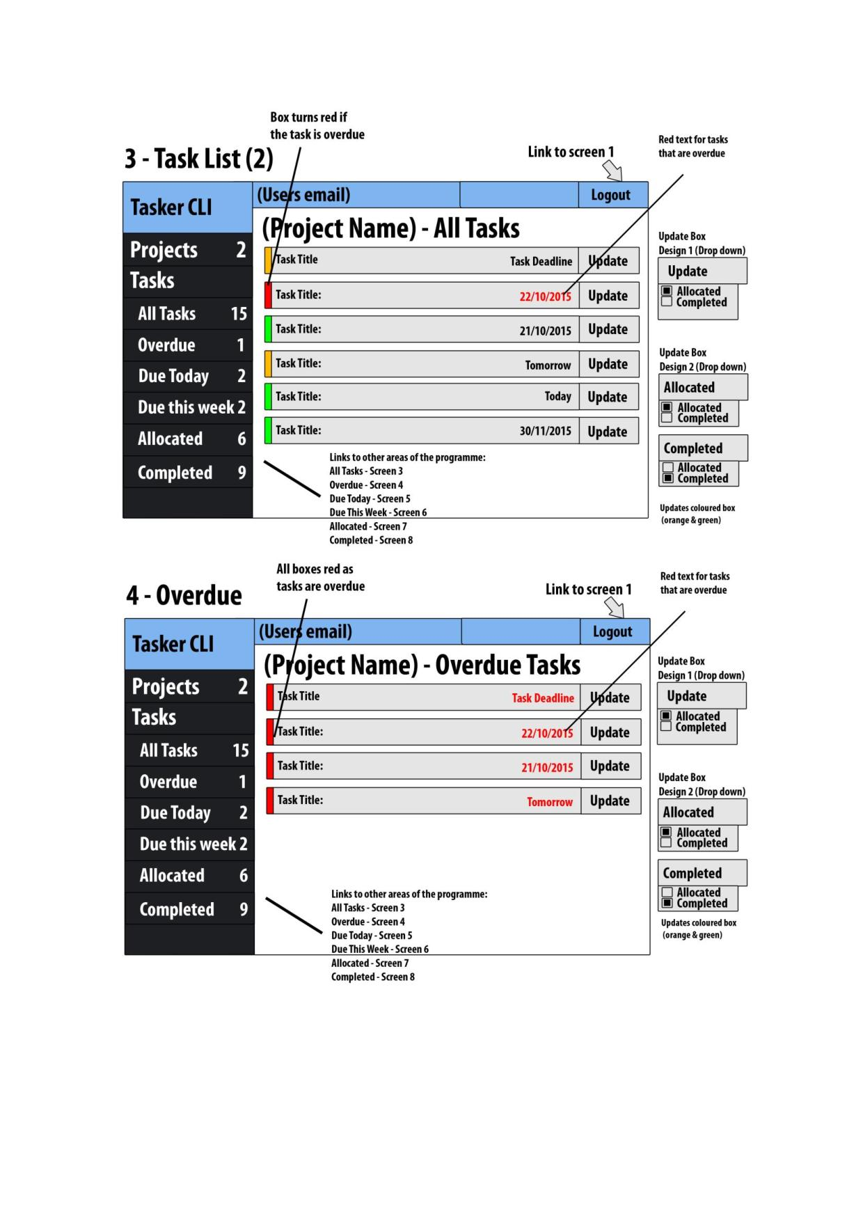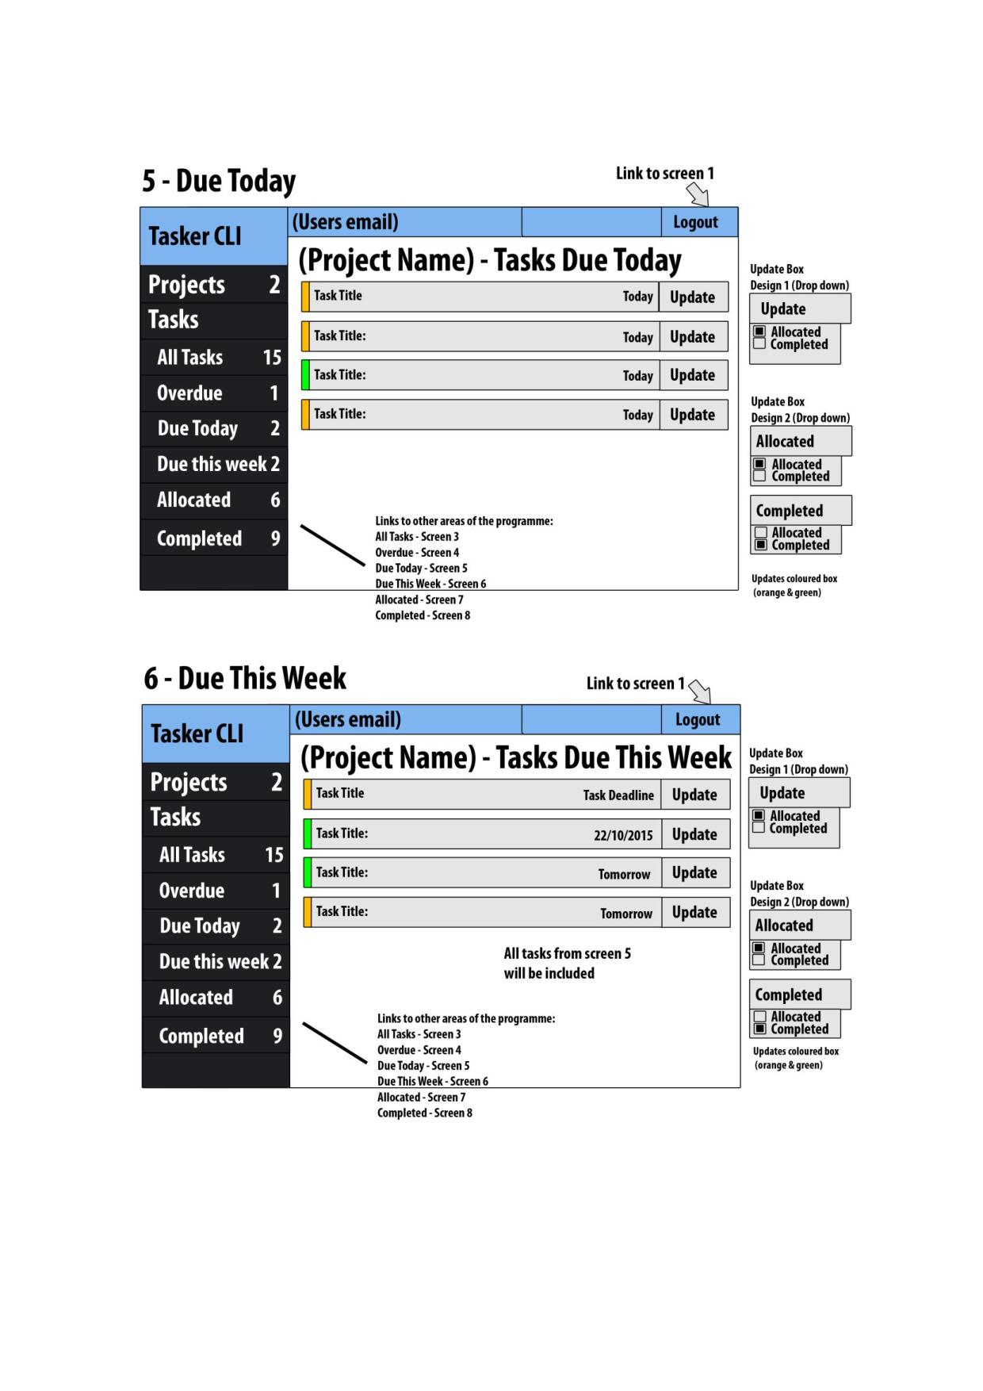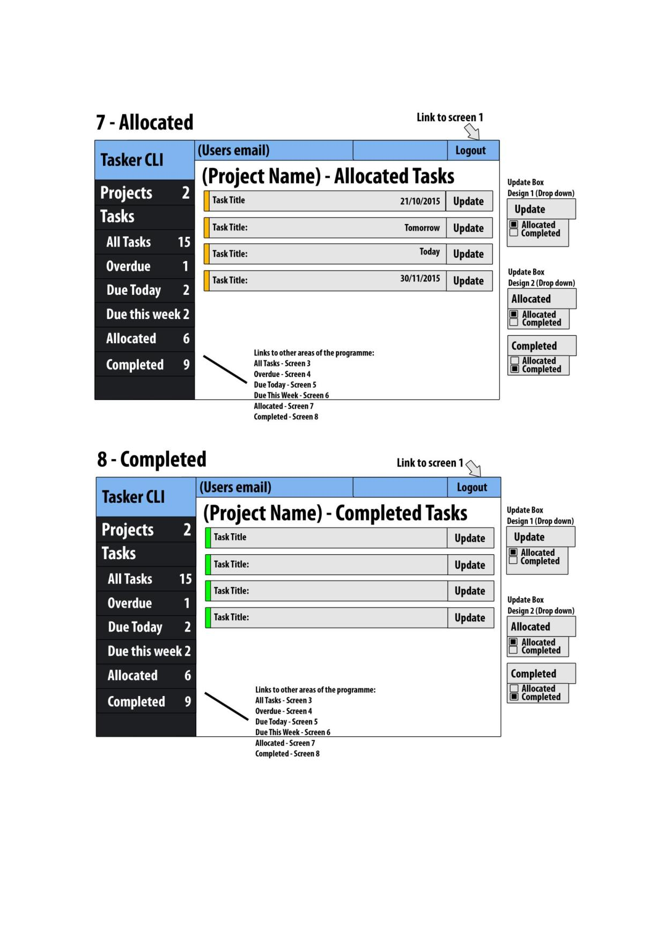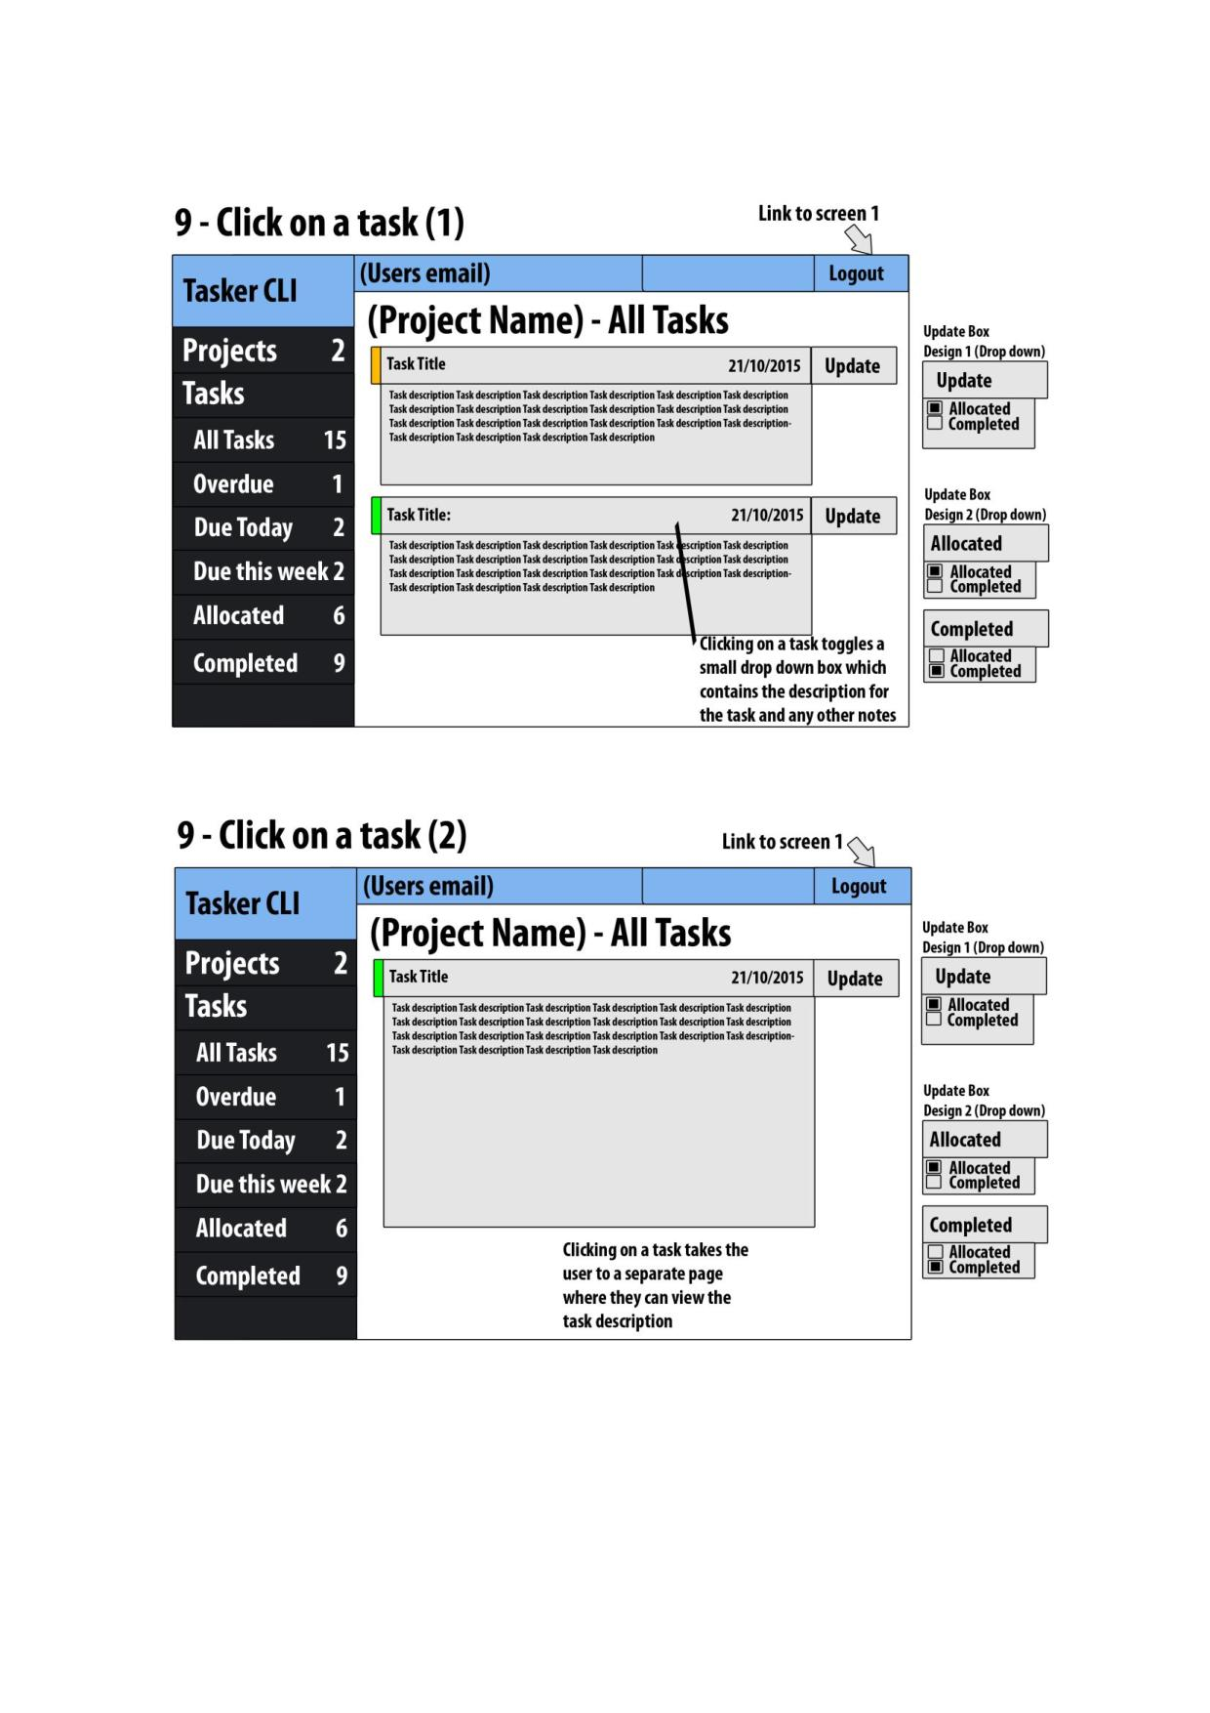

# 8 References

[1] Software Engineering Group Projects: Design Specification Standards.

# 9 Document History

|  |  |  |  |  |
| --- | --- | --- | --- | --- |
| Version | CCF No. | Date | Changes made to document | Changed by |
| 1.0 | N/A | 19/11/2015 | Document adapted from Interaction and High Level Design for purpose of Design Specification. | AJW21 |
| 1.1 | N/A | 24/11/2015 | Final Changes to the document | AJW21 |